**Extracting the iron concentration in silicon solar cells using photovoltaic parameters and machine learning**

Oleg Olikh, Oleksii Zavhorodnii

*Taras Shevchenko National University of Kyiv, 64/13, Volodymyrska Street, Kyiv, 01601, Ukraine*

olegolikh@knu.ua

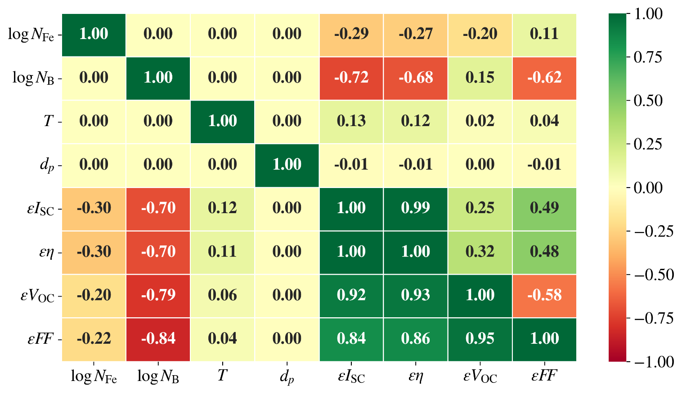

Fig.S1. Correlation plot of features in training set. Data above and below the main diagonal correspond to AM1.5 and 940 nm illumination, respectively.

Table S1. Hyperparameter space for RF

|  |  |
| --- | --- |
| Hyperparameter | Values |
| # estimators | 100, 200, 250, 300, 350, 400, 450,500,550, 600, 650, 700 |
| max depth | 10, 15, 20, 25, 30, 35, 40, 45 |
| min samples leaf | 1, 2, 3, 4, 5, 6, 7 |
| min samples split | 2, 3, 4, 5, 6, 7 |
| bootstrap | True, False |
| max features | 'log2', 'sqrt', 1.0, 0.9, 0.8, 0.7, 0.6, 0.5, 0.4, 0.3, 0.2 |

Table S2. Hyperparameter space for GB

|  |  |
| --- | --- |
| Hyperparameter | Values |
| # estimators | 100, 200, 250, 300, 350, 400, 450,500,550, 600, 650 |
| max depth | 15, 20, 25, 30, 35, 40, 45 |
| min samples leaf | 1, 2, 3, 4, 5, 6, 7 |
| min samples split | 2, 3, 4, 5, 6, 7 |
| learning rate | [10-3, 10-1] |
| max features | 'log2', 'sqrt', 1.0, 0.9, 0.8, 0.7, 0.6, 0.5, 0.4, 0.3, 0.2 |

Table S3. Hyperparameter space for XGB

|  |  |
| --- | --- |
| Hyperparameter | Values |
| booster | gbtree, gblinear, dart |
| max depth* | 3, 4, 5, 6, 7, 10, 15, 20 |
| min split loss* | [10-6; 5] |
| min child weight* | [0; 15] |
| subsample* | 0.2, 0.3, 0.4, 0.5, 0.6, 0.7, 0.8, 0.9, 1.0 |
| сolsample by tree* | 0.2, 0.3, 0.4, 0.5, 0.6, 0.7, 0.8, 0.9, 1.0 |
| # estimators | 200, 300, 400, 500, 600, 700, 800, 900 |
| learning rate | [10-5; 1] |
| L1 | [10-8; 1] |
| L2 | [10-8; 10] |
| * for all boosters except gblinear | |

Table S4. Hyperparameter space for SVR

|  |  |
| --- | --- |
| Hyperparameter | Values |
| kernel | linear, poly, rbf, sigmoid |
| degree* | 2, 3, 4, 5, 6 |
| C0 | [0; 5] |
| Tolerance | [10-5; 10-2] |
| C | [10-2; 15] |
| Epsilon | [10-3; 1] |
| * for poly kernel only | |

Table S5. Hyperparameter space for DNN

|  |  |
| --- | --- |
| Hyperparameter | Values |
| hidden layers configuration* | Pipe, Trapezium, Triangle, Butterfly, Fir |
| # nodes for first hidden layer | 5, 10, 20, 30, 50, 75, 100, 120, 150, 200, 250 |
| # hidden layers** | 5, 6, 8, 10, 12, 15 |
| batch size | 8, 16, 32, 64, 128 |
| activation function | ReLu, sigmoid, tanh, SELU, ELU |
| optimizer | SGD, RMSprop, Adam, Adadelta, Adagrad, Adamax, Nadam, Ftrl |
| learning rate | [10-5; 10-2] |
| # epochs | 100, 300, 400, 500, 600, 700, 1000, 1500 |
| weight initializer | Xavier Normal, Xavier Uniform, He Normal, He Uniform, Random Normal, Random Uniform |
| * The configurations are shown in Fig.S2. | |
| ** For Pipe configuration only | |

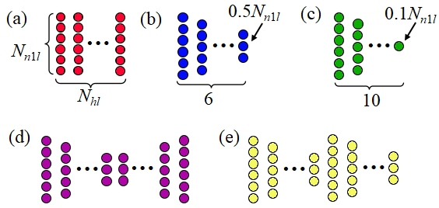 Fig.S2. The considered configuration of the hidden layers for DNN models: a) pipe; b) trapezium; c) triangle; d) butterfly (two serial reflected trapezium); e) fir (two serial trapezium). *Nn*1*l* is the number nodes for first hidden layer, *Nhl* is the number of hidden layers.

Table S6. Chosen hyperparameter combinations for RF models

|  |  |  |  |  |  |  |
| --- | --- | --- | --- | --- | --- | --- |
| Model | Hyperparameter | | | | | |
| # estimators | max depth | min sample split | min sample leaf | max features | bootstrap |
| $${RF}_{4}^{AM}$$ | 200 | 15 | 3 | 1 | 1.0 | True |
| $${RF}_{4:PC}^{AM}$$ | 650 | 15 | 2 | 1 | 0.9 | True |
| $${RF}_{4}^{940}$$ | 500 | 30 | 2 | 1 | 0.9 | True |
| $${RF}_{4:PC}^{940}$$ | 200 | 20 | 2 | 1 | 0.9 | True |
| $${RF}_{5}^{AM}$$ | 600 | 20 | 2 | 1 | 0.6 | False |
| $${RF}_{5:PC}^{AM}$$ | 300 | 15 | 4 | 1 | 0.6 | False |
| $${RF}_{5}^{940}$$ | 500 | 35 | 2 | 1 | 1.0 | True |
| $${RF}_{5:PC}^{940}$$ | 700 | 45 | 2 | 1 | 0.6 | True |
| $${RF}_{6}^{AM}$$ | 500 | 30 | 2 | 1 | 0.5 | False |
| $${RF}_{6:PC}^{AM}$$ | 600 | 30 | 2 | 1 | 0.6 | False |
| $${RF}_{6}^{940}$$ | 400 | 30 | 2 | 1 | 0.5 | False |
| $${RF}_{6:PC}^{940}$$ | 500 | 25 | 2 | 1 | 0.7 | False |
| $${RF}_{7}^{AM}$$ | 600 | 45 | 2 | 1 | 0.7 | False |
| $${RF}_{7:PC}^{AM}$$ | 550 | 40 | 2 | 1 | 0.6 | False |
| $${RF}_{7}^{940}$$ | 450 | 40 | 2 | 1 | 0.7 | False |
| $${RF}_{7:PC}^{940}$$ | 450 | 30 | 2 | 1 | 0.6 | False |

Table S7. Chosen hyperparameter combinations for GB models

|  |  |  |  |  |  |  |
| --- | --- | --- | --- | --- | --- | --- |
| Model | Hyperparameter | | | | | |
| # estimators | max depth | min sample split | min sample leaf | max features | learning rate |
| $${GB}_{4}^{AM}$$ | 500 | 15 | 4 | 7 | 0.8 | 8.3e-03 |
| $${GB}_{4:PC}^{AM}$$ | 550 | 15 | 5 | 7 | 0.8 | 8.1e-03 |
| $${GB}_{4}^{940}$$ | 650 | 30 | 6 | 6 | 0.8 | 1.1e-02 |
| $${GB}_{4:PC}^{940}$$ | 650 | 45 | 4 | 7 | 0.7 | 1.3e-02 |
| $${GB}_{5}^{AM}$$ | 650 | 45 | 2 | 4 | 0.8 | 4.3e-02 |
| $${GB}_{5:PC}^{AM}$$ | 550 | 15 | 4 | 3 | 0.6 | 7.2e-03 |
| $${GB}_{5}^{940}$$ | 600 | 40 | 4 | 6 | 0.7 | 1.9e-02 |
| $${GB}_{5:PC}^{940}$$ | 600 | 40 | 6 | 6 | 0.5 | 3.8e-02 |
| $${GB}_{6}^{AM}$$ | 600 | 45 | 7 | 5 | 0.7 | 3.4e-02 |
| $${GB}_{6:PC}^{AM}$$ | 550 | 30 | 7 | 7 | 0.6 | 1.9e-02 |
| $${GB}_{6}^{940}$$ | 650 | 45 | 7 | 7 | 0.7 | 2.7e-02 |
| $${GB}_{6:PC}^{940}$$ | 400 | 35 | 3 | 7 | 0.9 | 3.5e-02 |
| $${GB}_{7}^{AM}$$ | 450 | 15 | 4 | 6 | 0.7 | 2.3e-02 |
| $${GB}_{7:PC}^{AM}$$ | 550 | 40 | 2 | 6 | 0.6 | 2.1e-02 |
| $${GB}_{7}^{940}$$ | 650 | 15 | 5 | 7 | 0.7 | 2.8e-02 |
| $${GB}_{7:PC}^{940}$$ | 600 | 40 | 3 | 5 | 0.6 | 2.7e-02 |

Table S8. Chosen hyperparameter combinations for XGB models

|  |  |  |  |  |  |  |  |  |  |  |
| --- | --- | --- | --- | --- | --- | --- | --- | --- | --- | --- |
| Model | Hyperparameter | | | | | | | | | |
| booster | max depth | min split loss | min child weight | sub  sample | сolsample bytree | # estimators | learning rate | L1 | L2 |
| $${XGB}_{4}^{AM}$$ | dart | 10 | 5.3e-4 | 10.8 | 0.6 | 1 | 400 | 1.7e-2 | 2.8e-2 | 3.1e-2 |
| $${XGB}_{4:PC}^{AM}$$ | gbtree | 15 | 1.9e-3 | 11.1 | 0.7 | 1 | 500 | 9.5e-3 | 1.8e-4 | 2.6e-3 |
| $${XGB}_{4}^{940}$$ | dart | 15 | 2.3e-5 | 5.2 | 0.7 | 1 | 700 | 1.1e-2 | 6.6e-3 | 5.3e-2 |
| $${XGB}_{4:PC}^{940}$$ | gbtree | 15 | 1.8e-6 | 4 | 0.7 | 1 | 800 | 8.2e-3 | 1.1e-4 | 1 |
| $${XGB}_{5}^{AM}$$ | gbtree | 15 | 1.1e-5 | 1.9 | 0.7 | 1 | 800 | 7.3e-2 | 9.9e-4 | 9.8 |
| $${XGB}_{5:PC}^{AM}$$ | dart | 15 | 1.6e-5 | 10.4 | 0.3 | 1 | 800 | 6.7e-3 | 7.0e-3 | 0.5 |
| $${XGB}_{5}^{940}$$ | dart | 20 | 1.3e-5 | 1.5 | 0.7 | 1 | 900 | 1.1e-2 | 1.4e-4 | 2.4 |
| $${XGB}_{5:PC}^{940}$$ | dart | 20 | 1.3e-4 | 6.9 | 0.6 | 1 | 900 | 1.1e-2 | 2.5e-3 | 1.4e-3 |
| $${XGB}_{6}^{AM}$$ | dart | 20 | 5.5e-5 | 0.7 | 0.5 | 1 | 500 | 1.7e-2 | 1.7e-3 | 0.3 |
| $${XGB}_{6:PC}^{AM}$$ | dart | 15 | 6.8e-6 | 5.7 | 0.8 | 1 | 400 | 6.3e-2 | 8.1e-2 | 6.9e-2 |
| $${XGB}_{6}^{940}$$ | gbtree | 20 | 1.0e-5 | 3 | 0.5 | 1 | 900 | 1.0e-2 | 7.2e-4 | 1.3e-3 |
| $${XGB}_{6:PC}^{940}$$ | dart | 15 | 4.3e-6 | 9.9 | 0.7 | 1 | 500 | 4.7e-2 | 4.9e-4 | 3.3e-2 |
| $${XGB}_{7}^{AM}$$ | dart | 15 | 1.4e-5 | 3.9 | 0.3 | 1 | 700 | 5.6e-2 | 2.0e-3 | 5.9 |
| $${XGB}_{7:PC}^{AM}$$ | gbtree | 20 | 4.7e-6 | 12.6 | 0.6 | 0.9 | 900 | 4.4e-2 | 7.9e-2 | 0.3 |
| $${XGB}_{7}^{940}$$ | dart | 20 | 2.5e-6 | 8.3 | 0.5 | 1 | 900 | 8.4e-2 | 1.1e-3 | 7.4 |
| $${XGB}_{7:PC}^{940}$$ | gbtree | 15 | 1.3e-4 | 1.5 | 0.4 | 1 | 600 | 2.4e-2 | 1.2e-4 | 4.9e-2 |

Table S9. Chosen hyperparameter combinations for SVR models

|  |  |  |  |  |  |
| --- | --- | --- | --- | --- | --- |
| Model | Hyperparameter | | | | |
| kernel | C0 | Tolerance | C | Epsilon |
| $${SVR}_{4}^{AM}$$ | rbf | 0.78 | 3.3e-05 | 15 | 0.15 |
| $${SVR}_{4:PC}^{AM}$$ | rbf | 0.81 | 1.1e-03 | 15 | 0.15 |
| $${SVR}_{4}^{940}$$ | rbf | 0.31 | 2.3e-03 | 15 | 0.11 |
| $${SVR}_{4:PC}^{940}$$ | rbf | 0.81 | 1.4e-03 | 15 | 0.09 |
| $${SVR}_{5}^{AM}$$ | rbf | 0.56 | 2.7e-04 | 15 | 0.16 |
| $${SVR}_{5:PC}^{AM}$$ | rbf | 0.88 | 4.5e-03 | 15 | 0.19 |
| $${SVR}_{5}^{940}$$ | rbf | 0.67 | 1.8e-04 | 15 | 0.15 |
| $${SVR}_{5:PC}^{940}$$ | rbf | 0.69 | 3.8e-04 | 15 | 0.17 |
| $${SVR}_{6}^{AM}$$ | rbf | 0.35 | 6.3e-03 | 15 | 0.19 |
| $${SVR}_{6:PC}^{AM}$$ | rbf | 0.11 | 1.9e-04 | 15 | 0.24 |
| $${SVR}_{6}^{940}$$ | rbf | 0.94 | 2.9e-04 | 15 | 0.16 |
| $${SVR}_{6:PC}^{940}$$ | rbf | 0.42 | 1.7e-04 | 15 | 0.19 |
| $${SVR}_{7}^{AM}$$ | rbf | 0.42 | 4.8e-04 | 15 | 0.22 |
| $${SVR}_{7:PC}^{AM}$$ | rbf | 0.02 | 9.5e-04 | 15 | 0.19 |
| $${SVR}_{7}^{940}$$ | rbf | 0.82 | 7.2e-04 | 15 | 0.19 |
| $${SVR}_{7:PC}^{940}$$ | rbf | 0.95 | 1.2e-04 | 15 | 0.17 |

Table S10. Chosen hyperparameter combinations for DNN models

|  |  |  |  |  |  |  |  |  |  |  |
| --- | --- | --- | --- | --- | --- | --- | --- | --- | --- | --- |
| Мережа | Параметр | | | | | | | | | |
| config | *Nhl* | *Nn*1*l* | BS | Epochs | LR, 10-4 | Optim | Activ | Init |
| $${DNN}_{4}^{AM}$$ | Pipe | 8 | 50 | 64 | 500 | 12.0 | Adamax | tanh | XN |
| $${DNN}_{4:PC}^{AM}$$ | Pipe | 8 | 120 | 16 | 500 | 5.4 | Nadam | tanh | XU |
| $${DNN}_{4}^{940}$$ | Pipe | 5 | 200 | 128 | 500 | 3.4 | Nadam | tanh | XU |
| $${DNN}_{4:PC}^{940}$$ | Trapezium | - | 250 | 16 | 500 | 3.7 | Adamax | tanh | XN |
| $${DNN}_{5}^{AM}$$ | Trapezium | - | 50 | 16 | 500 | 2.7 | Adam | tanh | XN |
| $${DNN}_{5:PC}^{AM}$$ | Pipe | 10 | 50 | 16 | 500 | 6.3 | Adamax | relu | XN |
| $${DNN}_{5}^{940}$$ | Trapezium | - | 200 | 64 | 500 | 7.8 | Adamax | tanh | XU |
| $${DNN}_{5:PC}^{940}$$ | Pipe | 5 | 100 | 16 | 500 | 1.9 | Adamax | relu | XN |
| $${DNN}_{6}^{AM}$$ | Trapezium | - | 150 | 8 | 500 | 3.5 | Nadam | tanh | XN |
| $${DNN}_{6:PC}^{AM}$$ | Trapezium | - | 150 | 128 | 500 | 1.5 | Nadam | tanh | XU |
| $${DNN}_{6}^{940}$$ | Pipe | 5 | 50 | 128 | 500 | 3.9 | Nadam | elu | XU |
| $${DNN}_{6:PC}^{940}$$ | Trapezium | - | 150 | 64 | 500 | 1.0 | Nadam | tanh | XU |
| $${DNN}_{7}^{AM}$$ | Pipe | 5 | 120 | 16 | 500 | 10.3 | Adamax | elu | XN |
| $${DNN}_{7:PC}^{AM}$$ | Trapezium | - | 100 | 32 | 500 | 18.3 | Adamax | relu | XN |
| $${DNN}_{7}^{940}$$ | Pipe | 6 | 50 | 16 | 500 | 16.4 | Nadam | tanh | XN |
| $${DNN}_{7:PC}^{940}$$ | Pipe | 6 | 100 | 8 | 500 | 60.5 | Adamax | elu | XU |

Table S11. Performance metrics of the models using fivefold cross-validation of train dataset

|  |  |  |  |  |  |  |  |
| --- | --- | --- | --- | --- | --- | --- | --- |
| Model | MSE, 10-3 | MAPE, % | R2, 10-3 | Model | MSE, 10-3 | MAPE, % | R2, 10-3 |
|  | 5.2 ± 0.1 | 11 ± 2 | 980 ± 5 |  | 32 ± 3 | 41 ± 7 | 970 ± 10 |
|  | 7.0 ± 1.0 | 12 ± 1 | 976 ± 4 |  | 52 ± 5 | 90 ± 30 | 910 ± 10 |
|  | 4.1 ± 0.5 | 9.6 ± 0.5 | 994 ± 1 |  | 12 ± 2 | 17 ± 3 | 993 ± 3 |
|  | 6 ± 1 | 13 ± 1 | 970 ± 10 |  | 76 ± 6 | 100 ± 20 | 895 ± 15 |
|  | 3.0 ± 0.8 | 7.1 ± 0.5 | 997 ± 2 |  | 4.3 ± 0.4 | 7.9 ± 0.5 | 994 ± 4 |
|  | 6 ± 1 | 14 ± 4 | 971 ± 8 |  | 25 ± 5 | 34 ± 10 | 940 ± 15 |
|  | 3.0 ± 0.8 | 6.6 ± 0.3 | **998 ± 1** |  | 3.9 ± 0.4 | 7.0 ± 0.7 | 994 ± 6 |
|  | 3.6 ± 0.9 | 9.0 ± 0.5 | 993 ± 2 |  | 7 ± 1 | 12 ± 1 | 966 ± 5 |
|  | 3.7 ± 0.9 | 7.4 ± 0.7 | 986 ± 3 |  | 34 ± 6 | 60 ± 20 | 940 ± 7 |
|  | 5.0 ± 0.9 | 10 ± 1 | 975 ± 8 |  | 55 ± 8 | 100 ± 30 | 910 ± 10 |
|  | 2.5 ± 0.5 | 6.5 ± 0.2 | 995 ± 1 |  | 10 ± 2 | 14 ± 4 | 993 ± 3 |
|  | 4 ± 1 | 9.4 ± 0.7 | 983 ± 4 |  | 77 ± 7 | 130 ± 10 | 900 ± 15 |
|  | 1.9 ± 0.3 | 5.2 ± 0.3 | 997 ± 1 |  | 4.1 ± 0.6 | 7.7 ± 0.9 | **997 ± 2** |
|  | 5 ± 1 | 11 ± 4 | 976 ± 7 |  | 23 ± 4 | 30 ± 10 | 937 ± 7 |
|  | 1.9 ± 0.2 | 5.3 ± 0.3 | **998 ± 1** |  | 3.3 ± 0.6 | 6.5 ± 0.4 | 992 ± 4 |
|  | 3.2 ± 0.6 | 8.0 ± 0.6 | 992 ± 3 |  | 5.4 ± 0.9 | 9.6 ± 0.5 | 970 ± 10 |
|  | 4.8 ± 0.5 | 9.2 ± 0.8 | 964 ± 4 |  | 36 ± 4 | 50 ± 10 | 925 ± 15 |
|  | 8.7 ± 0.5 | 15 ± 1 | 960 ± 6 |  | 52 ± 5 | 110 ± 50 | 900 ± 10 |
|  | 2.8 ± 0.4 | 6.4 ± 0.4 | 982 ± 4 |  | 10 ± 2 | 19 ± 7 | 985 ± 2 |
|  | 6.5 ± 0.4 | 11.2 ± 0.3 | 966 ± 6 |  | 80 ± 4 | 130 ± 30 | 870 ± 10 |
|  | **1.4 ± 0.3** | **4.3 ± 0.3** | 996 ± 1 |  | 3.3 ± 0.5 | 6.8 ± 0.7 | **997 ± 3** |
|  | 5.8 ± 0.9 | 11 ± 1 | 968 ± 6 |  | 22 ± 2 | 35 ± 10 | 950 ± 10 |
|  | 1.5 ± 0.2 | 5.4 ± 0.1 | 996 ± 1 |  | 2.7 ± 0.3 | 6.5 ± 0.6 | 992 ± 4 |
|  | 4 ± 1 | 8.1 ± 0.5 | 970 ± 20 |  | 5 ± 1 | 10 ± 1 | 961 ± 7 |
|  | 220 ± 20 | 200 ± 20 | 540 ± 30 |  | 230 ± 5 | 220 ± 20 | 500 ± 20 |
|  | 221 ± 7 | 205 ± 15 | 530 ± 40 |  | 230 ± 10 | 215 ± 10 | 510 ± 20 |
|  | 210 ± 10 | 180 ± 15 | 480 ± 40 |  | 200 ± 10 | 180 ± 30 | 520 ± 20 |
|  | 215 ± 9 | 180 ± 15 | 520 ± 20 |  | 243 ± 8 | 220 ± 8 | 500 ± 20 |
|  | 180 ± 7 | 127 ± 7 | 600 ± 10 |  | 180 ± 15 | 59 ± 2 | 420 ± 30 |
|  | 204 ± 8 | 150 ± 10 | 515 ± 20 |  | 210 ± 15 | 76 ± 4 | 300 ± 60 |
|  | 161 ± 9 | 115 ± 10 | 610 ± 30 |  | 140 ± 8 | 55 ± 1 | 390 ± 60 |
|  | 188 ± 9 | 124 ± 8 | 600 ± 20 |  | 140 ± 9 | 50 ± 1 | 450 ± 10 |
|  | 6 ± 1 | 10 ± 2 | 971 ± 3 |  | 38 ± 4 | 57 ± 3 | 940 ± 10 |
|  | 6 ± 2 | 9 ± 2 | 980 ± 10 |  | 80 ± 20 | 125 ± 40 | 860 ± 30 |
|  | 6 ± 1 | 11 ± 2 | 970 ± 7 |  | 9 ± 6 | 25 ± 15 | 985 ± 5 |
|  | 7 ± 2 | 12 ± 3 | 973 ± 6 |  | 80 ± 8 | 230 ± 110 | 930 ± 15 |
|  | 4 ± 1 | 11 ± 3 | 970 ± 9 |  | 10 ± 6 | 14 ± 5 | 980 ± 15 |
|  | 5 ± 2 | 12 ± 7 | 967 ± 6 |  | 2.2 ± 0.7 | 7 ± 2 | 994 ± 4 |
|  | 20 ± 10 | 45 ± 25 | 880 ± 100 |  | **0.8 ± 0.4** | 3.2 ± 0.7 | 997 ± 2 |
|  | 15 ± 10 | 14 ± 2 | 975 ± 7 |  | 0.9 ± 0.5 | **3 ± 1** | 997 ± 2 |

Table S12. Performance metrics of the models for train dataset. Illumination 940 nm.

|  |  |  |  |  |  |  |
| --- | --- | --- | --- | --- | --- | --- |
| Model | MSE, 10-3 | R2 | MAPE, % | MedAPE, % | *p*01, % | *p*10, % |
|  | 0.60 | 0.9979 | 3.11 | 1.468 | 39.85 | 95.37 |
|  | 1.05 | 0.99639 | 4.20 | 2.134 | 32.19 | 91.22 |
|  | 0.444 | 0.99976 | 2.91 | 1.077 | 48.39 | 94.63 |
|  | 0.662 | 0.9967 | 3.89 | 2.174 | 29.56 | 92.1 |
|  | 0 | 1.000 | 0.002 | 8.17E-13 | 100 | 100 |
|  | 0.0036 | 0.999 | 0.045 | 8.203E-13 | 99.47 | 99.91 |
|  | 0 | 1.000 | 0 | 8.184E-13 | 100 | 100 |
|  | 0 | 1.000 | 0.0026 | 8.184E-13 | 99.96 | 100 |
|  | 0.499 | 0.99725 | 0.160 | 0.5048 | 71.02 | 97.87 |
|  | 0.47 | 0. 9977 | 1.52 | 0.4638 | 72.64 | 97.98 |
|  | 0.0402 | 0.99970 | 0.604 | 0.2315 | 87.26 | 99.47 |
|  | 0.0087 | 0.99993 | 0.36 | 0.1678 | 93.65 | 99.93 |
|  | 0.0058 | 0.999 | 0.26 | 0.1112 | 95.68 | 99.98 |
|  | 0.0370 | 0. 99970 | 0.599 | 0.2469 | 86.68 | 99.56 |
|  | 0.0119 | 0.99992 | 0.50 | 0.2419 | 87.62 | 99.9 |
|  | 0.0007 | 1.000 | 0.107 | 0.05002 | 99.14 | 100 |
|  | 2.282 | 0.98091 | 4.64 | 1.559 | 36 | 92.15 |
|  | 3.929 | 0.9846 | 7.41 | 2.17 | 30.5 | 82.72 |
|  | 0.788 | 0.99490 | 1.94 | 0.617 | 66.3 | 97.31 |
|  | 3.729 | 0.9857 | 6.56 | 1.85 | 32.43 | 88.35 |
|  | 0.174 | 0.99954 | 1.060 | 0.4432 | 76.06 | 98.93 |
|  | 1.97 | 0.9924 | 4.63 | 1.645 | 34.76 | 91.14 |
|  | 0.052 | 0.99983 | 0.84 | 0.4336 | 77.72 | 99.52 |
|  | 0.35 | 0.9992 | 2.01 | 1.156 | 44.52 | 98.1 |
|  | 215 | 0.549 | 201 | 33.24 | 1.358 | 15.48 |
|  | 215 | 0.537 | 200 | 29.55 | 1.673 | 17.46 |
|  | 204 | 0.492 | 171 | 34.94 | 1.552 | 15.05 |
|  | 210 | 0.535 | 177 | 40.48 | 1.139 | 12.77 |
|  | 174 | 0.609 | 124 | 35.86 | 1.608 | 13.71 |
|  | 199 | 0.548 | 142 | 41.63 | 1.277 | 11.81 |
|  | 155 | 0.626 | 112 | 37.34 | 1.188 | 12.42 |
|  | 182 | 0.628 | 122 | 36.34 | 1.349 | 14.22 |
|  | 5 | 0.962 | 12 | 6.787 | 7.717 | 67.28 |
|  | 11 | 0.952 | 17 | 7.833 | 6.804 | 60.34 |
|  | 8 | 0.963 | 12 | 5.977 | 8.727 | 72.91 |
|  | 8 | 0.940 | 17 | 6.983 | 7.572 | 65.73 |
|  | 4 | 0.966 | 9 | 5.205 | 10.26 | 75.68 |
|  | 4 | 0.958 | 9 | 4.611 | 12.86 | 77.29 |
|  | 12 | 0.931 | 24 | 14.4 | 4.186 | 38.54 |
|  | 4 | 0.983 | 8 | 5.109 | 10.03 | 77.92 |

Table S13. Performance metrics of the models for train dataset. Illumination AM1.5.

|  |  |  |  |  |  |  |
| --- | --- | --- | --- | --- | --- | --- |
| Model | MSE, 10-3 | R2 | MAPE, % | MedAPE, % | *p*01, % | *p*10, % |
|  | 15.7 | 0.986 | 16.3 | 2.264 | 37.96 | 78.81 |
|  | 27.6 | 0.9407 | 30.9 | 3.939 | 18.95 | 73.54 |
|  | 0.25 | 0.99993 | 1.0 | 0.1921 | 90.97 | 98.26 |
|  | 43.1 | 0.929 | 44.1 | 3.89 | 24.28 | 68.2 |
|  | 0.0009 | 0.99999 | 0.1 | 8.107E-13 | 100 | 100 |
|  | 0.0008 | 1.000 | 0.0032 | 1.635E-12 | 98.95 | 100 |
|  | 0 | 1.000 | 0 | 1.234E-12 | 100 | 100 |
|  | 0 | 1.000 | 0 | 8.184E-13 | 100 | 100 |
|  | 12.9 | 0.9693 | 16.3 | 4.521 | 10.55 | 81.41 |
|  | 19.4 | 0.9559 | 21.9 | 3.506 | 14.34 | 82.42 |
|  | 0 | 1.000 | 0.008 | 0.002666 | 100 | 100 |
|  | 20.3 | 0.9586 | 23.4 | 6.337 | 7.232 | 70.86 |
|  | 0.0002 | 1.000 | 0.0027 | 0.007811 | 99.77 | 100 |
|  | 0.00142 | 0.99858 | 1.01 | 0.3292 | 80.75 | 98.55 |
|  | 0.026 | 0.99984 | 0.48 | 0.1894 | 89.64 | 99.77 |
|  | 0.0078 | 0. 99971 | 0.197 | 0.08304 | 97.52 | 99.88 |
|  | 24.2 | 0.9465 | 26.9 | 4.362 | 14.63 | 73.26 |
|  | 32.3 | 0.933 | 43.9 | 4.954 | 12.61 | 69.65 |
|  | 1.820 | 0.99777 | 1.158 | 0.541 | 73.43 | 98.59 |
|  | 55.0 | 0.906 | 66.4 | 7.317 | 9.891 | 57.49 |
|  | 0.025 | 0.999 | 0.897 | 0.6342 | 68.15 | 99.85 |
|  | 0.161 | 0.9983 | 2.27 | 1.592 | 33.94 | 98.52 |
|  | 0.17 | 0.9991 | 1.38 | 0.731 | 61.61 | 98.93 |
|  | 0.154 | 0.9979 | 2.04 | 1.389 | 38.34 | 98.63 |
|  | 225 | 0.520 | 209 | 42.62 | 1.131 | 11.71 |
|  | 224 | 0.521 | 209 | 41.86 | 1.366 | 12.08 |
|  | 197 | 0.551 | 181 | 38.96 | 1.244 | 11.14 |
|  | 238 | 0.525 | 213 | 50.62 | 0.897 | 9.939 |
|  | 170 | 0.465 | 56 | 38.36 | 1.261 | 11.85 |
|  | 202 | 0.336 | 74 | 46.59 | 0.9212 | 9.228 |
|  | 133 | 0.444 | 53 | 38.09 | 1.172 | 12.66 |
|  | 133 | 0.504 | 49 | 34.6 | 1.584 | 14.17 |
|  | 31 | 0.936 | 37 | 10.17 | 5.067 | 49.32 |
|  | 47 | 0.870 | 61 | 14.32 | 3.79 | 36.55 |
|  | 8 | 0.987 | 61 | 5.279 | 10.41 | 75.47 |
|  | 48 | 0.941 | 57 | 6.544 | 9.156 | 63.31 |
|  | 6 | 0.979 | 11 | 5.287 | 10.69 | 75.45 |
|  | 2 | 0.995 | 5 | 3.01 | 19.61 | 92.74 |
|  | 0.3 | 0.998 | 3 | 1.747 | 29.81 | 98 |
|  | 0.4 | 0.998 | 3 | 2.146 | 24.64 | 97.9 |

Table S14. Performance metrics of the models for Fe-altered dataset. Illumination 940 nm.

|  |  |  |  |  |  |  |
| --- | --- | --- | --- | --- | --- | --- |
| Model | MSE, 10-3 | R2 | MAPE, % | MedAPE, % | *p*01, % | *p*10, % |
|  | 1.93 | 0.98227 | 8.297 | 6.465 | 10.06 | 67.99 |
|  | 1.80 | 0.98639 | 8.124 | 6.382 | 9.478 | 70.21 |
|  | 2.64 | 0.97601 | 9.836 | 7.667 | 7.06 | 60.54 |
|  | 2.26 | 0.98933 | 8.037 | 6.002 | 8.511 | 72.24 |
|  | 2.92 | 0.97052 | 10.86 | 8.007 | 6.576 | 59.48 |
|  | 2.90 | 0.96918 | 10.85 | 7.339 | 7.737 | 60.35 |
|  | 3.99 | 0.95518 | 12.19 | 8.888 | 5.706 | 54.16 |
|  | 7.07 | 0.97509 | 10.93 | 8.738 | 5.416 | 56.38 |
|  | 1.55 | 0.97806 | 7.04 | 4.628 | 13.64 | 76.5 |
|  | 1.55 | 0.98672 | 6.394 | 4.351 | 14.12 | 80.27 |
|  | 2.04 | 0.97360 | 7.787 | 4.962 | 13.64 | 72.73 |
|  | 1.17 | 0.98839 | 6.269 | 4.633 | 12.48 | 82.4 |
|  | 1.87 | 0.97725 | 8.986 | 6.781 | 8.027 | 65.47 |
|  | 3.07 | 0.96512 | 10.17 | 6.731 | 9.091 | 64.02 |
|  | 3.23 | 0.96334 | 10.53 | 7.874 | 7.157 | 60.74 |
|  | 6.50 | 0.97438 | 10.01 | 7.413 | 7.64 | 61.8 |
|  | 2.35 | 0.96177 | 8.179 | 4.818 | 11.03 | 75.63 |
|  | 4.76 | 0.97031 | 11.52 | 6.906 | 9.768 | 63.54 |
|  | 1.44 | 0.97614 | 6.91 | 4.457 | 11.7 | 78.63 |
|  | 5.15 | 0.97509 | 10.89 | 6.202 | 10.15 | 68.57 |
|  | 1.45 | 0.97764 | 8.313 | 6.489 | 9.865 | 68.67 |
|  | 4.72 | 0.97393 | 12.9 | 7.569 | 8.511 | 59.86 |
|  | 2.02 | 0.97104 | 9.116 | 6.163 | 8.801 | 65.96 |
|  | 11.79 | 0.96917 | 12.1 | 7.964 | 7.544 | 60.93 |
|  | 286.00 | 0.49423 | 231.2 | 31.13 | 1.451 | 14.89 |
|  | 284.50 | 0.49771 | 227.7 | 26.71 | 1.354 | 18.18 |
|  | 278.60 | 0.50241 | 204.5 | 36.29 | 1.644 | 14.41 |
|  | 285.20 | 0.47433 | 206 | 42.66 | 0.8704 | 10.83 |
|  | 246.90 | 0.50040 | 139 | 37.02 | 1.161 | 13.44 |
|  | 277.20 | 0.50533 | 163.8 | 44.77 | 0.4836 | 8.994 |
|  | 216.50 | 0.51077 | 132.9 | 39.1 | 1.161 | 9.478 |
|  | 261.80 | 0.52347 | 142.9 | 38.09 | 1.064 | 13.73 |
|  | 4.10 | 0.95275 | 11.95 | 8.057 | 7.737 | 58.8 |
|  | 5.49 | 0.95394 | 12.81 | 7.484 | 7.64 | 60.54 |
|  | 9.91 | 0.96142 | 14.39 | 7.419 | 6.48 | 65.96 |
|  | 8.17 | 0.90736 | 19.56 | 9.015 | 6.673 | 54.74 |
|  | 3.17 | 0.95853 | 10.68 | 6.976 | 7.06 | 64.8 |
|  | 4.00 | 0.94863 | 12.7 | 8.146 | 5.803 | 59.28 |
|  | 13.81 | 0.87451 | 28.15 | 17.34 | 4.062 | 33.08 |
|  | 11.44 | 0.97279 | 11.3 | 6.933 | 8.897 | 64.7 |

Table S15. Performance metrics of the models for Fe-altered dataset. Illumination AM1.5.

|  |  |  |  |  |  |  |
| --- | --- | --- | --- | --- | --- | --- |
| Model | MSE, 10-3 | R2 | MAPE, % | MedAPE, % | *p*01, % | *p*10, % |
|  | 42.09 | 0.93787 | 137.3 | 8.293 | 7.544 | 56.96 |
|  | 40.47 | 0.90574 | 54.72 | 8.003 | 8.124 | 57.93 |
|  | 10.75 | 0.96320 | 16.91 | 6.963 | 10.06 | 64.22 |
|  | 59.90 | 0.88453 | 74.43 | 9.459 | 6.963 | 52.13 |
|  | 5.81 | 0.96987 | 9.559 | 5.461 | 11.03 | 72.44 |
|  | 9.87 | 0.98317 | 17.39 | 5.659 | 10.93 | 72.92 |
|  | 5.21 | 0.97475 | 10.54 | 6.274 | 10.44 | 68.76 |
|  | 2.47 | 0.98833 | 8.003 | 4.624 | 13.25 | 82.21 |
|  | 39.07 | 0.94290 | 67.97 | 6.95 | 9.865 | 62.38 |
|  | 32.96 | 0.93494 | 55.26 | 6.27 | 9.381 | 67.21 |
|  | 11.42 | 0.96642 | 17.69 | 6.547 | 11.22 | 66.63 |
|  | 41.22 | 0.92106 | 51.6 | 8.045 | 7.253 | 57.35 |
|  | 4.47 | 0.97433 | 8.746 | 5.312 | 11.9 | 74.37 |
|  | 8.88 | 0.97181 | 14.87 | 4.406 | 15.38 | 79.11 |
|  | 3.88 | 0.97626 | 8.511 | 4.967 | 12.19 | 75.34 |
|  | 2.18 | 0.97403 | 7.053 | 3.728 | 17.41 | 84.33 |
|  | 35.50 | 0.92471 | 51.41 | 6.433 | 10.06 | 62.67 |
|  | 40.42 | 0.88995 | 60.37 | 7.752 | 8.317 | 60.15 |
|  | 9.03 | 0.98019 | 12.12 | 4.258 | 13.83 | 74.66 |
|  | 68.42 | 0.84697 | 98.32 | 9.036 | 6.576 | 52.32 |
|  | 2.83 | 0.98403 | 7.305 | 4.134 | 14.8 | 83.17 |
|  | 13.01 | 0.90698 | 27.49 | 4.791 | 11.8 | 77.18 |
|  | 2.46 | 0.97431 | 7.187 | 3.712 | 15.18 | 83.27 |
|  | 1.93 | 0.98072 | 6.971 | 3.942 | 15.57 | 82.98 |
|  | 292.00 | 0.46291 | 215.5 | 41.18 | 1.064 | 11.41 |
|  | 291.90 | 0.46609 | 214.5 | 40.54 | 0.7737 | 11.8 |
|  | 263.80 | 0.51379 | 182.7 | 39.72 | 1.741 | 10.93 |
|  | 301.10 | 0.47320 | 201.3 | 51.91 | 1.354 | 9.768 |
|  | 256.60 | 0.49606 | 69.42 | 37.27 | 1.644 | 14.41 |
|  | 290.90 | 0.44225 | 95.99 | 44.17 | 0.7737 | 10.06 |
|  | 209.00 | 0.49635 | 61.7 | 36.47 | 0.677 | 13.35 |
|  | 211.70 | 0.52200 | 57.14 | 32.53 | 1.257 | 15.18 |
|  | 40.71 | 0.91073 | 60 | 11.43 | 3.965 | 44.78 |
|  | 54.62 | 0.84528 | 73.65 | 13.04 | 4.352 | 41.59 |
|  | 5.10 | 0.98509 | 10.85 | 5.967 | 10.06 | 72.34 |
|  | 64.35 | 0.89702 | 122.2 | 6.839 | 6.77 | 61.41 |
|  | 10.16 | 0.96623 | 12.83 | 6.295 | 8.801 | 69.92 |
|  | 2.90 | 0.99558 | 7.893 | 3.178 | 17.79 | 90.23 |
|  | 0.46 | 0.99829 | 2.752 | 1.634 | 32.59 | 98.65 |
|  | 0.83 | 0.99591 | 3.655 | 2.401 | 23.5 | 96.71 |

Table S16. Performance metrics of the models for T-altered dataset. Illumination 940 nm.

|  |  |  |  |  |  |  |
| --- | --- | --- | --- | --- | --- | --- |
| Model | MSE, 10-3 | R2 | MAPE, % | MedAPE, % | *p*01, % | *p*10, % |
|  | 69.78 | 0.84561 | 15.75 | 6.496 | 18.17 | 60.42 |
|  | 59.13 | 0.84709 | 88.8 | 13.08 | 8.917 | 40.75 |
|  | 51.03 | 0.85443 | 13.69 | 5.594 | 22.42 | 62.92 |
|  | 58.70 | 0.83160 | 108.4 | 13.19 | 6.75 | 40.67 |
|  | 27.96 | 0.84293 | 12.17 | 4.612 | 20.75 | 68.83 |
|  | 58.37 | 0.83311 | 62.69 | 13.27 | 8.583 | 43.5 |
|  | 28.81 | 0.86010 | 12.5 | 5.065 | 21.5 | 67.42 |
|  | 37.64 | 0.92529 | 42.14 | 9.82 | 12 | 50.42 |
|  | 70.00 | 0.85026 | 16.57 | 5.289 | 20.67 | 62 |
|  | 65.78 | 0.82069 | 103.7 | 12.53 | 6.667 | 42.92 |
|  | 49.34 | 0.84448 | 13.11 | 4.909 | 19.08 | 66.17 |
|  | 60.95 | 0.84203 | 117.9 | 12.55 | 7 | 44.67 |
|  | 23.67 | 0.85694 | 11.17 | 3.411 | 22.33 | 73.08 |
|  | 63.59 | 0.87022 | 25.16 | 9.116 | 11.17 | 52.42 |
|  | 26.26 | 0.87180 | 11.87 | 5.028 | 15.58 | 68.25 |
|  | 37.74 | 0.92012 | 47.61 | 9.722 | 10.17 | 51 |
|  | 68.88 | 0.85367 | 13.93 | 5.034 | 22.75 | 64.58 |
|  | 76.52 | 0.84224 | 263.2 | 10.9 | 8.917 | 46.92 |
|  | 43.56 | 0.86367 | 12.26 | 3.648 | 28.42 | 67.33 |
|  | 54.66 | 0.84626 | 72.76 | 9.006 | 8.75 | 53 |
|  | 26.34 | 0.87100 | 10.79 | 2.467 | 33.58 | 73.67 |
|  | 99.80 | 0.85109 | 502.1 | 10.35 | 6.75 | 49.17 |
|  | 36.28 | 0.92555 | 37.62 | 9.93 | 9.917 | 50.25 |
|  | 23.12 | 0.88644 | 12.08 | 5.371 | 14.92 | 67.92 |
|  | 219.10 | 0.51892 | 184.3 | 30.86 | 1.5 | 15.25 |
|  | 219.50 | 0.48183 | 182.5 | 27.82 | 1.583 | 18.25 |
|  | 214.70 | 0.41805 | 163.6 | 33.67 | 1.75 | 15.25 |
|  | 218.90 | 0.48736 | 170.2 | 37.96 | 1 | 12.92 |
|  | 193.10 | 0.54653 | 123.6 | 38.25 | 1.5 | 14.25 |
|  | 218.50 | 0.47052 | 140.4 | 40.89 | 1.5 | 15 |
|  | 11.49 | 0.85364 | 25.22 | 18.64 | 3.833 | 29.83 |
|  | 21.89 | 0.96887 | 10.97 | 6.852 | 7.5 | 66.33 |
|  | 68.54 | 0.89534 | 15.41 | 6.915 | 7.833 | 65.33 |
|  | 43.70 | 0.92956 | 21.91 | 7.544 | 8.333 | 59 |
|  | 40.16 | 0.90703 | 17.4 | 6.528 | 9.167 | 68.83 |
|  | 43.05 | 0.77231 | 19.96 | 8.897 | 5.5 | 53.83 |
|  | 64.31 | 0.88275 | 47.07 | 7.094 | 7.5 | 66.75 |
|  | 75.55 | 0.86614 | 19.75 | 7.178 | 9.25 | 61.08 |
|  | 159.50 | 0.56892 | 105.4 | 39.34 | 1.25 | 10.67 |
|  | 202.20 | 0.61104 | 114.8 | 35.91 | 1.5 | 13.33 |

Table S17. Performance metrics of the models for T-altered dataset. Illumination AM1.5.

|  |  |  |  |  |  |  |
| --- | --- | --- | --- | --- | --- | --- |
| Model | MSE, 10-3 | R2 | MAPE, % | MedAPE, % | *p*01, % | *p*10, % |
|  | 1.13 | 0.99669 | 3.859 | 1.881 | 28.08 | 95.58 |
|  | 78.27 | 0.87791 | 33.16 | 11.62 | 11.75 | 45.17 |
|  | 75.60 | 0.87690 | 60.81 | 9.576 | 12.08 | 51.33 |
|  | 56.01 | 0.86155 | 15.43 | 5.901 | 16.58 | 62.67 |
|  | 113.30 | 0.82529 | 202.7 | 14.16 | 9.5 | 42.08 |
|  | 46.25 | 0.89751 | 9.652 | 2.127 | 35.25 | 77.25 |
|  | 49.88 | 0.89996 | 24.66 | 5.051 | 17.67 | 68.25 |
|  | 38.76 | 0.92339 | 8.381 | 1.935 | 38.67 | 79.83 |
|  | 9.50 | 0.93431 | 9.603 | 3.47 | 21.5 | 80.58 |
|  | 77.04 | 0.85860 | 34.62 | 10.07 | 5.083 | 49.83 |
|  | 80.71 | 0.87958 | 65.03 | 9.343 | 6.583 | 51.75 |
|  | 54.54 | 0.87705 | 15.48 | 4.891 | 22.17 | 65 |
|  | 116.50 | 0.81980 | 246 | 12.74 | 4.667 | 43.17 |
|  | 43.01 | 0.91443 | 8.811 | 1.812 | 40.58 | 78.25 |
|  | 51.20 | 0.87893 | 24.7 | 5.137 | 13.92 | 70.67 |
|  | 33.95 | 0.91560 | 8.447 | 2.444 | 31.25 | 79.33 |
|  | 8.70 | 0.93937 | 9.207 | 3.403 | 20.83 | 80.83 |
|  | 72.27 | 0.85333 | 30.52 | 8.718 | 8.417 | 53.75 |
|  | 67.36 | 0.86514 | 51.57 | 9.875 | 7 | 50.33 |
|  | 51.61 | 0.88102 | 14.27 | 5.136 | 23.67 | 66.25 |
|  | 86.02 | 0.83263 | 84.37 | 10.5 | 6.583 | 48.58 |
|  | 44.93 | 0.91934 | 9.168 | 2.08 | 34.42 | 78 |
|  | 61.43 | 0.72294 | 30.35 | 5.775 | 12.33 | 69.17 |
|  | 31.79 | 0.93280 | 9.607 | 3.376 | 19.33 | 78.25 |
|  | 10.43 | 0.93791 | 11.41 | 5.111 | 13.58 | 72.92 |
|  | 228.60 | 0.46039 | 190.1 | 36.37 | 0.6667 | 12.75 |
|  | 228.00 | 0.44475 | 191.1 | 35.73 | 1.167 | 13.5 |
|  | 215.30 | 0.57609 | 155.8 | 37.5 | 0.9167 | 12.83 |
|  | 243.00 | 0.52458 | 204 | 47.55 | 0.6667 | 9.833 |
|  | 186.00 | 0.51621 | 50.19 | 37.06 | 1.25 | 12.75 |
|  | 206.30 | 0.36883 | 66.01 | 46.24 | 0.75 | 9.583 |
|  | 160.90 | 0.47854 | 47.8 | 36.26 | 1.833 | 15.42 |
|  | 63.95 | 0.91010 | 31.78 | 10.46 | 4.583 | 47.33 |
|  | 81.17 | 0.85777 | 353 | 14.15 | 4.667 | 37.17 |
|  | 28.56 | 0.94268 | 11.81 | 5.461 | 10.92 | 71.58 |
|  | 76.93 | 0.89598 | 59.61 | 7.439 | 7.417 | 58.42 |
|  | 32.77 | 0.96081 | 13.96 | 4.924 | 10.67 | 79.17 |
|  | 28.40 | 0.96082 | 8.36 | 2.994 | 18.25 | 90.92 |
|  | 159.50 | 0.51856 | 44.63 | 32.16 | 1 | 14.67 |
|  | 1.51 | 0.98916 | 4.562 | 2.526 | 23.17 | 92.5 |

Table S18. Performance metrics of the models for B-altered dataset. Illumination 940 nm.

|  |  |  |  |  |  |  |
| --- | --- | --- | --- | --- | --- | --- |
| Model | MSE, 10-3 | R2 | MAPE, % | MedAPE, % | *p*01, % | *p*10, % |
|  | 237.00 | 0.17566 | 219.3 | 46.43 | 0.9091 | 11.91 |
|  | 58.24 | 0.66534 | 62.06 | 19.17 | 5.091 | 28.73 |
|  | 250.30 | 0.07713 | 279.8 | 46.57 | 2.091 | 12.18 |
|  | 64.75 | 0.65235 | 49.81 | 17.75 | 3.545 | 31.64 |
|  | 200.30 | 0.44404 | 118.8 | 35.74 | 2.182 | 12.73 |
|  | 75.56 | 0.66769 | 40.53 | 18.35 | 4.273 | 35.09 |
|  | 178.20 | 0.53873 | 100.1 | 34.42 | 2.545 | 13.91 |
|  | 100.60 | 0.74054 | 204 | 21.38 | 5.455 | 29.55 |
|  | 222.90 | 0.21052 | 169.5 | 46.1 | 0.9091 | 13.64 |
|  | 67.56 | 0.61500 | 82.7 | 21.28 | 3.545 | 29.27 |
|  | 221.50 | 0.33584 | 175.4 | 44.88 | 0.3636 | 7.364 |
|  | 66.32 | 0.66782 | 43.36 | 16.26 | 4.273 | 33.91 |
|  | 204.40 | 0.40385 | 146 | 34.24 | 1.545 | 18 |
|  | 82.23 | 0.72353 | 29.44 | 13.82 | 7.364 | 42.73 |
|  | 178.50 | 0.54835 | 106.5 | 34.17 | 0.6364 | 16.27 |
|  | 96.16 | 0.74536 | 187.4 | 19.8 | 5.455 | 29.91 |
|  | 265.50 | -0.37901 | 360.4 | 53.14 | 2.545 | 16.09 |
|  | 61.98 | 0.63961 | 47.26 | 17.54 | 6.364 | 34.45 |
|  | 249.50 | -0.52427 | 320.5 | 53.49 | 3.455 | 15.18 |
|  | 85.80 | 0.70969 | 31.65 | 15.42 | 5.909 | 38.27 |
|  | 212.90 | -0.01877 | 216.3 | 46.35 | 1.818 | 19.27 |
|  | 74.10 | 0.74486 | 29.04 | 14.95 | 5.091 | 38.82 |
|  | 198.90 | 0.22815 | 134.5 | 41.97 | 1.364 | 15.82 |
|  | 89.04 | 0.75441 | 88.98 | 18.4 | 5.364 | 34 |
|  | 218.40 | 0.57731 | 193.5 | 32.26 | 1.727 | 15.55 |
|  | 218.30 | 0.57180 | 194.2 | 31.52 | 1.636 | 17.36 |
|  | 214.20 | 0.48047 | 166 | 32.25 | 1.455 | 14.82 |
|  | 217.30 | 0.53682 | 168.1 | 35.95 | 1.727 | 15.45 |
|  | 185.20 | 0.56918 | 120.6 | 29.56 | 2.636 | 22.45 |
|  | 211.10 | 0.48657 | 135.9 | 35.34 | 1.091 | 15.91 |
|  | 165.50 | 0.51390 | 106 | 34 | 1.909 | 17 |
|  | 194.70 | 0.62327 | 113.4 | 30.48 | 1.364 | 18.18 |
|  | 59.84 | 0.89686 | 13.9 | 7.144 | 8.091 | 63.27 |
|  | 53.97 | 0.90963 | 21.74 | 8.048 | 5.636 | 59.64 |
|  | 62.95 | 0.93001 | 13.38 | 6.045 | 10.73 | 71.36 |
|  | 54.48 | -0.98864 | 52.72 | 8.059 | 8 | 57.36 |
|  | 125.70 | 0.32622 | 19.21 | 5.832 | 10.64 | 68.27 |
|  | 77.46 | 0.91035 | 14.36 | 7.181 | 8.182 | 62.45 |
|  | 33.28 | 0.76409 | 34.09 | 17.64 | 1.636 | 27.45 |
|  | 28.12 | 0.96535 | 11.96 | 6.147 | 10.91 | 67 |

Table S19. Performance metrics of the models for B-altered dataset. Illumination AM1.5.

|  |  |  |  |  |  |  |
| --- | --- | --- | --- | --- | --- | --- |
| Model | MSE, 10-3 | R2 | MAPE, % | MedAPE, % | *p*01, % | *p*10, % |
|  | 247.60 | 0.32926 | 281.5 | 43.96 | 1.818 | 16.55 |
|  | 63.68 | 0.79917 | 56 | 16.15 | 4.636 | 34.18 |
|  | 196.80 | 0.50262 | 139.4 | 33.45 | 2 | 14.73 |
|  | 104.80 | 0.73111 | 87.68 | 19.54 | 2.455 | 29.73 |
|  | 116.10 | 0.70345 | 76.01 | 14.37 | 8.455 | 41.09 |
|  | 82.45 | 0.81908 | 51.55 | 14.37 | 4.636 | 37.91 |
|  | 113.50 | 0.76931 | 69.86 | 14.52 | 9.364 | 38.45 |
|  | 50.70 | 0.79184 | 77.74 | 11.63 | 6.091 | 45.18 |
|  | 222.30 | 0.43009 | 286.5 | 39.69 | 2.818 | 17.36 |
|  | 67.81 | 0.81815 | 52.77 | 15.75 | 5.545 | 36.73 |
|  | 204.10 | 0.42829 | 186.6 | 33.21 | 3.091 | 16.09 |
|  | 102.70 | 0.72873 | 73.73 | 18.08 | 6.364 | 33.73 |
|  | 114.70 | 0.71059 | 79.73 | 11.53 | 14.27 | 47.18 |
|  | 72.86 | 0.82640 | 36.96 | 12.03 | 4.545 | 43.82 |
|  | 112.00 | 0.77544 | 73.31 | 12.39 | 9.182 | 44.36 |
|  | 47.32 | 0.79384 | 70.26 | 10.1 | 6.909 | 49.73 |
|  | 239.30 | -0.32435 | 352.6 | 52.72 | 1.273 | 13 |
|  | 69.80 | 0.80871 | 44.08 | 15.65 | 5.455 | 37 |
|  | 172.70 | 0.13227 | 200.7 | 40.9 | 2.364 | 14.91 |
|  | 94.77 | 0.79418 | 60.59 | 14.36 | 5.364 | 40.45 |
|  | 97.98 | 0.60147 | 88.64 | 11.89 | 12.64 | 46.91 |
|  | 81.46 | 0.85240 | 32.39 | 12.38 | 6.091 | 43.45 |
|  | 105.60 | 0.69495 | 94.86 | 12.21 | 6.909 | 46.55 |
|  | 67.49 | 0.76663 | 70.86 | 11.36 | 6.909 | 45.73 |
|  | 230.70 | 0.55300 | 190.6 | 36.89 | 1.818 | 16.27 |
|  | 231.20 | 0.55003 | 190.1 | 35.85 | 1.727 | 16.45 |
|  | 210.60 | 0.55433 | 161.5 | 35.67 | 1 | 13.09 |
|  | 247.40 | 0.53297 | 192.9 | 44.84 | 1.727 | 11.91 |
|  | 192.50 | 0.41155 | 50.62 | 31.62 | 1.727 | 19.36 |
|  | 216.40 | 0.25970 | 67.43 | 40.67 | 1.455 | 12.45 |
|  | 156.50 | 0.44278 | 50.76 | 34.38 | 1.636 | 17 |
|  | 157.50 | 0.50126 | 47.66 | 32.31 | 2.455 | 17.73 |
|  | 53.62 | 0.92244 | 28.94 | 10.6 | 3.818 | 47.82 |
|  | 70.94 | 0.84166 | 58.29 | 14.91 | 4.545 | 34.18 |
|  | 29.83 | 0.94650 | 13.4 | 5.758 | 8.636 | 68 |
|  | 80.74 | 0.87019 | 42.68 | 8.362 | 5.909 | 54.91 |
|  | 42.59 | 0.95455 | 13.67 | 5.646 | 9.182 | 71.09 |
|  | 43.07 | 0.96718 | 6.814 | 2.93 | 17.09 | 86 |
|  | 33.93 | 0.86914 | 9.889 | 2.486 | 23.45 | 82.82 |
|  | 34.59 | 0.88393 | 14.06 | 3.272 | 16.27 | 81 |

Table S20. Performance metrics of the models for All-altered dataset. Illumination 940 nm.

|  |  |  |  |  |  |  |
| --- | --- | --- | --- | --- | --- | --- |
| Model | MSE, 10-3 | R2 | MAPE, % | MedAPE, % | *p*01, % | *p*10, % |
|  | 268.60 | -0.29637 | 242.1 | 55.82 | 0.9244 | 10.67 |
|  | 44.93 | 0.74165 | 39.84 | 17.19 | 4.37 | 35.46 |
|  | 295.90 | -0.65622 | 352.5 | 55.21 | 1.261 | 10.34 |
|  | 72.38 | 0.68490 | 42.43 | 17.38 | 3.529 | 32.44 |
|  | 222.60 | 0.28271 | 185.6 | 41.6 | 2.017 | 17.82 |
|  | 105.90 | 0.65666 | 49.71 | 19.25 | 3.95 | 32.69 |
|  | 220.30 | 0.44046 | 165.3 | 38.42 | 1.008 | 15.46 |
|  | 78.08 | 0.79213 | 48.22 | 20.4 | 3.025 | 29.24 |
|  | 276.50 | -0.37258 | 265 | 58.4 | 1.008 | 10.84 |
|  | 57.12 | 0.66397 | 57.76 | 17.53 | 4.454 | 33.28 |
|  | 262.40 | -0.03788 | 244.9 | 56.09 | 0.7563 | 11.68 |
|  | 84.98 | 0.69529 | 38.39 | 16.48 | 4.538 | 36.97 |
|  | 246.10 | 0.06949 | 255.3 | 43.06 | 1.849 | 16.72 |
|  | 106.60 | 0.73106 | 27.16 | 13.42 | 5.126 | 41.51 |
|  | 225.10 | 0.42052 | 196.5 | 39.93 | 0.9244 | 14.96 |
|  | 80.69 | 0.79660 | 44.45 | 19.87 | 3.697 | 30.84 |
|  | 376.90 | -0.36214 | 604.6 | 57.56 | 0.4202 | 7.479 |
|  | 52.96 | 0.74225 | 32.69 | 17.98 | 5.462 | 34.71 |
|  | 332.20 | -0.47366 | 437.3 | 59.25 | 1.092 | 8.908 |
|  | 116.30 | 0.76353 | 25.69 | 14.77 | 4.37 | 39.58 |
|  | 249.00 | 0.01020 | 72.16 | 45.66 | 0.4202 | 11.18 |
|  | 100.90 | 0.76651 | 24.28 | 14.98 | 6.05 | 38.66 |
|  | 228.10 | 0.00347 | 60.01 | 44.52 | 1.345 | 8.235 |
|  | 90.56 | 0.79167 | 34.96 | 22.74 | 2.689 | 30.34 |
|  | 248.90 | 0.50327 | 181.6 | 30.64 | 1.765 | 17.65 |
|  | 248.20 | 0.50790 | 183.2 | 28.4 | 1.429 | 19.58 |
|  | 235.90 | 0.48347 | 143.7 | 32.83 | 1.681 | 15.88 |
|  | 243.30 | 0.47722 | 151.9 | 37.92 | 1.765 | 13.95 |
|  | 205.60 | 0.58378 | 99.06 | 29.83 | 2.269 | 20.92 |
|  | 228.90 | 0.51810 | 110.5 | 37.33 | 1.261 | 13.28 |
|  | 180.50 | 0.56210 | 88.77 | 34 | 2.017 | 17.06 |
|  | 212.00 | 0.59044 | 91.29 | 30.68 | 2.101 | 16.97 |
|  | 79.72 | 0.89992 | 11.33 | 6.288 | 8.067 | 67.14 |
|  | 94.14 | 0.87045 | 15.36 | 7.342 | 6.975 | 63.03 |
|  | 60.07 | 0.89209 | 13.73 | 6.954 | 7.647 | 64.45 |
|  | 79.33 | 0.86180 | 19.53 | 10.18 | 4.622 | 49.41 |
|  | 143.90 | 0.89102 | 13.97 | 6.522 | 8.235 | 69.41 |
|  | 91.31 | 0.89745 | 14.1 | 7.595 | 9.328 | 60.5 |
|  | 75.11 | 0.64662 | 641.3 | 19.08 | 2.689 | 28.57 |
|  | 35.18 | 0.96134 | 12.08 | 7.156 | 8.992 | 63.28 |

Table S21. Performance metrics of the models for All-altered dataset. Illumination AM1.5.

|  |  |  |  |  |  |  |
| --- | --- | --- | --- | --- | --- | --- |
| Model | MSE, 10-3 | R2 | MAPE, % | MedAPE, % | *p*01, % | *p*10, % |
|  | 241.90 | 0.01964 | 109.1 | 42.75 | 1.933 | 13.19 |
|  | 84.25 | 0.79653 | 59.29 | 16.03 | 4.034 | 35.8 |
|  | 209.50 | 0.30277 | 69.55 | 33.39 | 1.345 | 15.8 |
|  | 122.90 | 0.74835 | 85.26 | 18.16 | 3.697 | 34.62 |
|  | 108.50 | 0.70011 | 28.89 | 15.59 | 2.521 | 33.45 |
|  | 111.50 | 0.77823 | 32.42 | 14.46 | 4.37 | 39.33 |
|  | 101.40 | 0.75045 | 24.47 | 14.31 | 3.613 | 36.22 |
|  | 68.99 | 0.83958 | 47.53 | 11.41 | 5.21 | 44.45 |
|  | 230.60 | 0.26327 | 116.1 | 53.54 | 1.176 | 12.44 |
|  | 90.45 | 0.80486 | 61 | 15.07 | 4.454 | 36.05 |
|  | 216.80 | 0.20543 | 83.28 | 39.36 | 1.597 | 15.29 |
|  | 120.20 | 0.75897 | 69.59 | 15.65 | 4.286 | 38.07 |
|  | 103.00 | 0.71814 | 28.97 | 14.52 | 4.034 | 35.97 |
|  | 98.78 | 0.78067 | 31.1 | 12.68 | 6.05 | 43.28 |
|  | 102.60 | 0.76149 | 24.06 | 13.34 | 2.689 | 40.59 |
|  | 62.11 | 0.84254 | 54.42 | 10.4 | 6.471 | 49.08 |
|  | 257.50 | 0.18150 | 113.2 | 65.05 | 0.8403 | 7.899 |
|  | 93.80 | 0.82410 | 51.58 | 14.81 | 4.202 | 38.82 |
|  | 227.00 | 0.13795 | 120.5 | 49.67 | 1.261 | 9.916 |
|  | 114.70 | 0.81864 | 57.63 | 12.12 | 5.714 | 44.45 |
|  | 137.90 | 0.58418 | 80.17 | 16.83 | 3.109 | 33.78 |
|  | 115.50 | 0.82518 | 34.76 | 12.25 | 3.866 | 43.78 |
|  | 121.60 | 0.61511 | 38.99 | 20.33 | 1.765 | 27.73 |
|  | 86.18 | 0.77532 | 44.99 | 11.73 | 5.294 | 45.46 |
|  | 264.10 | 0.51140 | 194.7 | 34.54 | 1.681 | 15.13 |
|  | 264.00 | 0.51283 | 195.2 | 33.8 | 2.017 | 16.13 |
|  | 233.40 | 0.52864 | 165.5 | 35.07 | 1.681 | 15.38 |
|  | 272.70 | 0.50239 | 188 | 41.73 | 1.008 | 13.11 |
|  | 228.40 | 0.46168 | 55.22 | 31.03 | 1.849 | 18.24 |
|  | 270.20 | 0.40539 | 74.78 | 40.97 | 1.681 | 12.35 |
|  | 167.30 | 0.48232 | 54.46 | 32.54 | 1.681 | 15.21 |
|  | 171.90 | 0.49291 | 51 | 28.96 | 2.353 | 18.66 |
|  | 97.70 | 0.90568 | 45.1 | 11.61 | 3.361 | 43.36 |
|  | 109.50 | 0.82655 | 43.19 | 13.44 | 3.529 | 39.92 |
|  | 61.15 | 0.91904 | 12.85 | 5.508 | 10.34 | 71.68 |
|  | 108.90 | 0.74673 | 56.64 | 7.737 | 7.563 | 57.98 |
|  | 66.73 | 0.93014 | 11.12 | 5.129 | 11.01 | 73.36 |
|  | 60.49 | 0.94365 | 7.001 | 3.058 | 17.73 | 87.98 |
|  | 95.48 | 0.85299 | 9.679 | 2.054 | 27.82 | 85.38 |
|  | 123.90 | 0.88645 | 10.24 | 3.458 | 17.14 | 80.59 |

Table S22. Performance metrics of the models for experimental dataset. Illumination 940 nm.

|  |  |  |  |  |  |  |
| --- | --- | --- | --- | --- | --- | --- |
| Model | MSE, 10-3 | R2 | MAPE, % | MedAPE, % | *p*01, % | *p*10, % |
|  |  |  |  |  |  |  |
|  |  |  |  |  |  |  |
|  |  |  |  |  |  |  |
|  |  |  |  |  |  |  |
|  |  |  |  |  |  |  |
|  |  |  |  |  |  |  |
|  |  |  |  |  |  |  |
|  |  |  |  |  |  |  |
|  |  |  |  |  |  |  |
|  |  |  |  |  |  |  |
|  |  |  |  |  |  |  |
|  |  |  |  |  |  |  |
|  |  |  |  |  |  |  |
|  |  |  |  |  |  |  |
|  |  |  |  |  |  |  |
|  |  |  |  |  |  |  |
|  |  |  |  |  |  |  |
|  |  |  |  |  |  |  |
|  |  |  |  |  |  |  |
|  |  |  |  |  |  |  |
|  |  |  |  |  |  |  |
|  |  |  |  |  |  |  |
|  |  |  |  |  |  |  |
|  |  |  |  |  |  |  |
|  |  |  |  |  |  |  |
|  |  |  |  |  |  |  |
|  |  |  |  |  |  |  |
|  |  |  |  |  |  |  |
|  |  |  |  |  |  |  |
|  |  |  |  |  |  |  |
|  |  |  |  |  |  |  |
|  |  |  |  |  |  |  |
|  |  |  |  |  |  |  |
|  |  |  |  |  |  |  |
|  |  |  |  |  |  |  |
|  |  |  |  |  |  |  |
|  |  |  |  |  |  |  |
|  |  |  |  |  |  |  |
|  |  |  |  |  |  |  |
|  |  |  |  |  |  |  |

++++++++++++++++++++++++++++++++++++++++++++++++++++++++++

Table S11. Performance metrics of the models for train dataset

|  |  |  |  |  |  |  |  |
| --- | --- | --- | --- | --- | --- | --- | --- |
| Model | MSE, 10-3 | MAPE, % | R2 | Model | MSE, 10-3 | MAPE, % | R2 |
|  | 0.60 ± 0.01 | 3.11 ± 0.01 | 0.9979 ± 0.0001 |  | 15.7 ± 0.2 | 16.3 ± 0.2 | 0.986 ± 0.001 |
|  | 1.05 ± 0.02 | 4.20 ± 0.02 | 0.99639 ± 0.00004 |  | 27.6 ± 0.1 | 30.9 ± 0.1 | 0.9407 ± 0.0004 |
|  | 0.444 ± 0.003 | 2.91 ± 0.01 | 0.99976 ± 0.00001 |  | 0.25 ± 0.01 | 1.0 ± 0.1 | 0.99993 ± 0.00004 |
|  | 0.662 ± 0.004 | 3.89 ± 0.01 | 0.9967 ± 0.0001 |  | 43.1 ± 0.2 | 44.1 ± 0.4 | 0.929 ± 0.001 |
|  | 0 | 0.002 ± 0.002 | 1.000 |  | 0.0009 ± 0.0004 | 0.1 ± 0.1 | 0.99999 ± 0.00002 |
|  | 0.0036 ± 0.0005 | 0.045 ± 0.003 | 0.999 |  | 0.0008 ± 0.0002 | 0.0032 ± 0.0004 | 1.000 |
|  | 0 | 0 | 1.000 |  | 0 | 0 | 1.000 |
|  | 0 | 0.0026 ± 0.0004 | 1.000 |  | 0 | 0 | 1.000 |
|  | 0.499 ± 0.003 | 0.160 ± 0.003 | 0.99725 ± 0.00002 |  | 12.9 ± 0.1 | 16.3 ± 0.1 | 0.9693 ± 0.0002 |
|  | 0.47 ± 0.01 | 1.52 ± 0.01 | 0. 9977 ± 0.0001 |  | 19.4 ± 0.1 | 21.9 ± 0.2 | 0.9559 ± 0.0004 |
|  | 0.0402 ± 0.0007 | 0.604 ± 0.004 | 0.99970 ± 0.00001 |  | 0 | 0.008 ± 0.001 | 1.000 |
|  | 0.0087 ± 0.0004 | 0.36 ± 0.01 | 0.99993 ± 0.00001 |  | 20.3 ± 0.1 | 23.4 ± 0.1 | 0.9586 ± 0.0004 |
|  | 0.0058 ± 0.0002 | 0.26 ± 0.01 | 0.999 |  | 0.0002 | 0.0027 ± 0.0001 | 1.000 |
|  | 0.0370 ± 0.0005 | 0.599 ± 0.002 | 0. 99970 ± 0.00002 |  | 0.00142 ± 0.00003 | 1.01 ± 0.01 | 0.99858 ± 0.00004 |
|  | 0.0119 ± 0.0004 | 0.50 ± 0.01 | 0.99992 ± 0.00001 |  | 0.026 ± 0.001 | 0.48 ± 0.01 | 0.99984 ± 0.00003 |
|  | 0.0007 | 0.107 ± 0.002 | 1.000 |  | 0.0078 ± 0.0004 | 0.197 ± 0.004 | 0. 99971 ± 0.00003 |
|  | 2.282 ± 0.0004 | 4.64 ± 0.01 | 0.98091 ± 0.00004 |  | 24.2 ± 0.08 | 26.9 ± 0.2 | 0.9465 ± 0.0002 |
|  | 3.929 ± 0.0003 | 7.41 ± 0.01 | 0.9846 ± 0.0001 |  | 32.3 ± 0.03 | 43.9 ± 0.5 | 0.933 ± 0.001 |
|  | 0.788 ± 0.004 | 1.94 ± 0.01 | 0.99490 ± 0.00002 |  | 1.820 ± 0.004 | 1.158 ± 0.0002 | 0.99777 ± 0.00001 |
|  | 3.729 ± 0.006 | 6.56 ± 0.02 | 0.9857 ± 0.0001 |  | 55.0 ± 0.1 | 66.4 ± 0.7 | 0.906 ± 0.001 |
|  | 0.174 ± 0.004 | 1.060 ± 0.003 | 0.99954 ± 0.00004 |  | 0.025 ± 0.001 | 0.897 ± 0.004 | 0.999 |
|  | 1.97 ± 0.01 | 4.63 ± 0.03 | 0.9924 ± 0.0001 |  | 0.161 ± 0.003 | 2.27 ± 0.02 | 0.9983 ± 0.0001 |
|  | 0.052 ± 0.001 | 0.84 ± 0.01 | 0.99983 ± 0.00001 |  | 0.17 ± 0.01 | 1.38 ± 0.02 | 0.9991 ± 0.0002 |
|  | 0.35 ± 0.01 | 2.01 ± 0.02 | 0.9992 ± 0.0001 |  | 0.154 ± 0.004 | 2.04 ± 0.01 | 0.9979 ± 0.0001 |
|  | 215 | 201 | 0.549 |  | 225 | 209 | 0.520 |
|  | 215 | 200 | 0.537 |  | 224 | 209 | 0.521 |
|  | 204 | 171 | 0.492 |  | 197 | 181 | 0.551 |
|  | 210 | 177 | 0.535 |  | 238 | 213 | 0.525 |
|  | 174 | 124 | 0.609 |  | 170 | 56 | 0.465 |
|  | 199 | 142 | 0.548 |  | 202 | 74 | 0.336 |
|  | 155 | 112 | 0.626 |  | 133 | 53 | 0.444 |
|  | 182 | 122 | 0.628 |  | 133 | 49 | 0.504 |
|  | 5 | 12 | 0.962 |  | 31 | 37 | 0.936 |
|  | 11 | 17 | 0.952 |  | 47 | 61 | 0.870 |
|  | 8 | 12 | 0.963 |  | 8 | 61 | 0.987 |
|  | 8 | 17 | 0.940 |  | 48 | 57 | 0.941 |
|  | 4 | 9 | 0.966 |  | 6 | 11 | 0.979 |
|  | 4 | 9 | 0.958 |  | 2 | 5 | 0.995 |
|  | 12 | 24 | 0.931 |  | 0.3 | 3 | 0.998 |
|  | 4 | 8 | 0.983 |  | 0.4 | 3 | 0.998 |

Table S12. Performance metrics of the models for train dataset

|  |  |  |  |  |  |  |  |
| --- | --- | --- | --- | --- | --- | --- | --- |
| Model | MSE, 10-3 | MAPE, % | R2 | Model | MSE, 10-3 | MAPE, % | R2 |
|  | 0.60 | 3.11 | 0.9979 |  | 15.7 | 16.3 | 0.986 |
|  | 1.05 | 4.20 | 0.99639 |  | 27.6 | 30.9 | 0.9407 |
|  | 0.444 | 2.91 | 0.99976 |  | 0.25 | 1.0 | 0.99993 |
|  | 0.662 | 3.89 | 0.9967 |  | 43.1 | 44.1 | 0.929 |
|  | 0 | 0.002 | 1.000 |  | 0.0009 | 0.1 | 0.99999 |
|  | 0.0036 | 0.045 | 0.999 |  | 0.0008 | 0.0032 | 1.000 |
|  | 0 | 0 | 1.000 |  | 0 | 0 | 1.000 |
|  | 0 | 0.0026 | 1.000 |  | 0 | 0 | 1.000 |
|  | 0.499 | 0.160 | 0.99725 |  | 12.9 | 16.3 | 0.9693 |
|  | 0.47 | 1.52 | 0. 9977 |  | 19.4 | 21.9 | 0.9559 |
|  | 0.0402 | 0.604 | 0.99970 |  | 0 | 0.008 | 1.000 |
|  | 0.0087 | 0.36 | 0.99993 |  | 20.3 | 23.4 | 0.9586 |
|  | 0.0058 | 0.26 | 0.999 |  | 0.0002 | 0.0027 | 1.000 |
|  | 0.0370 | 0.599 | 0. 99970 |  | 0.00142 | 1.01 | 0.99858 |
|  | 0.0119 | 0.50 | 0.99992 |  | 0.026 | 0.48 | 0.99984 |
|  | 0.0007 | 0.107 | 1.000 |  | 0.0078 | 0.197 | 0. 99971 |
|  | 2.282 | 4.64 | 0.98091 |  | 24.2 | 26.9 | 0.9465 |
|  | 3.929 | 7.41 | 0.9846 |  | 32.3 | 43.9 | 0.933 |
|  | 0.788 | 1.94 | 0.99490 |  | 1.820 | 1.158 | 0.99777 |
|  | 3.729 | 6.56 | 0.9857 |  | 55.0 | 66.4 | 0.906 |
|  | 0.174 | 1.060 | 0.99954 |  | 0.025 | 0.897 | 0.999 |
|  | 1.97 | 4.63 | 0.9924 |  | 0.161 | 2.27 | 0.9983 |
|  | 0.052 | 0.84 | 0.99983 |  | 0.17 | 1.38 | 0.9991 |
|  | 0.35 | 2.01 | 0.9992 |  | 0.154 | 2.04 | 0.9979 |
|  | 215 | 201 | 0.549 |  | 225 | 209 | 0.520 |
|  | 215 | 200 | 0.537 |  | 224 | 209 | 0.521 |
|  | 204 | 171 | 0.492 |  | 197 | 181 | 0.551 |
|  | 210 | 177 | 0.535 |  | 238 | 213 | 0.525 |
|  | 174 | 124 | 0.609 |  | 170 | 56 | 0.465 |
|  | 199 | 142 | 0.548 |  | 202 | 74 | 0.336 |
|  | 155 | 112 | 0.626 |  | 133 | 53 | 0.444 |
|  | 182 | 122 | 0.628 |  | 133 | 49 | 0.504 |
|  | 5 | 12 | 0.962 |  | 31 | 37 | 0.936 |
|  | 11 | 17 | 0.952 |  | 47 | 61 | 0.870 |
|  | 8 | 12 | 0.963 |  | 8 | 61 | 0.987 |
|  | 8 | 17 | 0.940 |  | 48 | 57 | 0.941 |
|  | 4 | 9 | 0.966 |  | 6 | 11 | 0.979 |
|  | 4 | 9 | 0.958 |  | 2 | 5 | 0.995 |
|  | 12 | 24 | 0.931 |  | 0.3 | 3 | 0.998 |
|  | 4 | 8 | 0.983 |  | 0.4 | 3 | 0.998 |

Table S11. Performance metrics of the models using fivefold cross-validation of train dataset

|  |  |  |  |  |  |  |  |
| --- | --- | --- | --- | --- | --- | --- | --- |
| Model | MSE, 10-3 | MAPE, % | R2 | Model | MSE, 10-3 | MAPE, % | R2 |
|  | ± | ± | ± |  | ± | ± | ± |
|  | ± | ± | ± |  | ± | ± | ± |
|  | ± | ± | ± |  | ± | ± | ± |
|  | ± | ± | ± |  | ± | ± | ± |
|  | ± | ± | ± |  | ± | ± | ± |
|  | ± | ± | ± |  | ± | ± | ± |
|  | ± | ± | ± |  | ± | ± | ± |
|  | ± | ± | ± |  | ± | ± | ± |
|  | ± | ± | ± |  | ± | ± | ± |
|  | ± | ± | ± |  | ± | ± | ± |
|  | ± | ± | ± |  | ± | ± | ± |
|  | ± | ± | ± |  | ± | ± | ± |
|  | ± | ± | ± |  | ± | ± | ± |
|  | ± | ± | ± |  | ± | ± | ± |
|  | ± | ± | ± |  | ± | ± | ± |
|  | ± | ± | ± |  | ± | ± | ± |
|  | ± | ± | ± |  | ± | ± | ± |
|  | ± | ± | ± |  | ± | ± | ± |
|  | ± | ± | ± |  | ± | ± | ± |
|  | ± | ± | ± |  | ± | ± | ± |
|  | ± | ± | ± |  | ± | ± | ± |
|  | ± | ± | ± |  | ± | ± | ± |
|  | ± | ± | ± |  | ± | ± | ± |
|  | ± | ± | ± |  | ± | ± | ± |
|  | ± | ± | ± |  | ± | ± | ± |
|  | ± | ± | ± |  | ± | ± | ± |
|  | ± | ± | ± |  | ± | ± | ± |
|  | ± | ± | ± |  | ± | ± | ± |
|  | ± | ± | ± |  | ± | ± | ± |
|  | ± | ± | ± |  | ± | ± | ± |
|  | ± | ± | ± |  | ± | ± | ± |
|  | ± | ± | ± |  | ± | ± | ± |
|  | ± | ± | ± |  | ± | ± | ± |
|  | ± | ± | ± |  | ± | ± | ± |
|  | ± | ± | ± |  | ± | ± | ± |
|  | ± | ± | ± |  | ± | ± | ± |
|  | ± | ± | ± |  | ± | ± | ± |
|  | ± | ± | ± |  | ± | ± | ± |
|  | ± | ± | ± |  | ± | ± | ± |
|  | ± | ± | ± |  | ± | ± | ± |

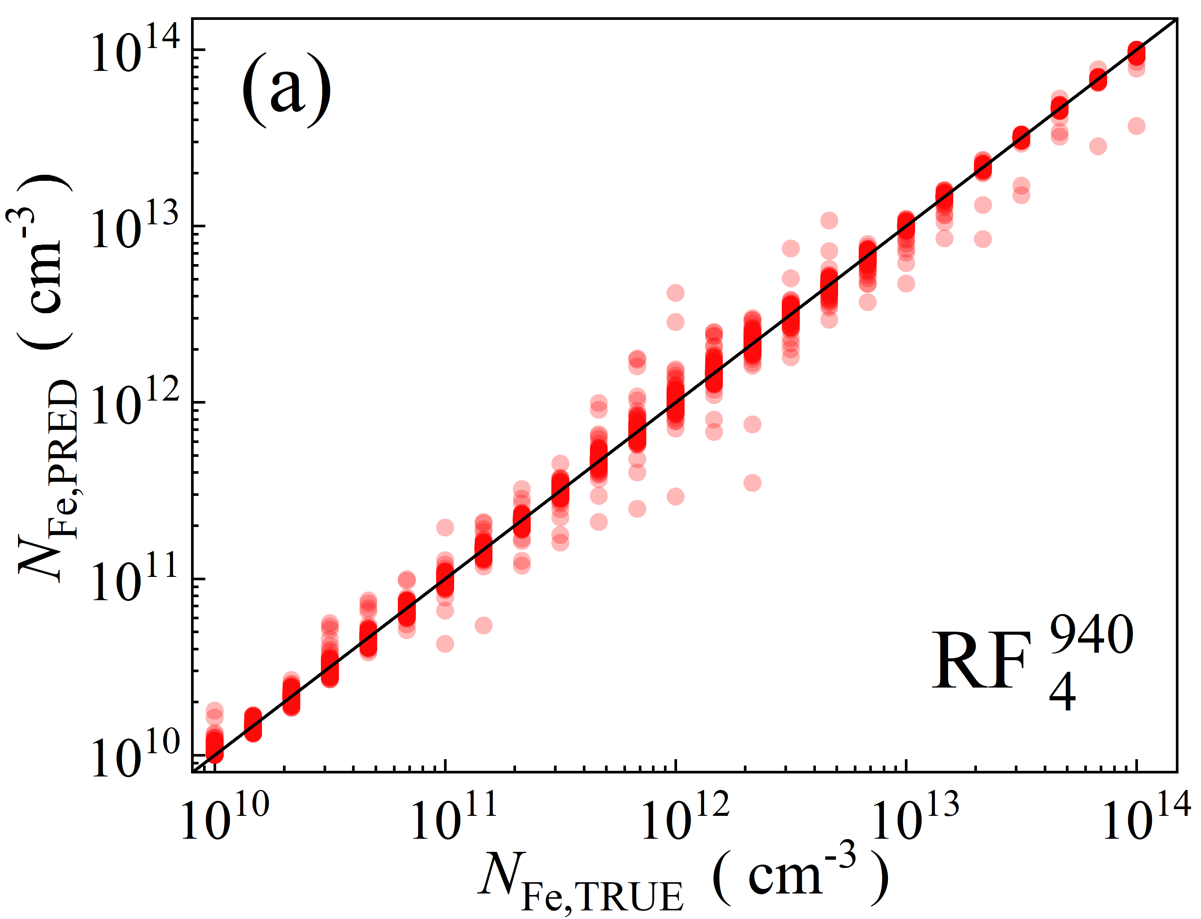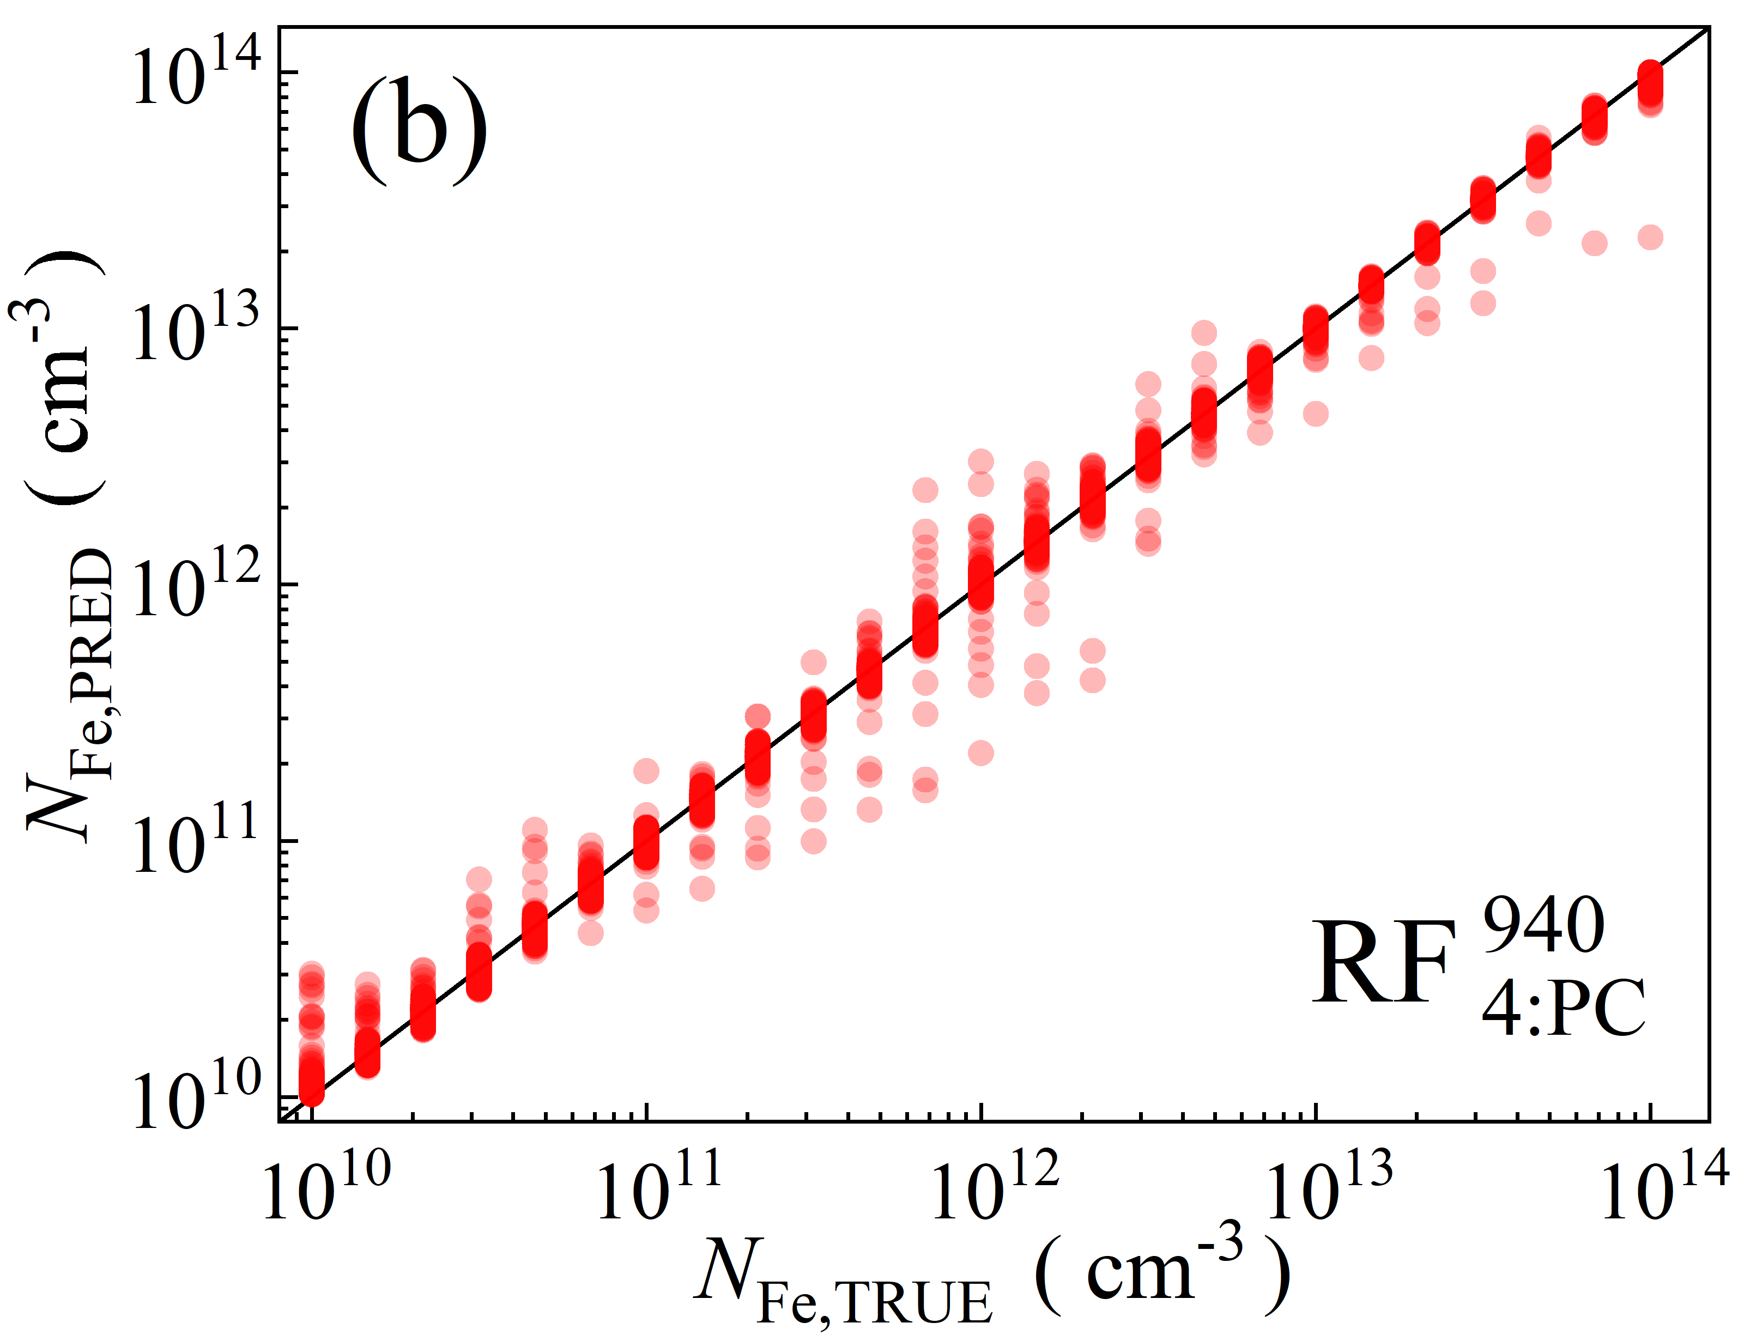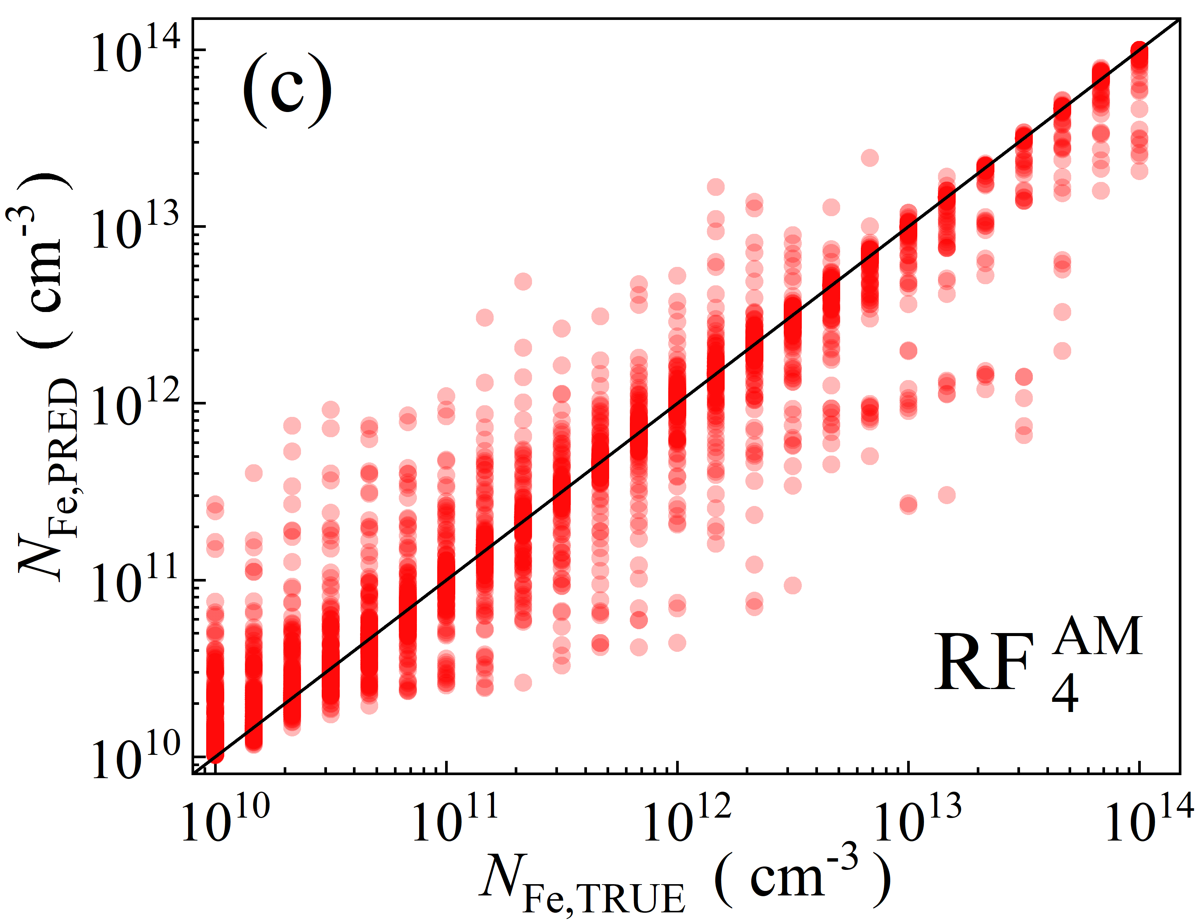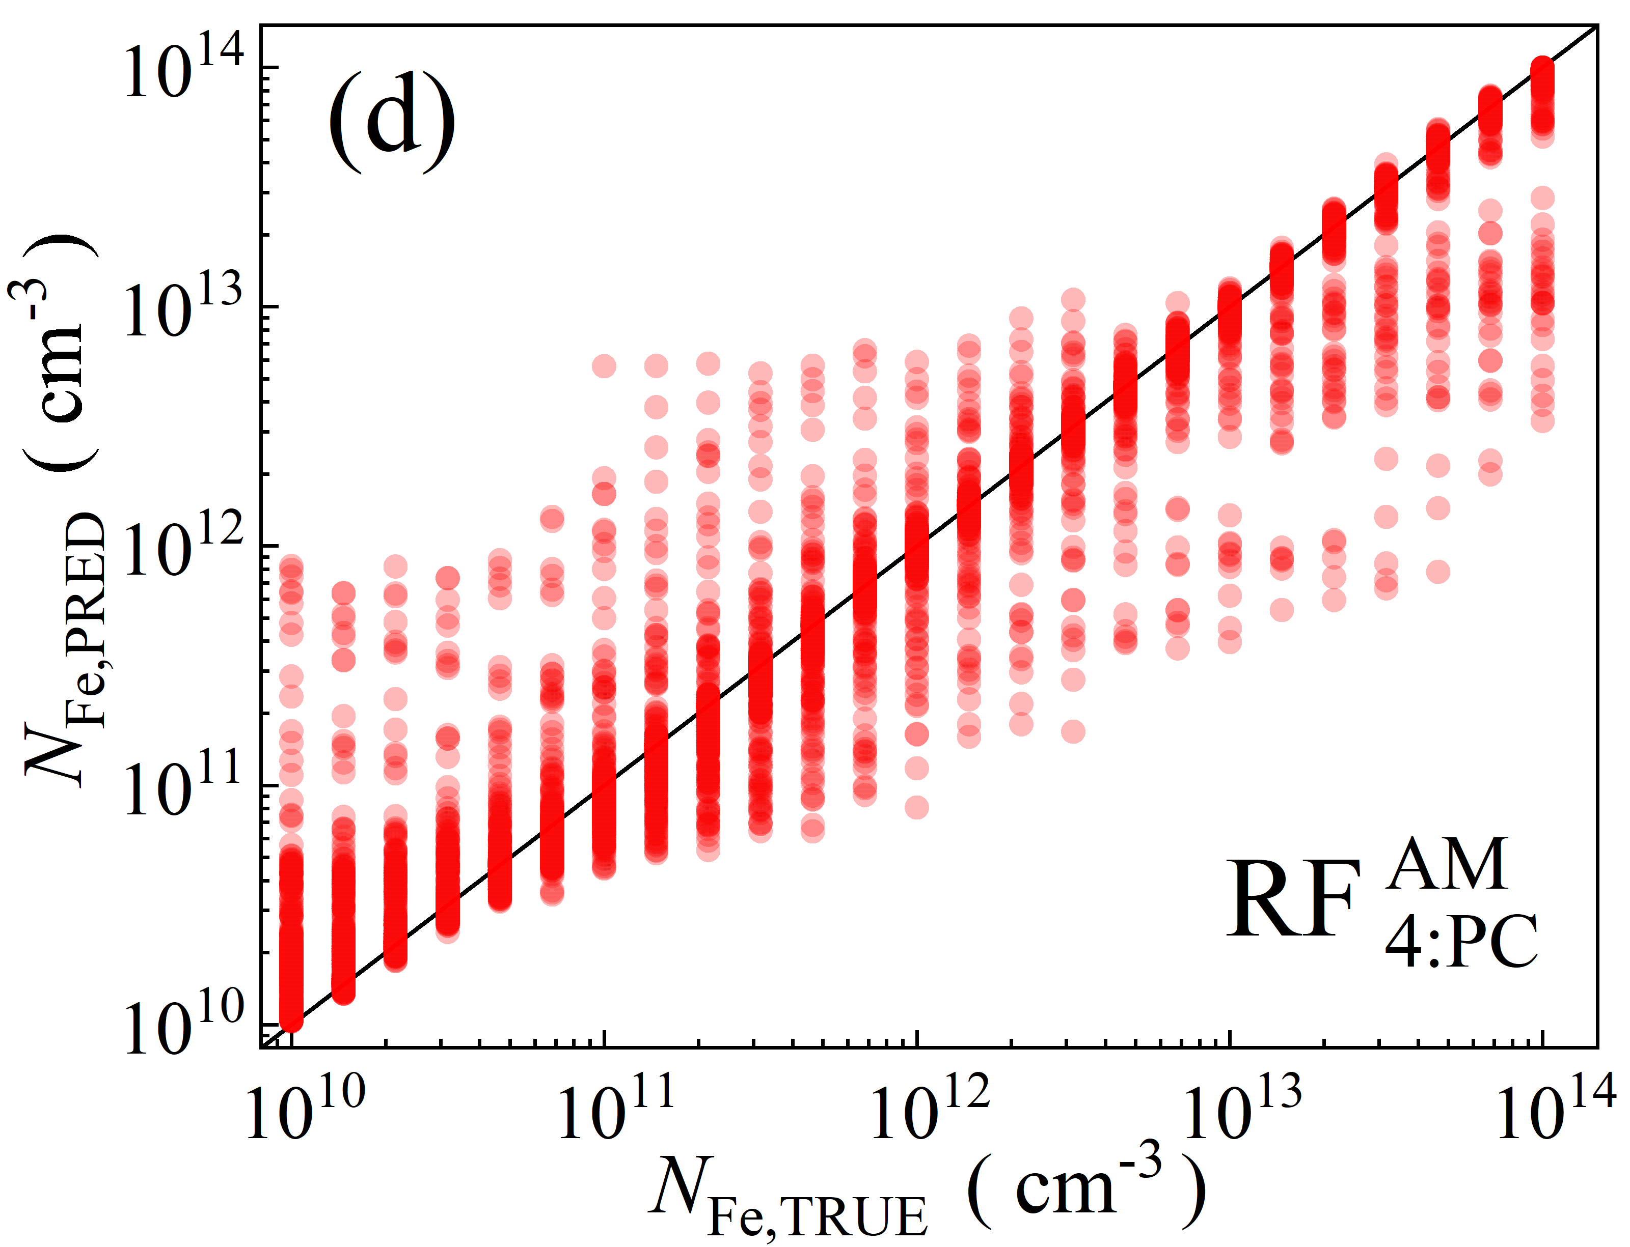

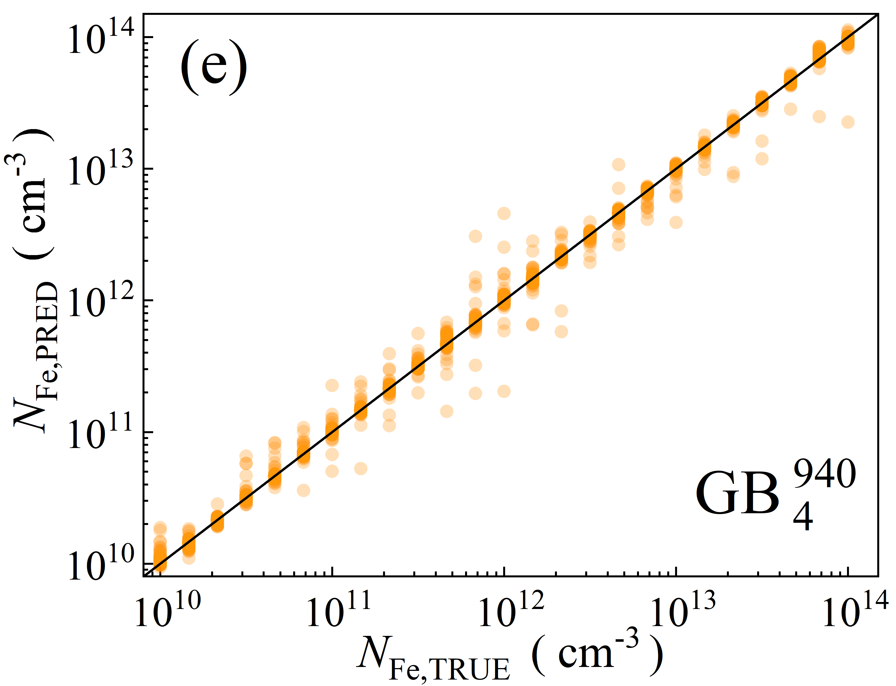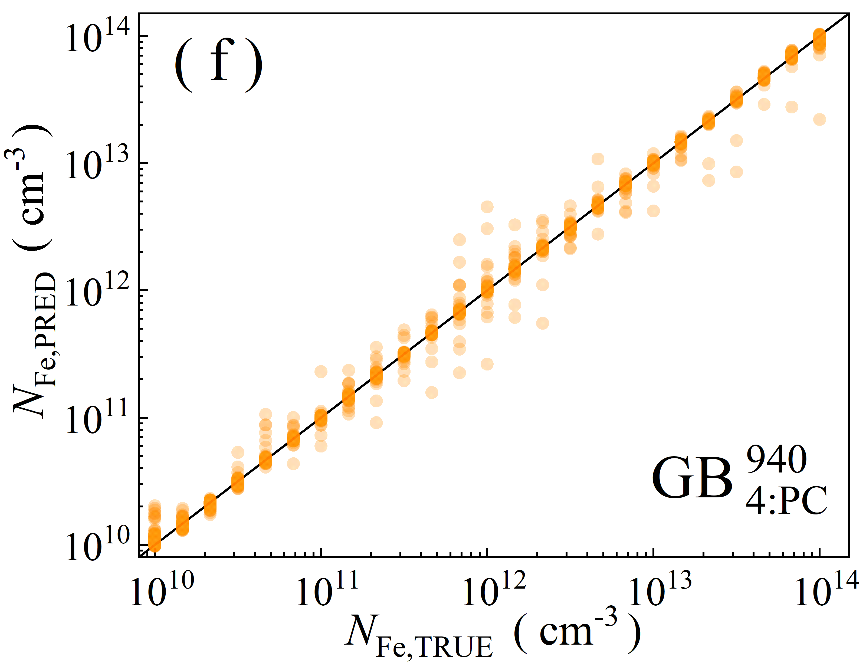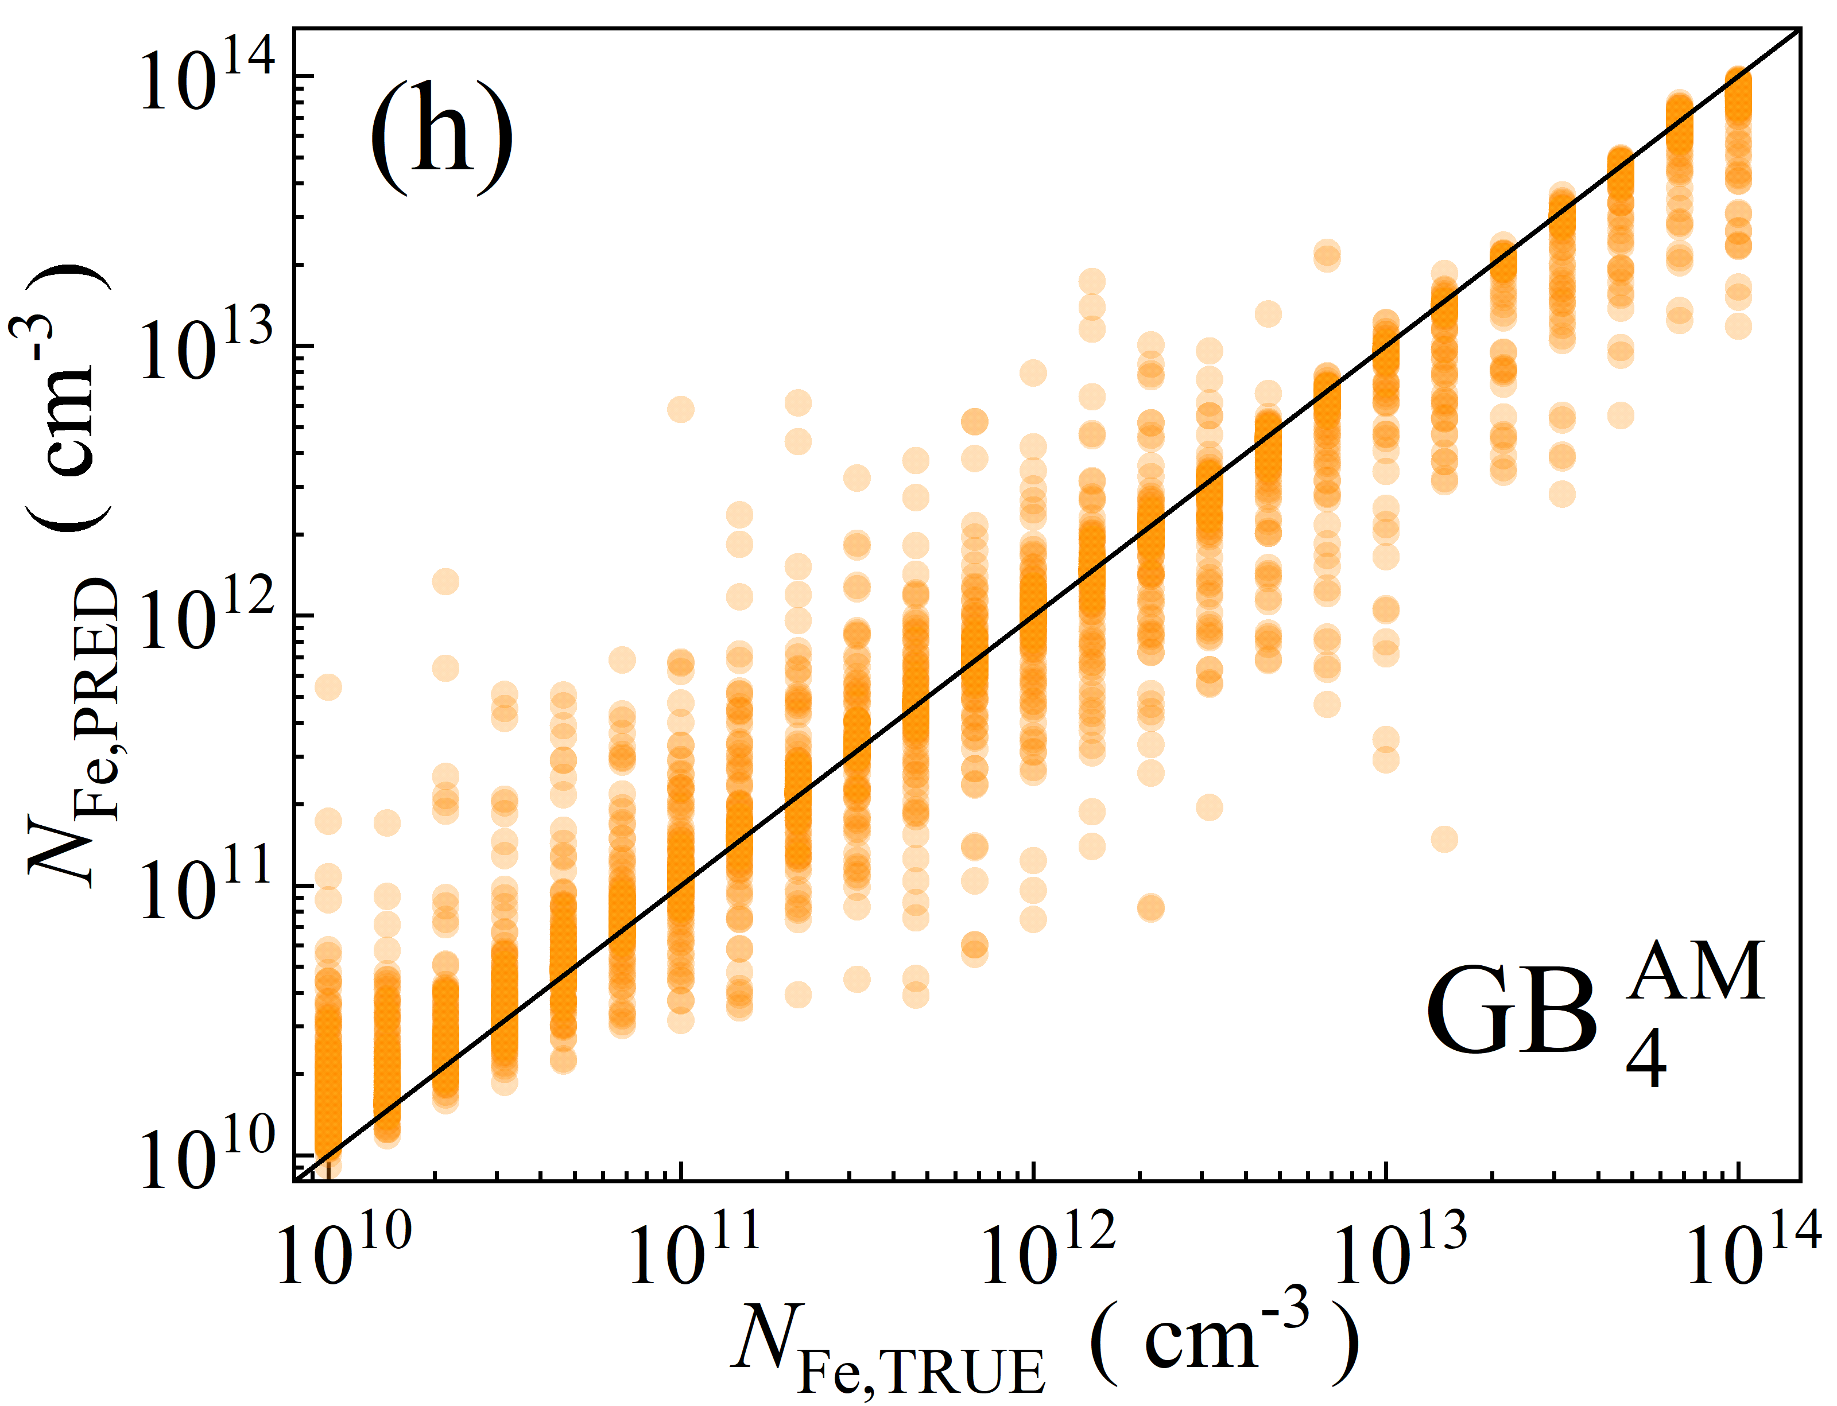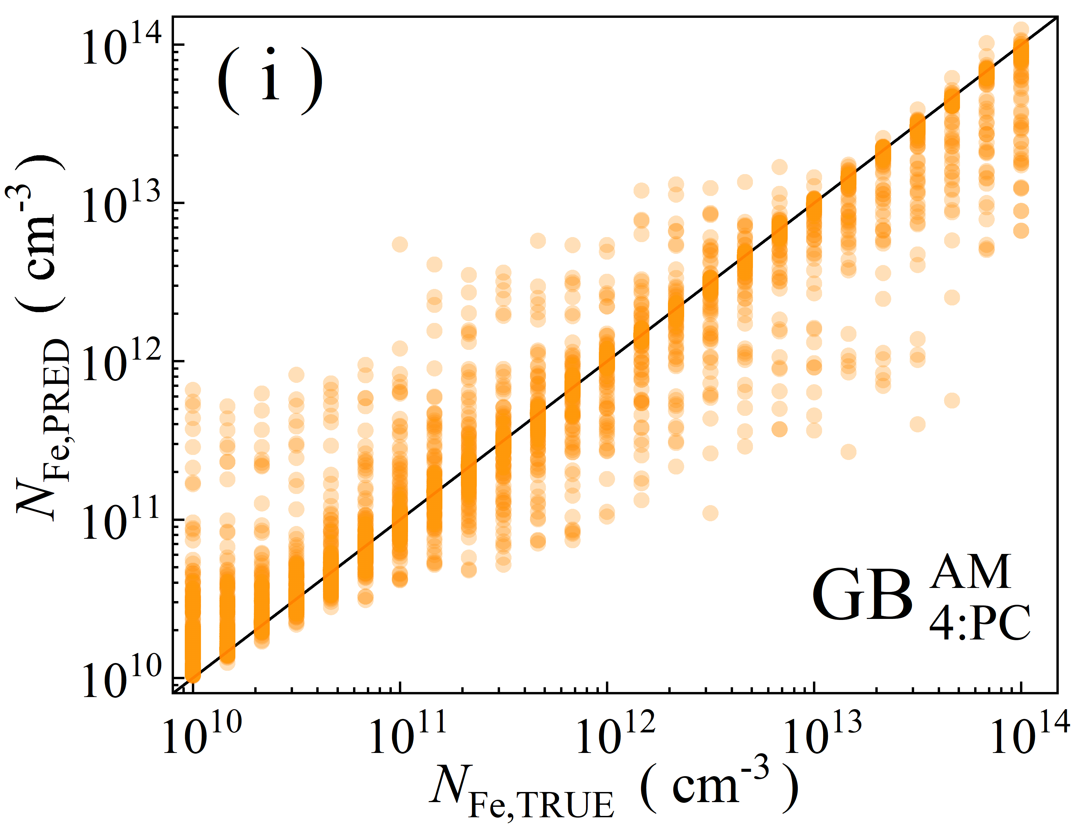

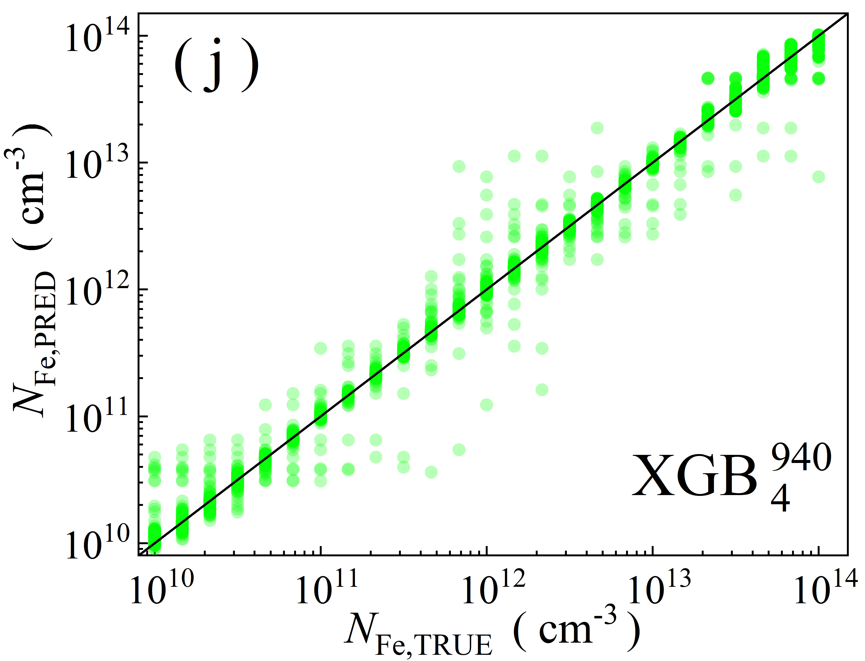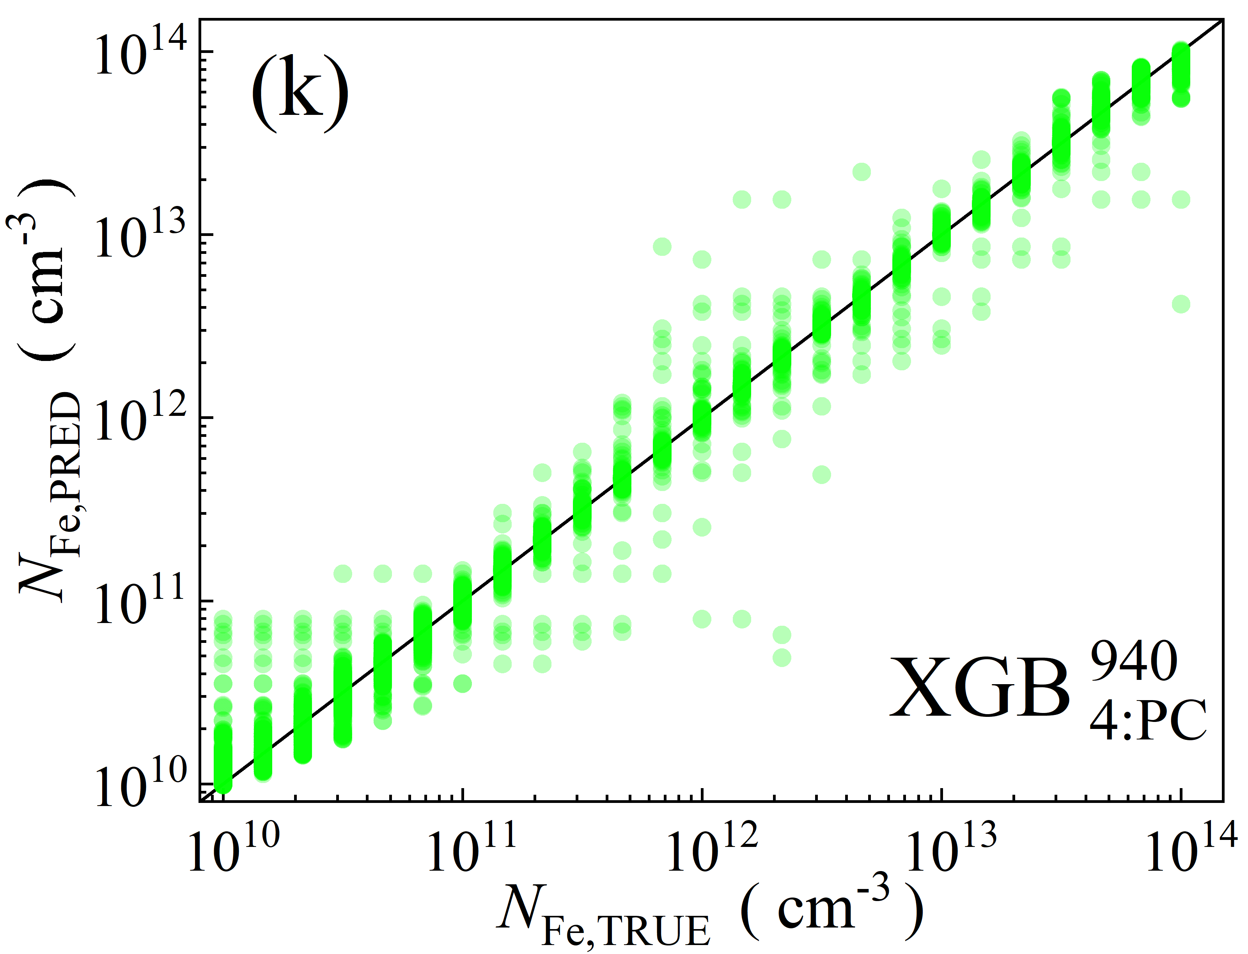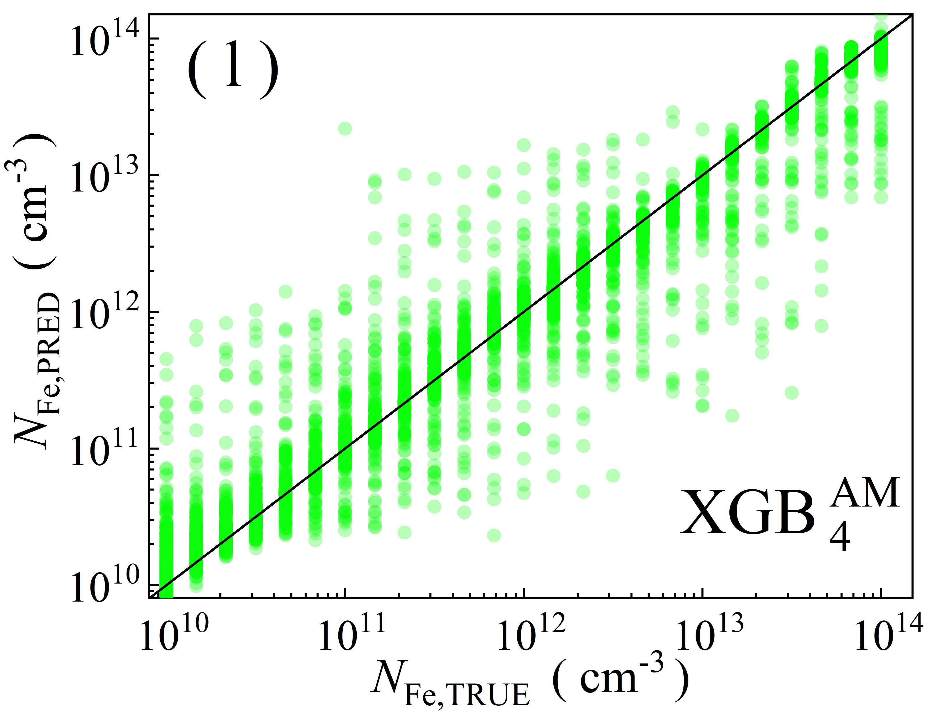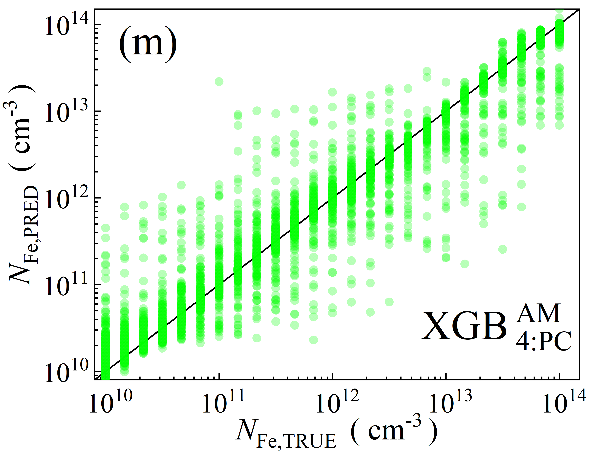

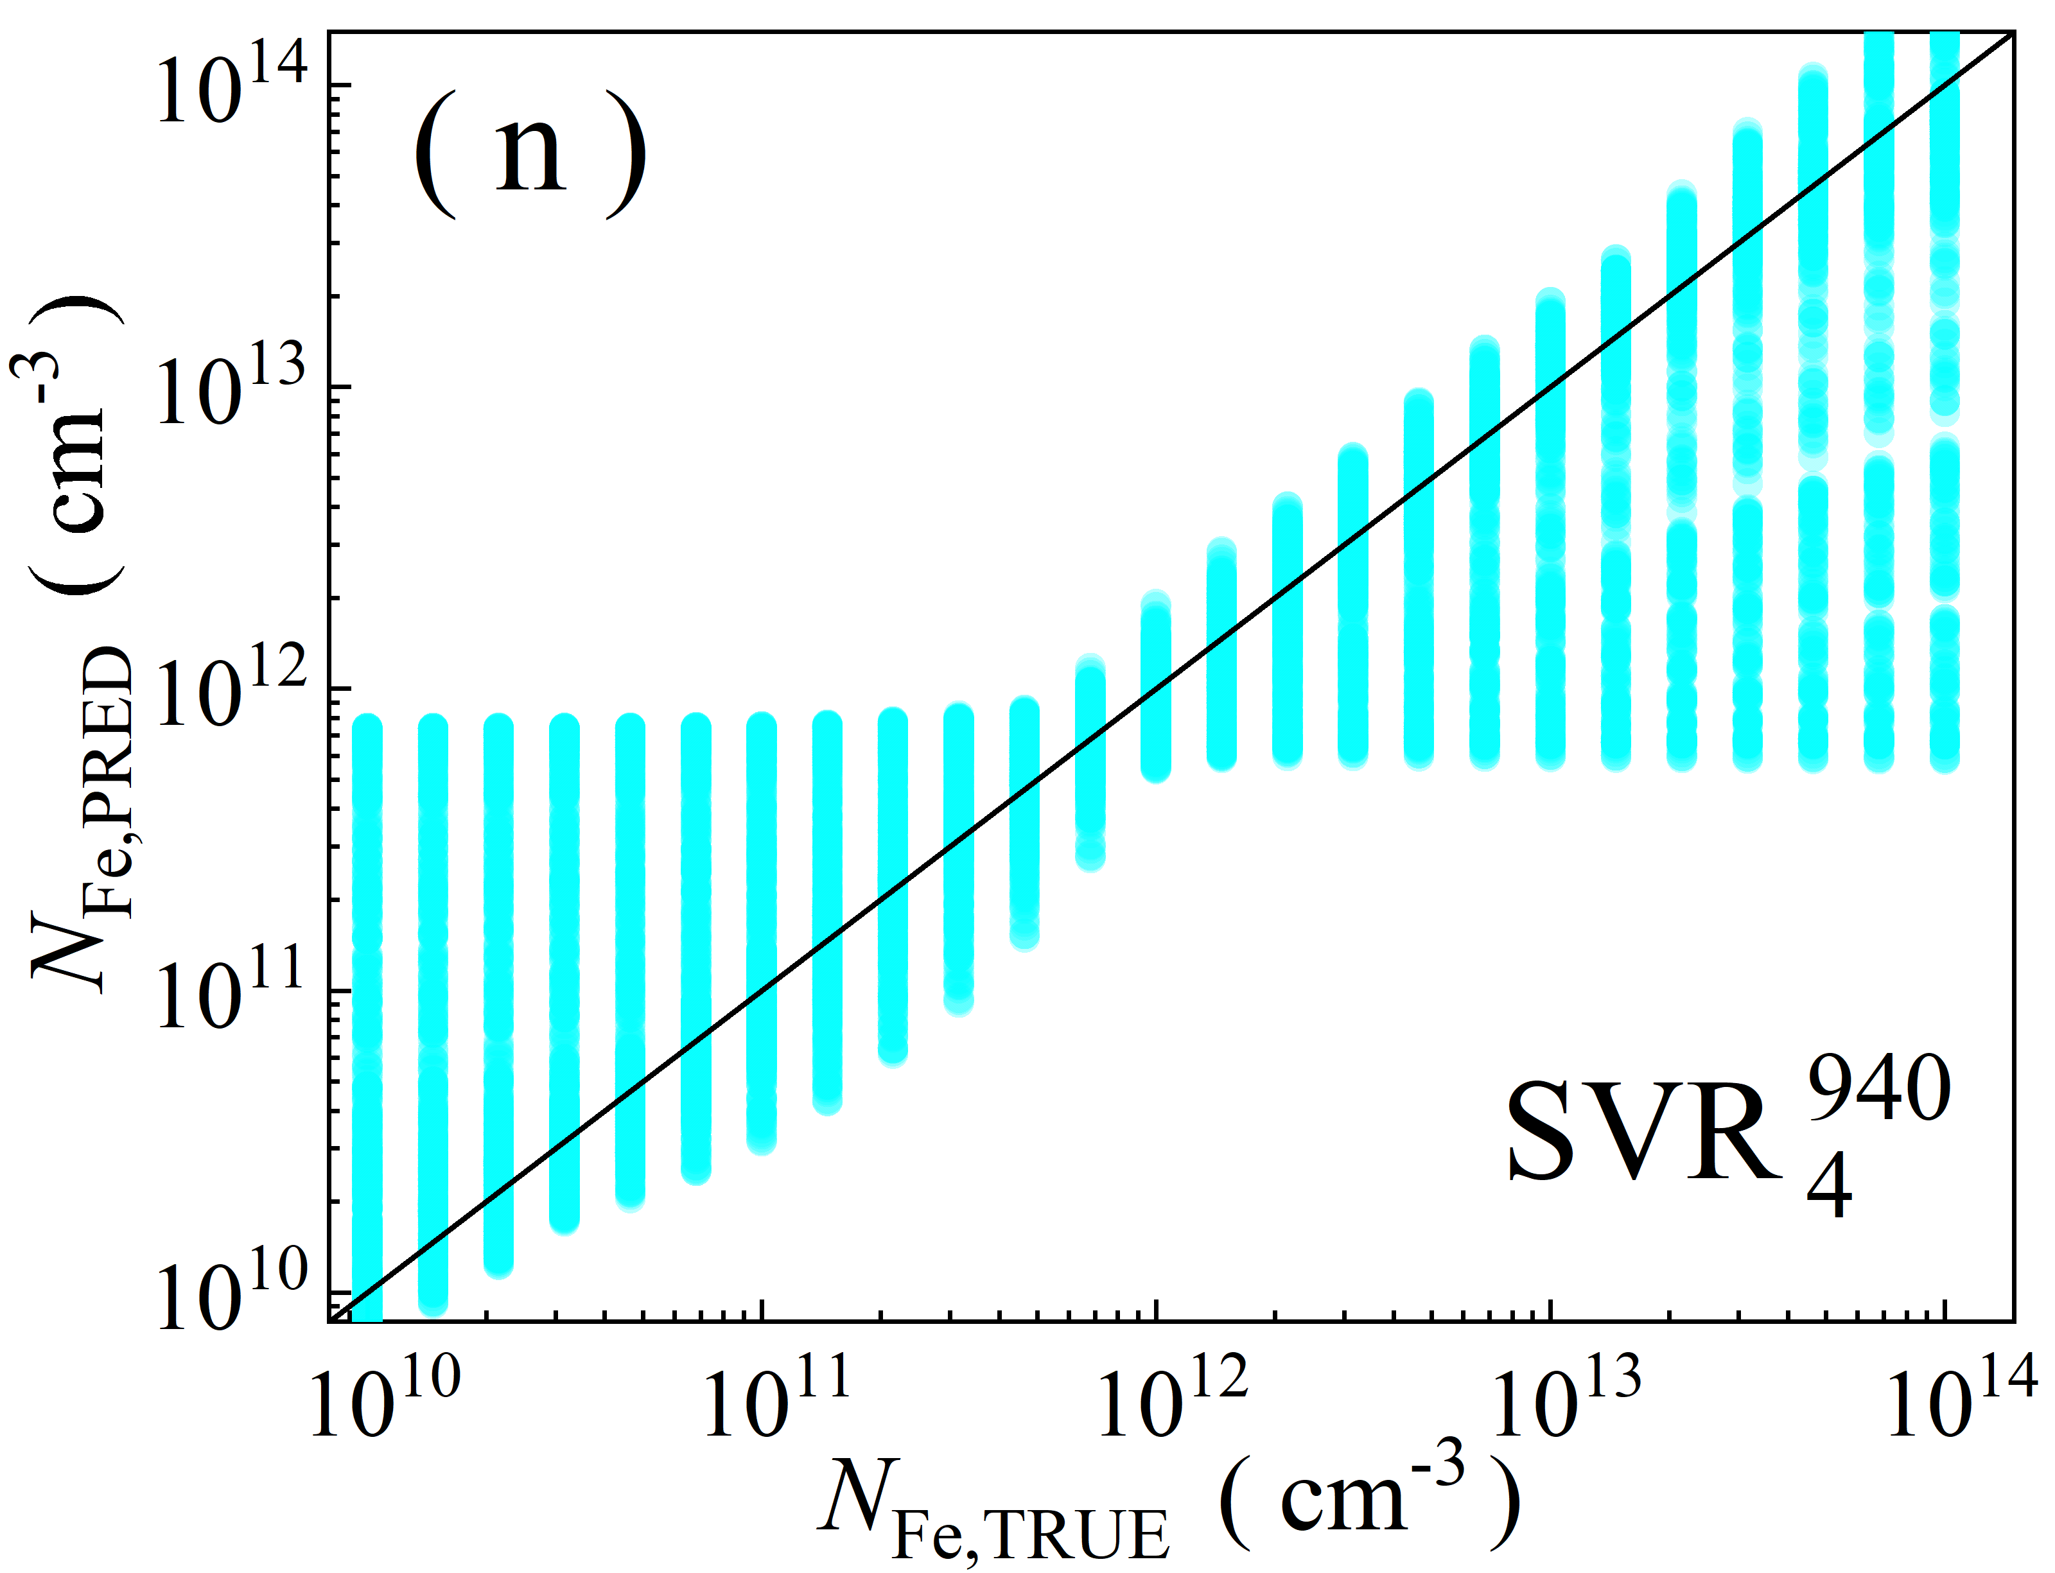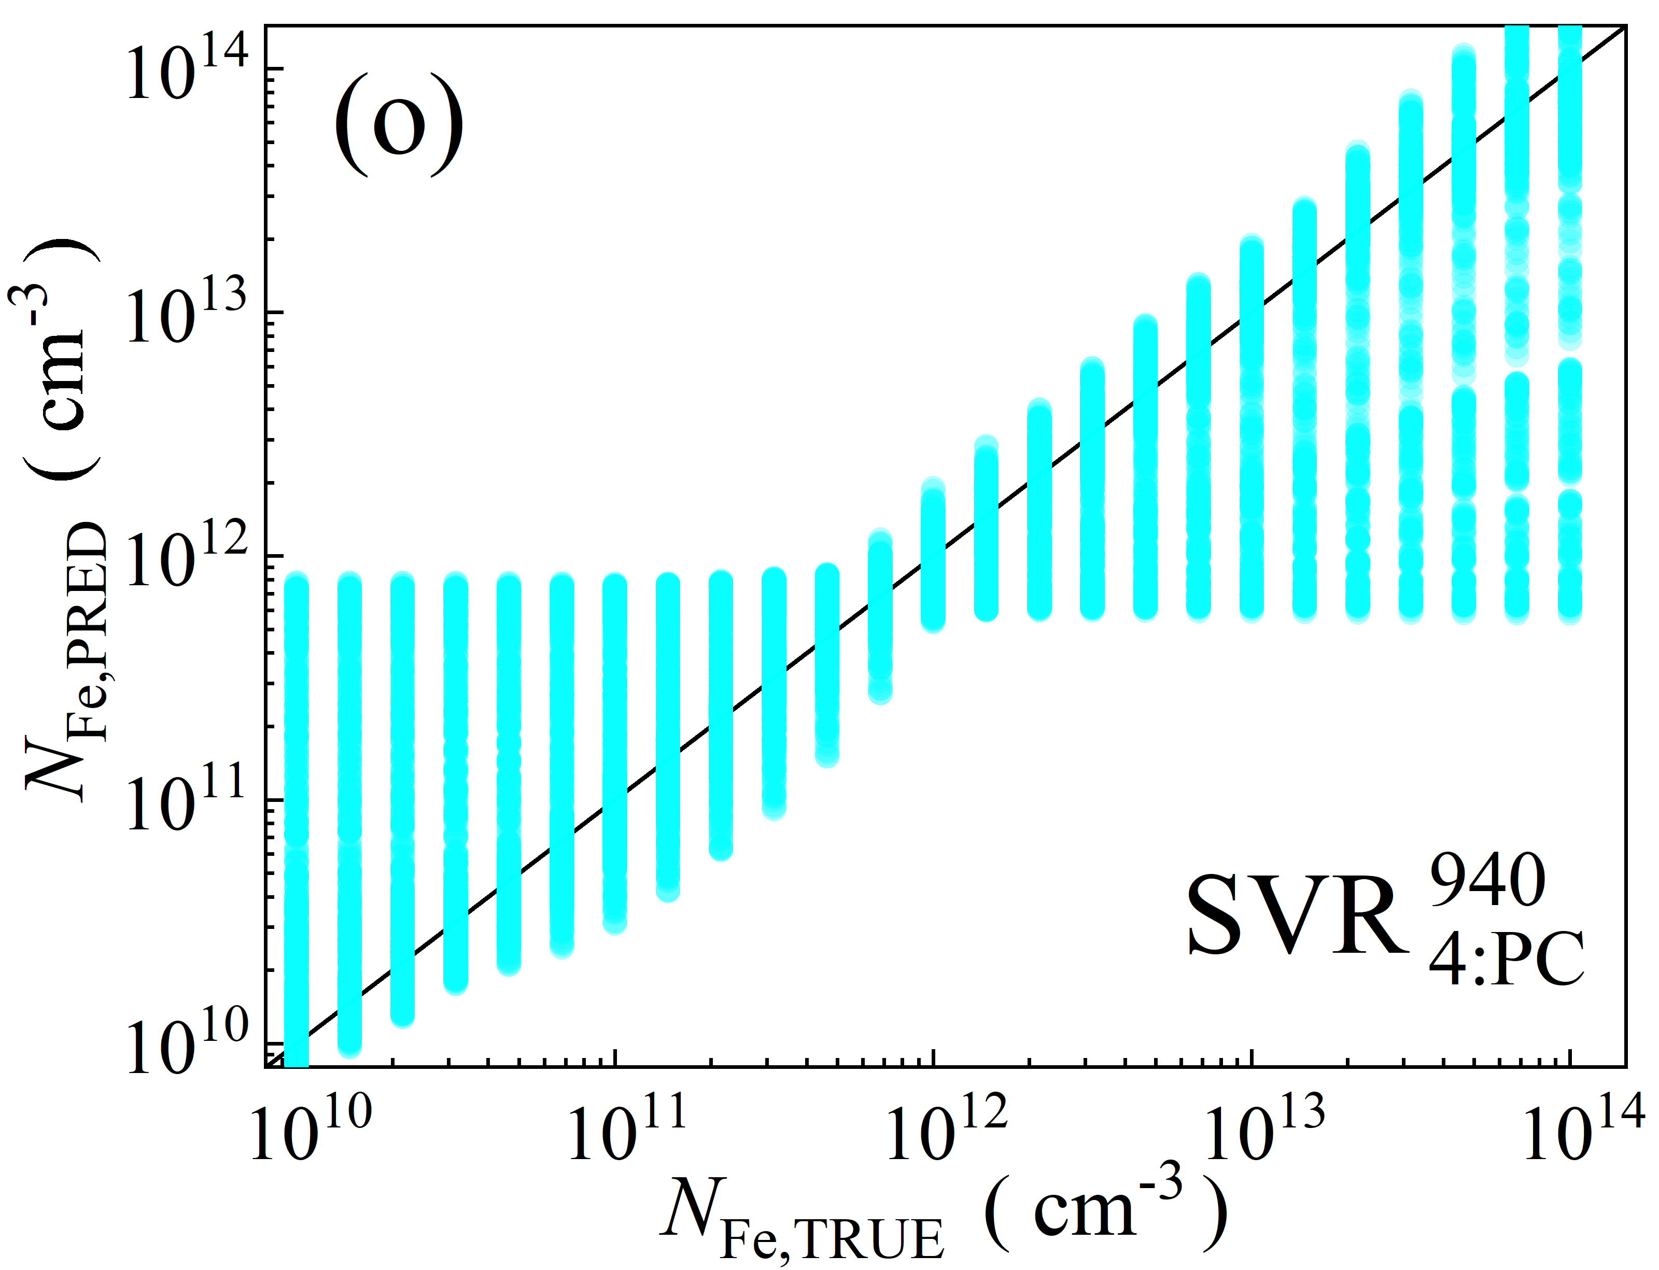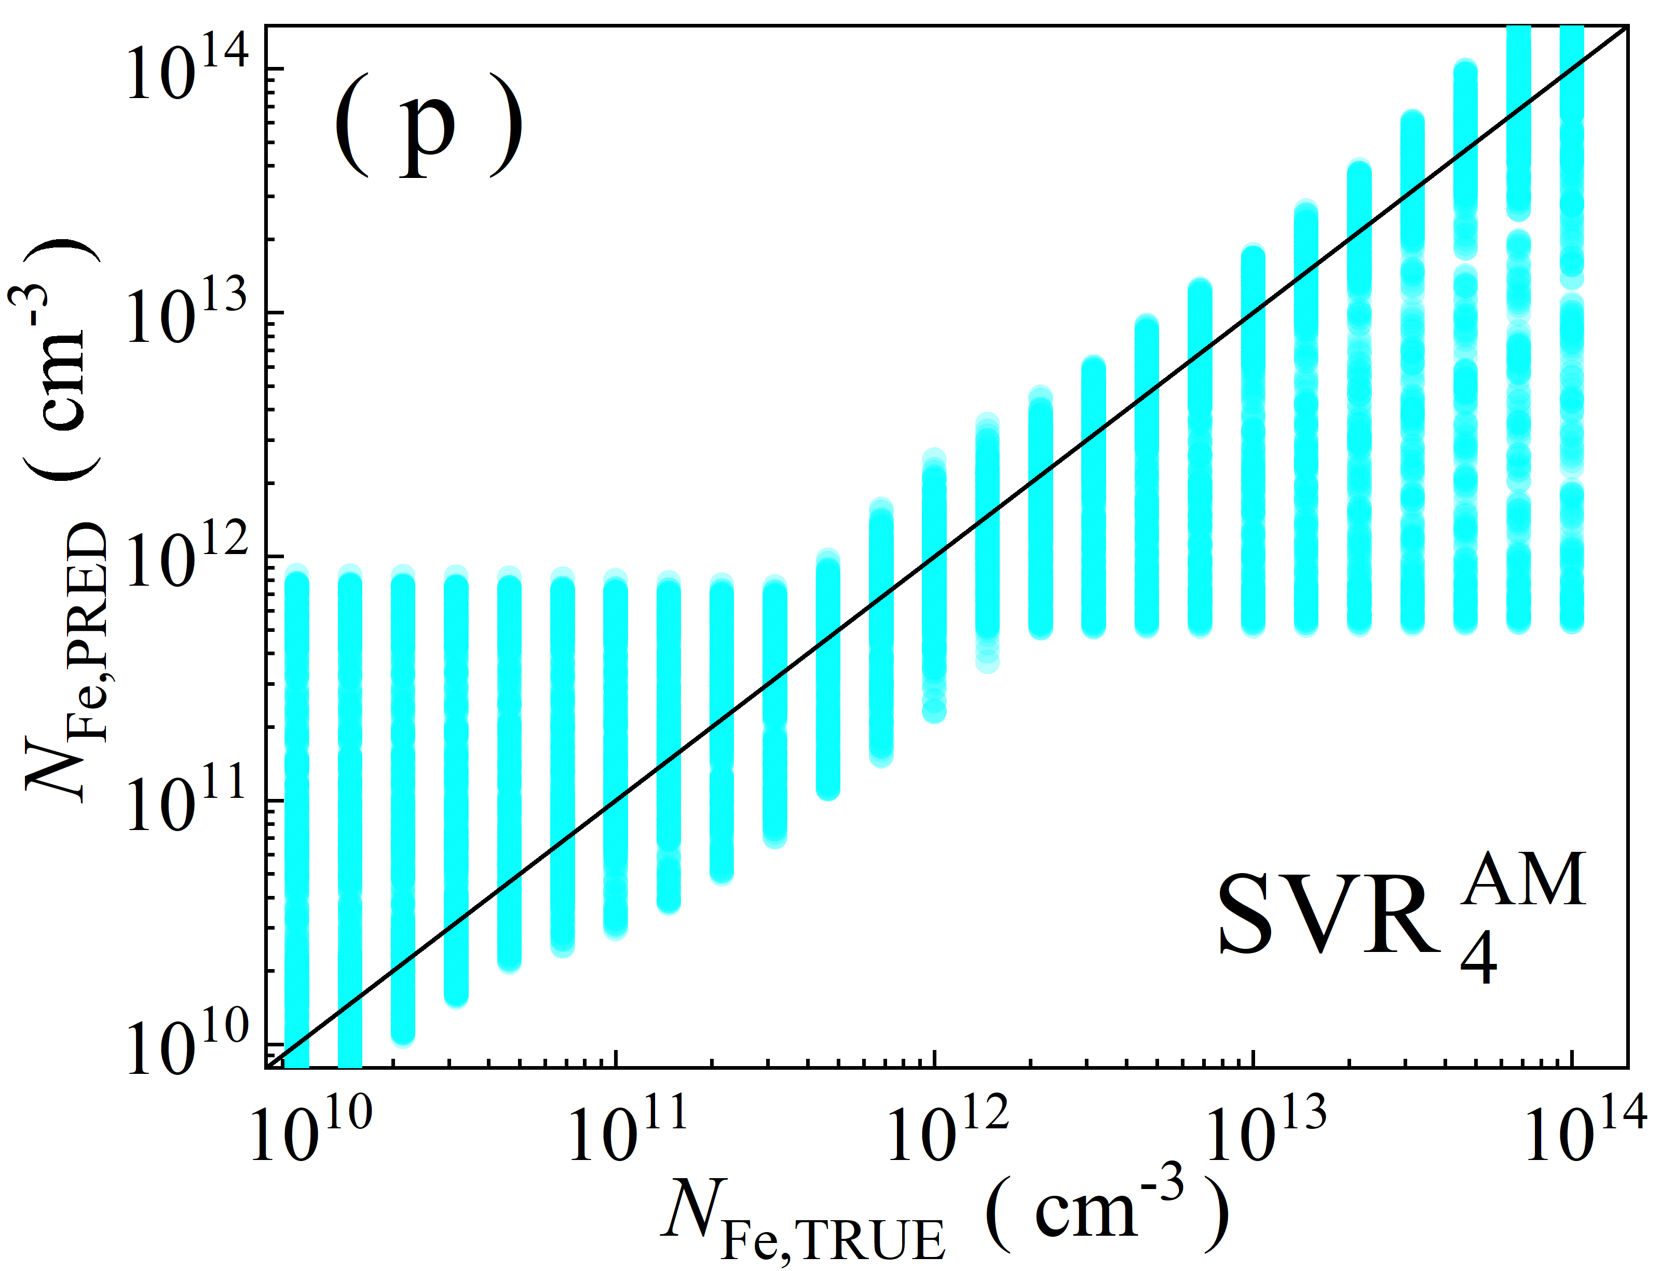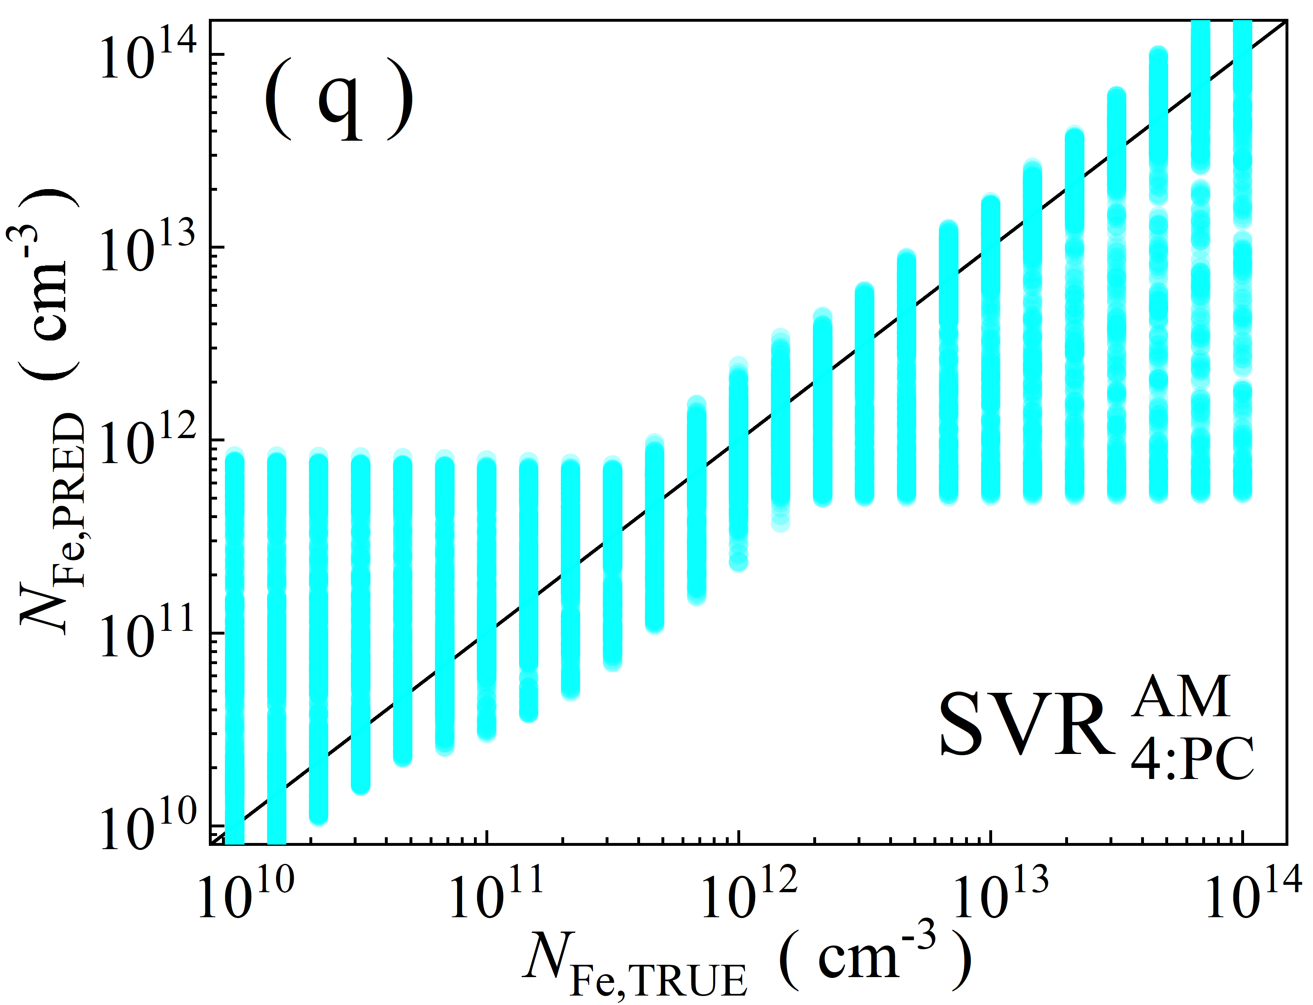

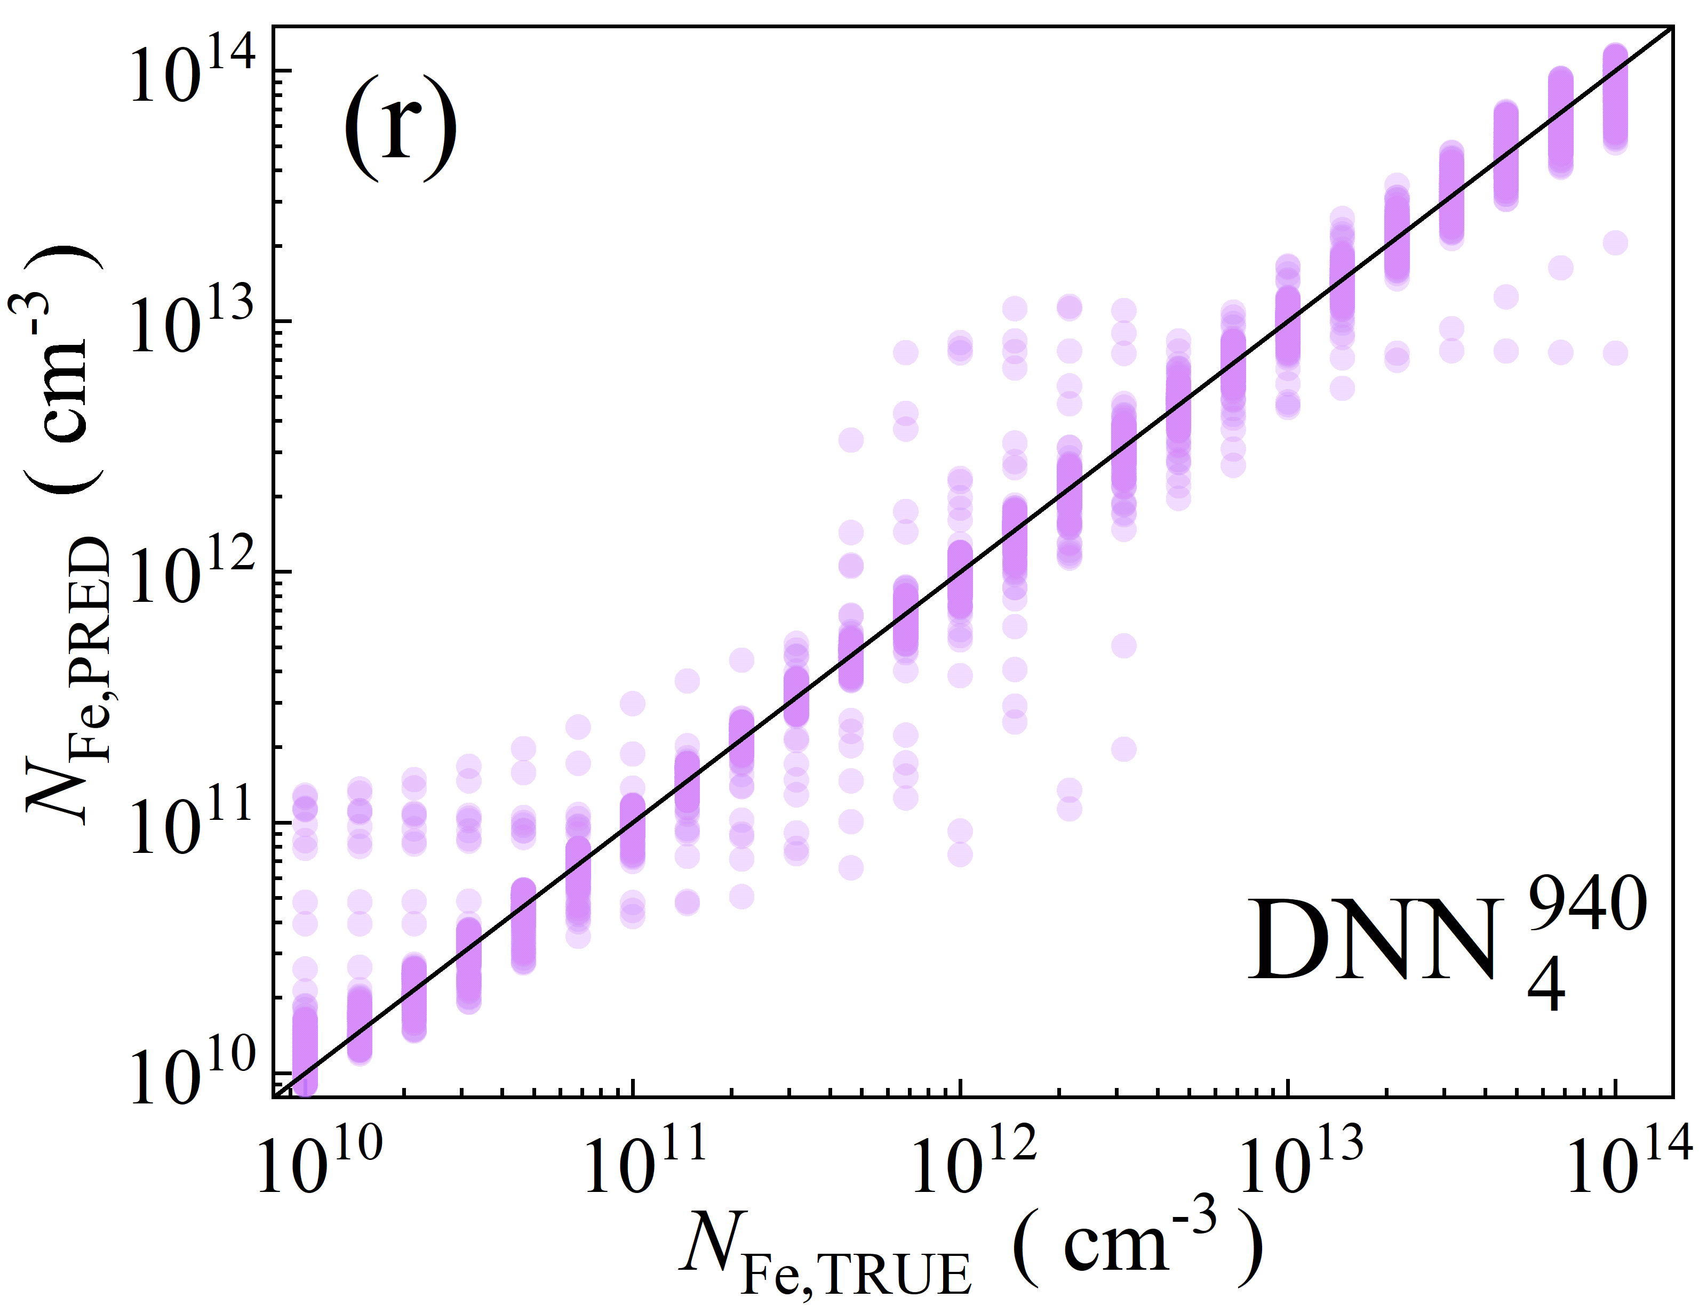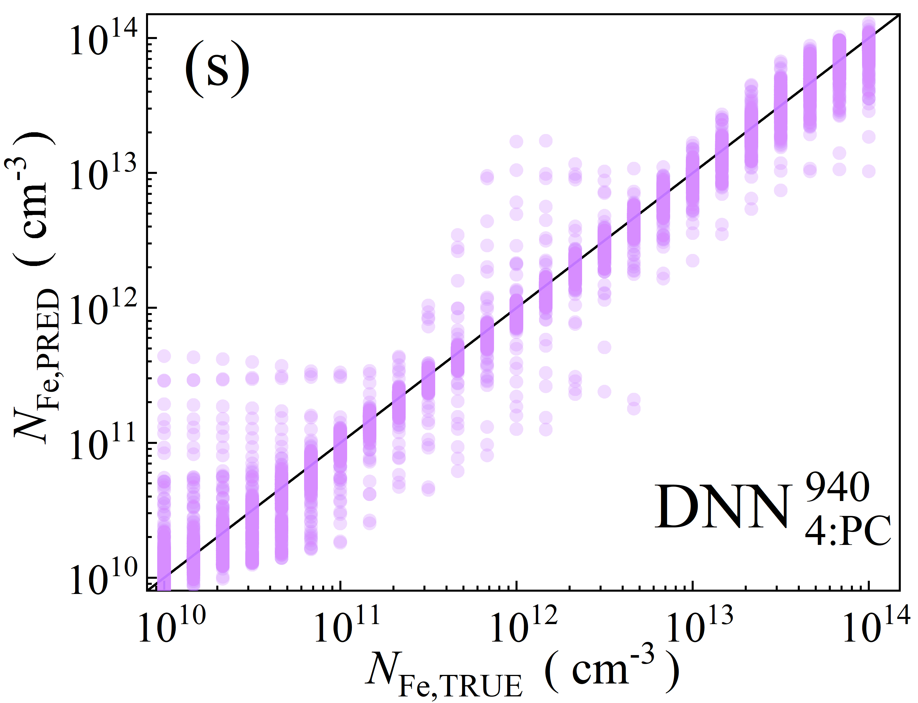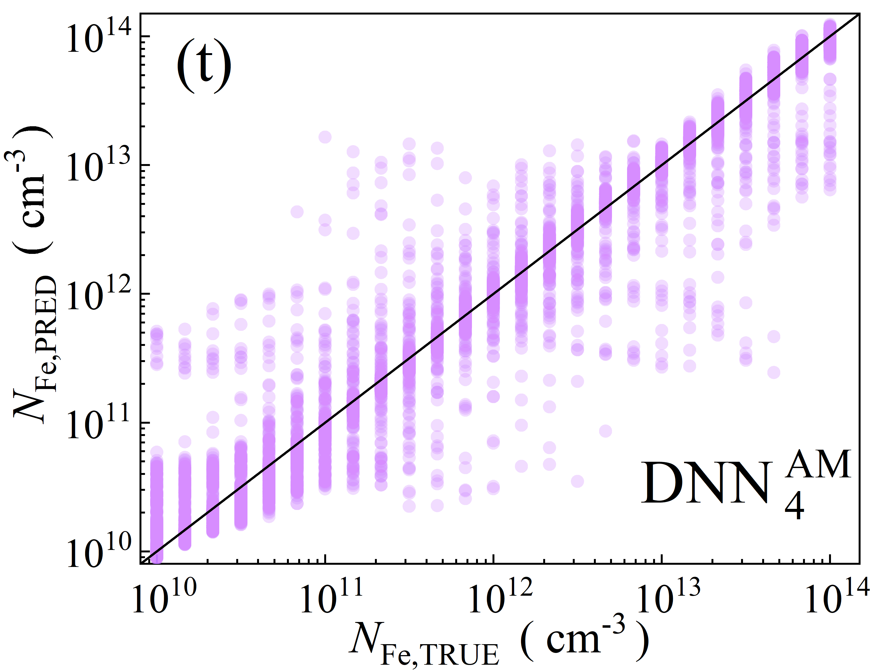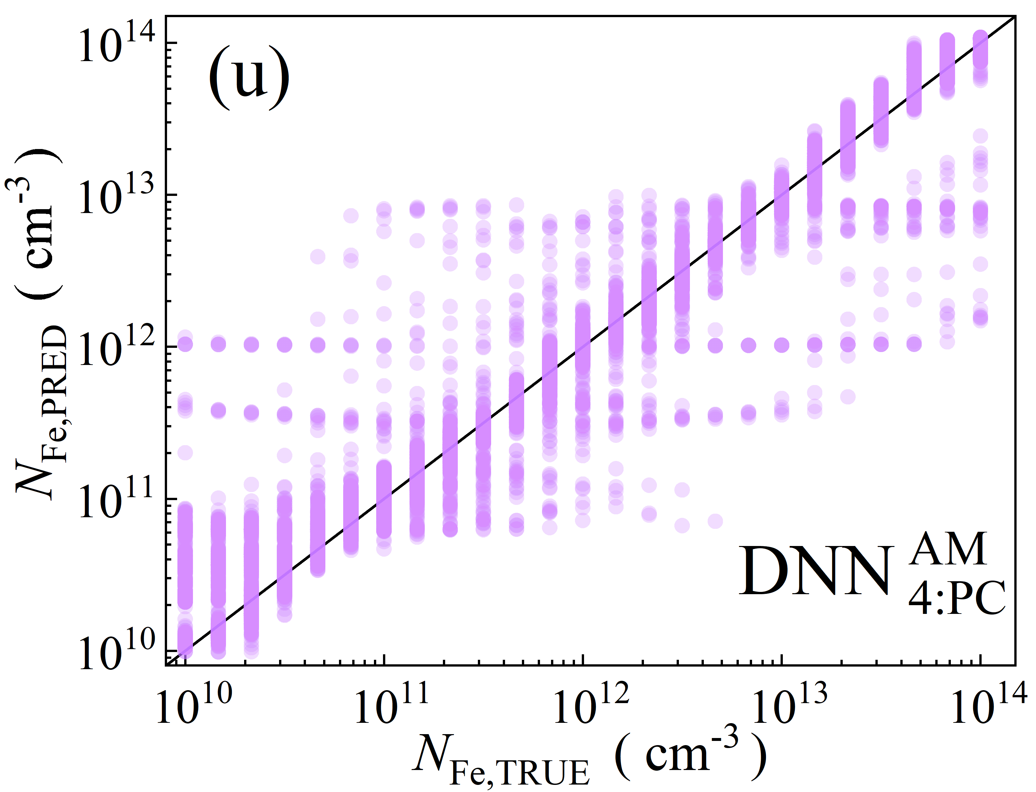

Fig.S3. Scatter plots of the iron concentrations between the reference values and ML predicted values for training phase in the case of 4D features. ML algorithms: RF (a-d), GB (e-i), XGB (j-m), SVR (n-q), DNN (r-u). The data are obtained for monochromatic (a, b, e, f, j, k, n, o, r, s) and AM1.5 (c, d, h, i, l, m, p, q, t, u) illuminations. PCA was used for the panels b, d, f, i, k, m, o, q, s, and u. The black lines are the identify lines servings as the references.

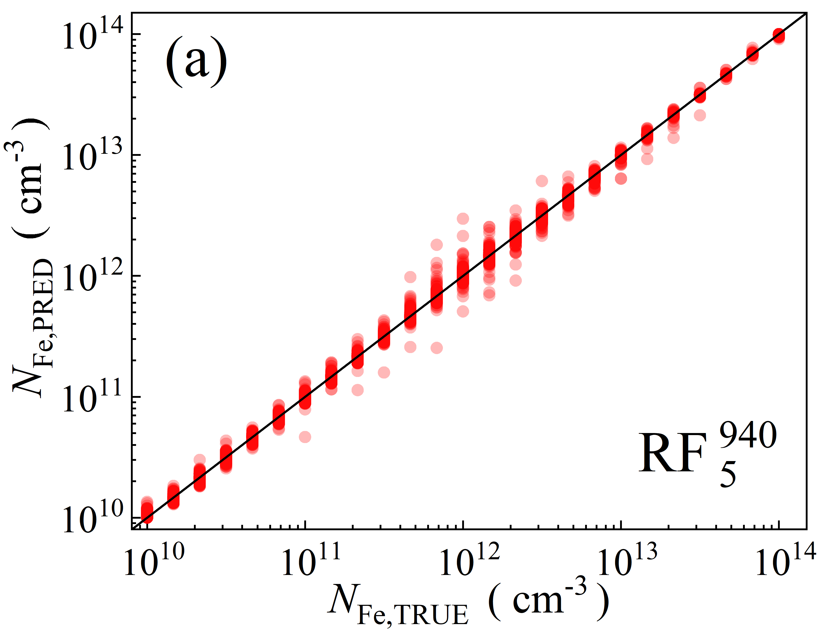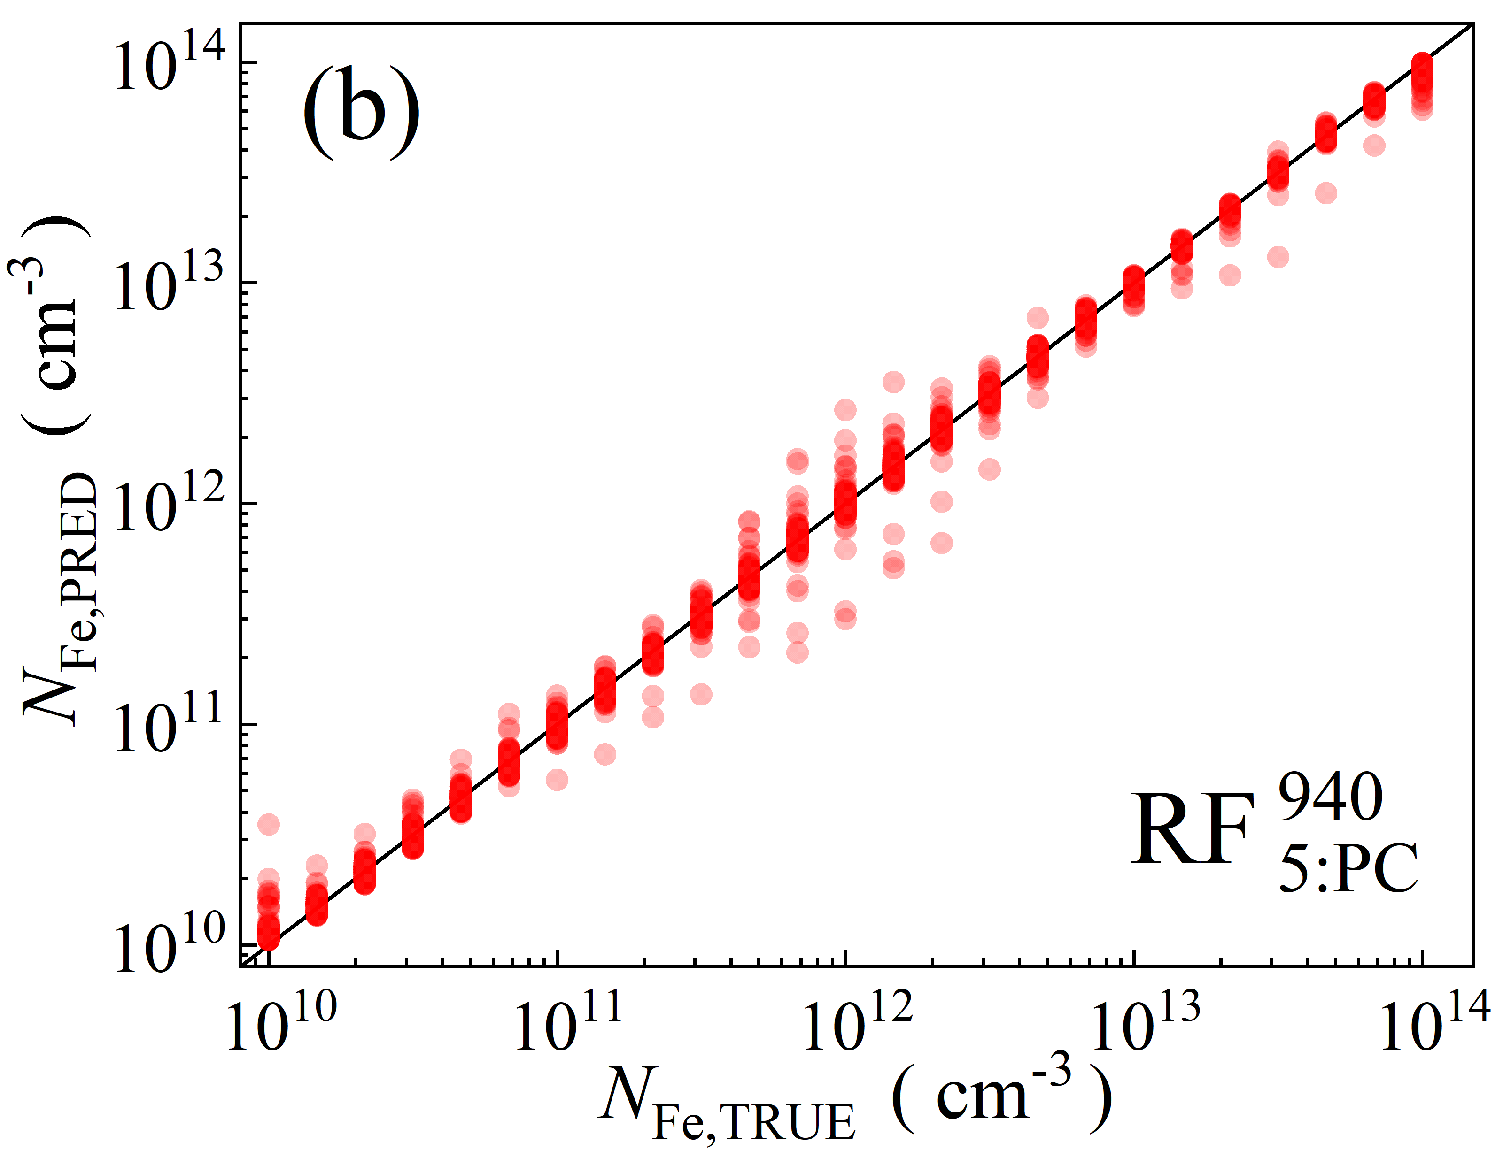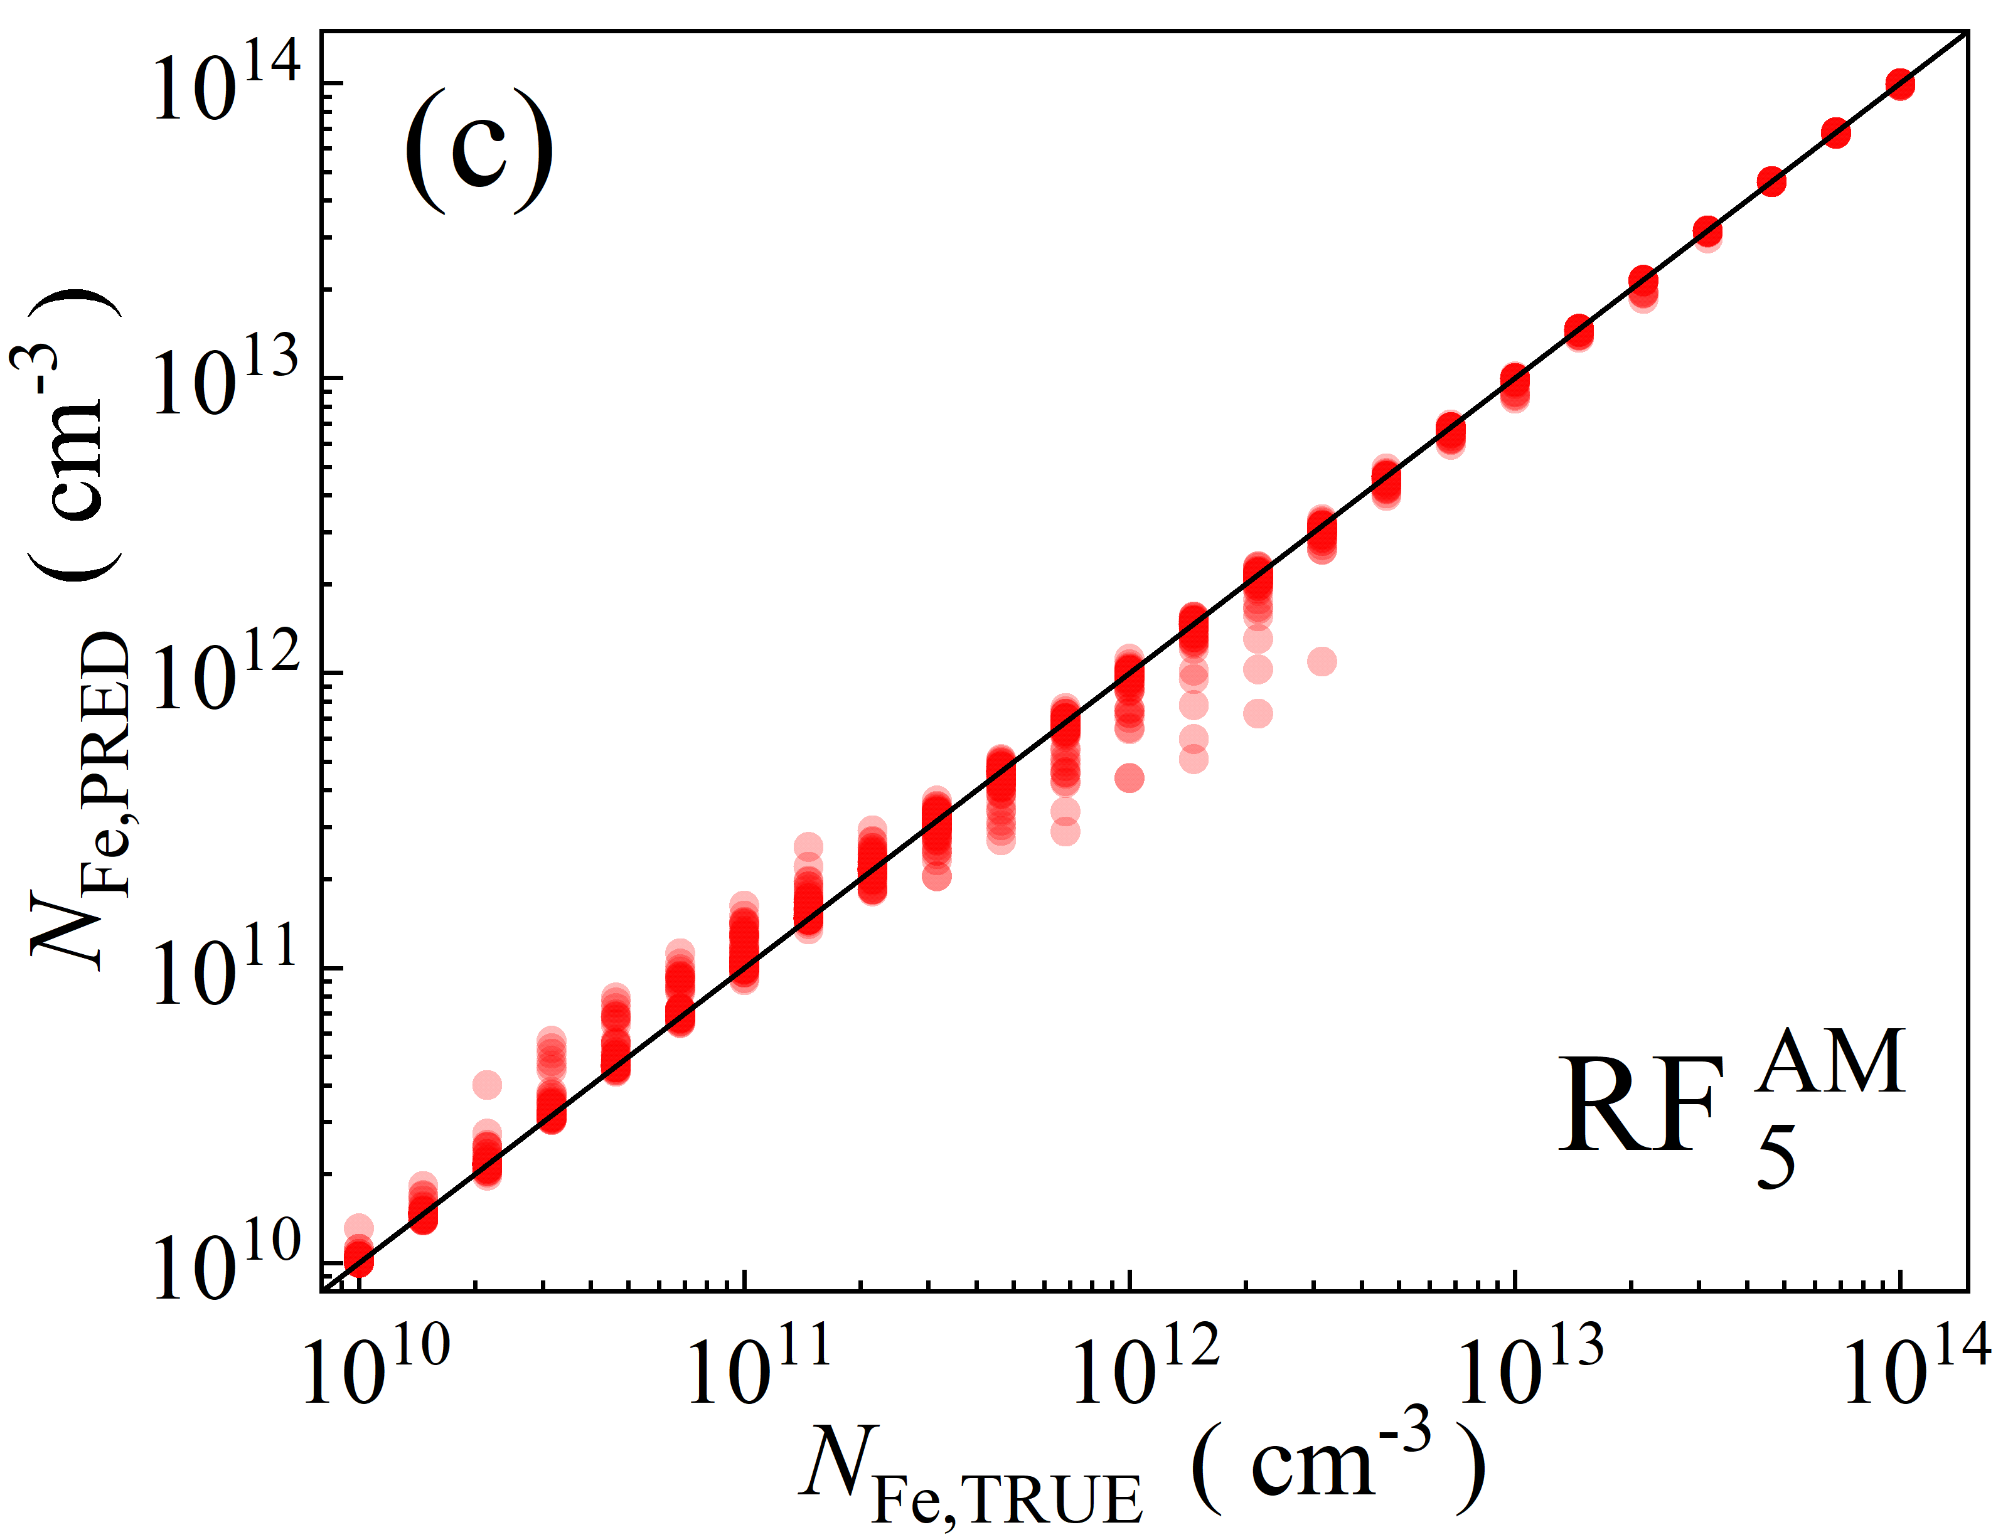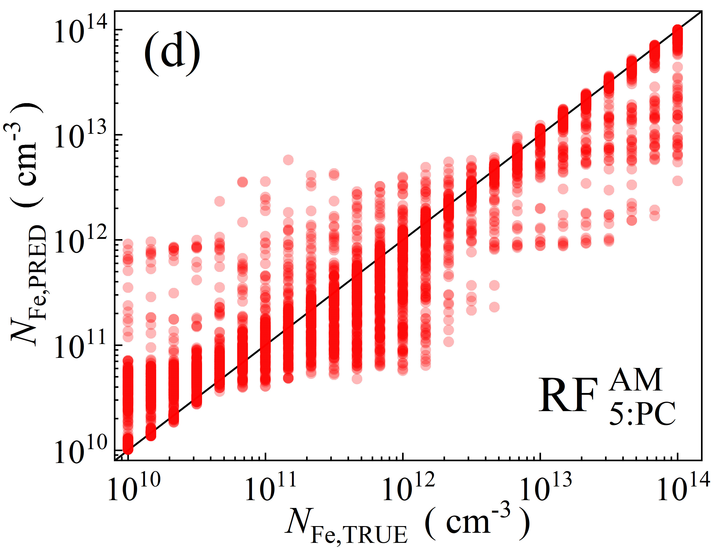

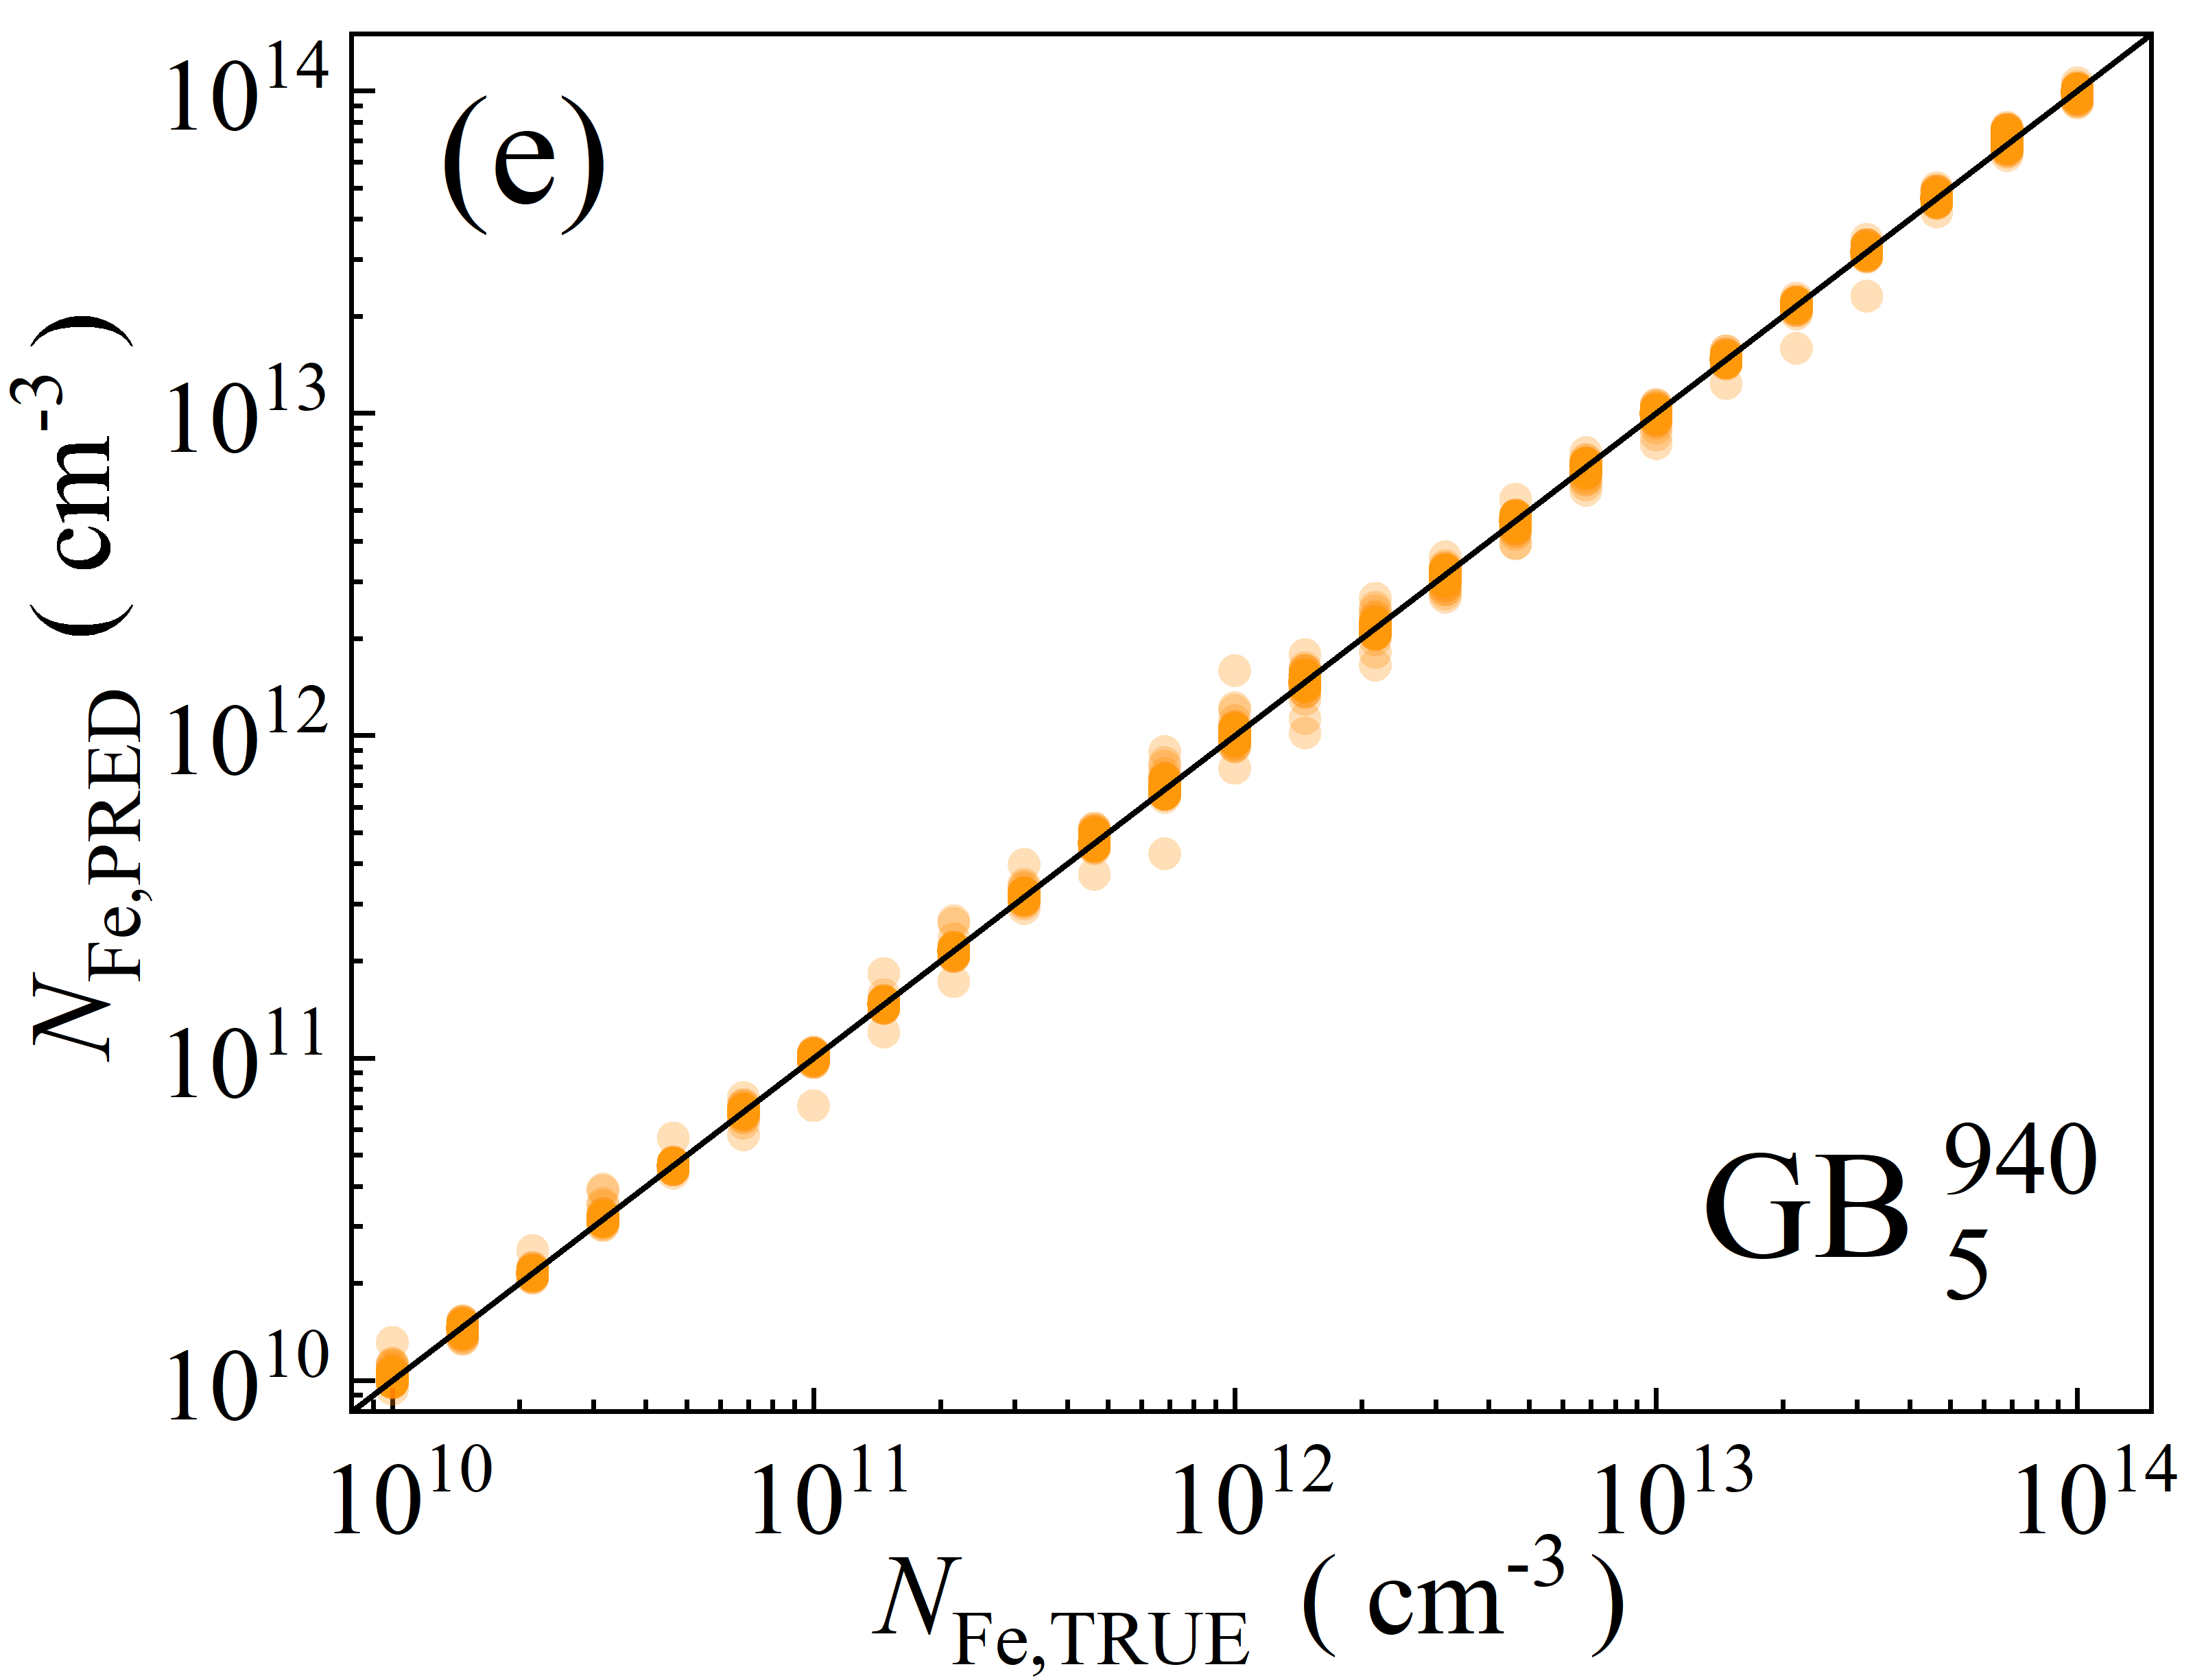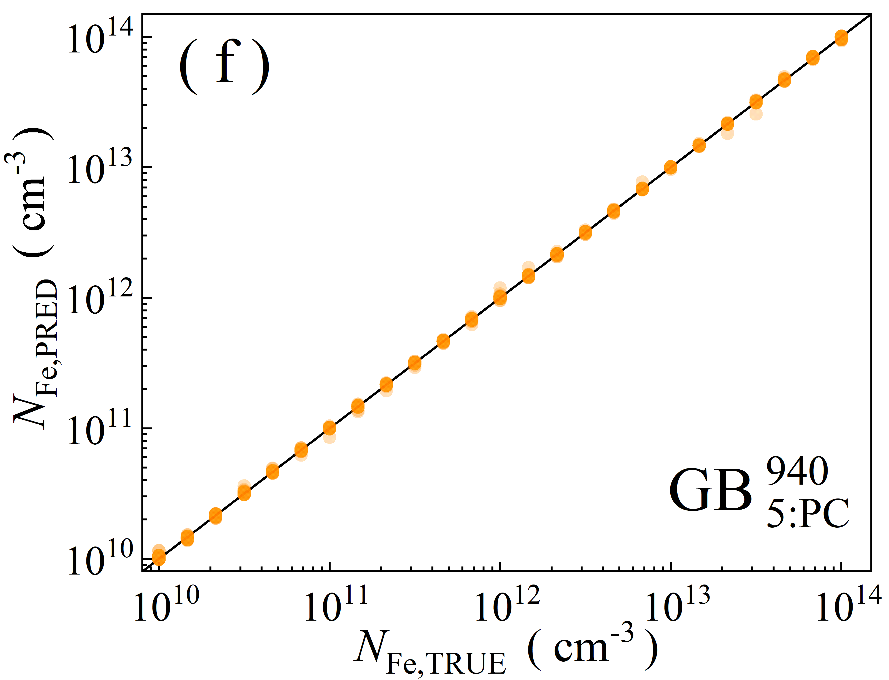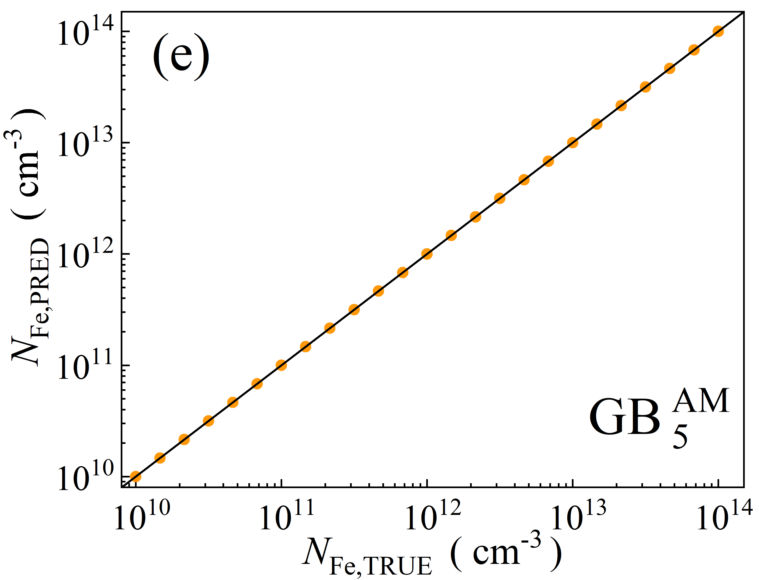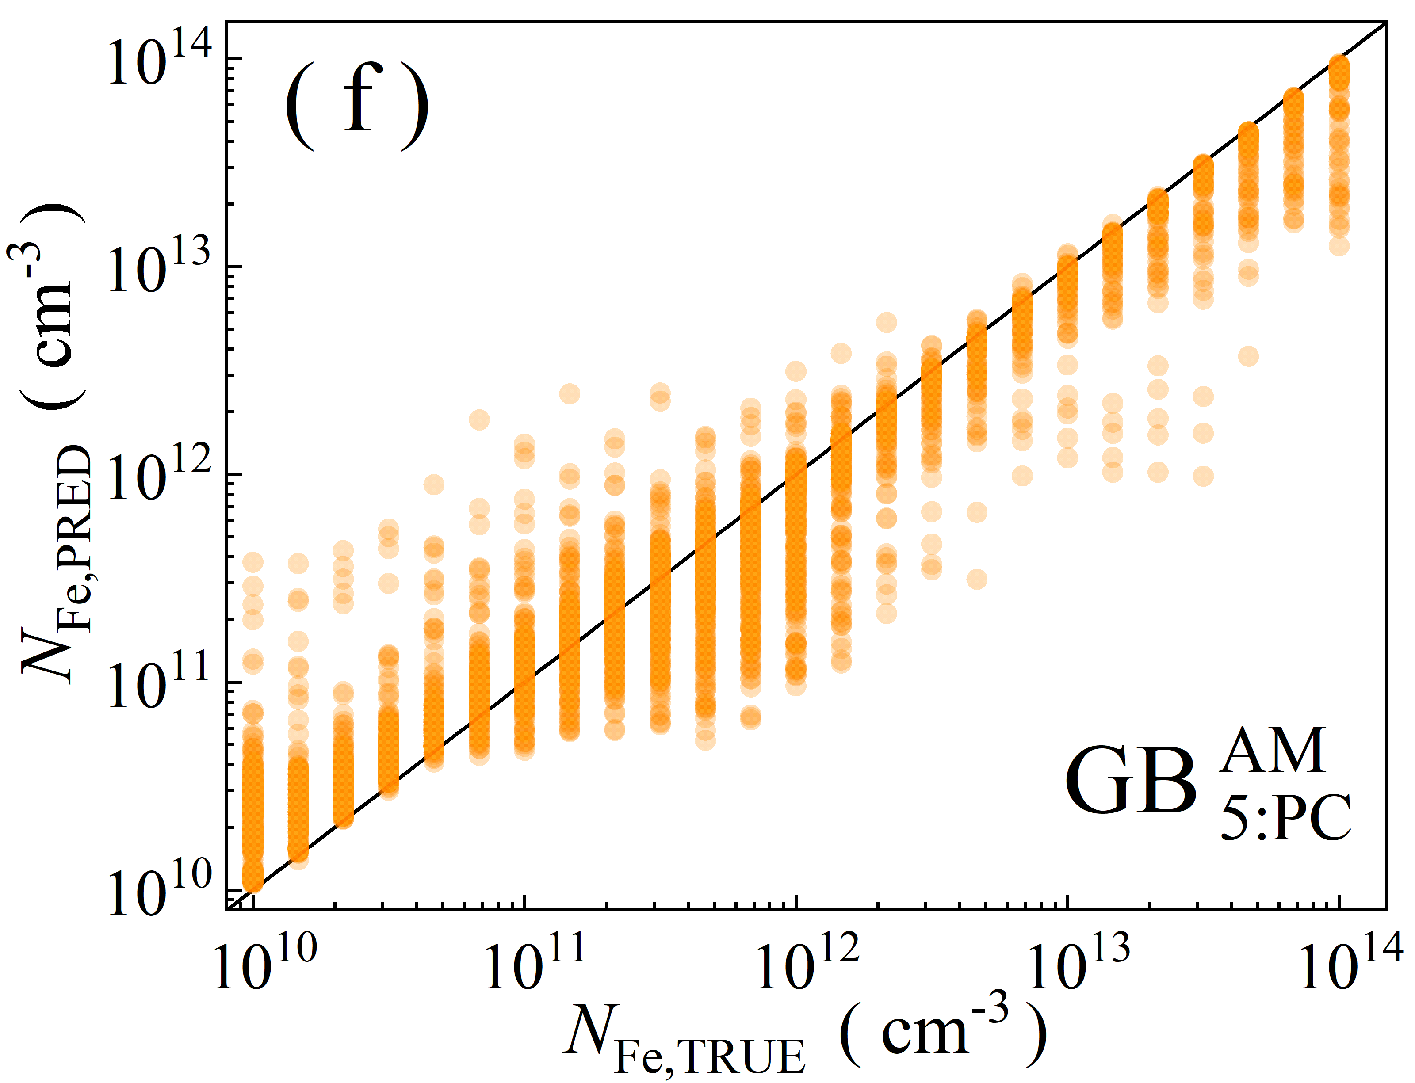

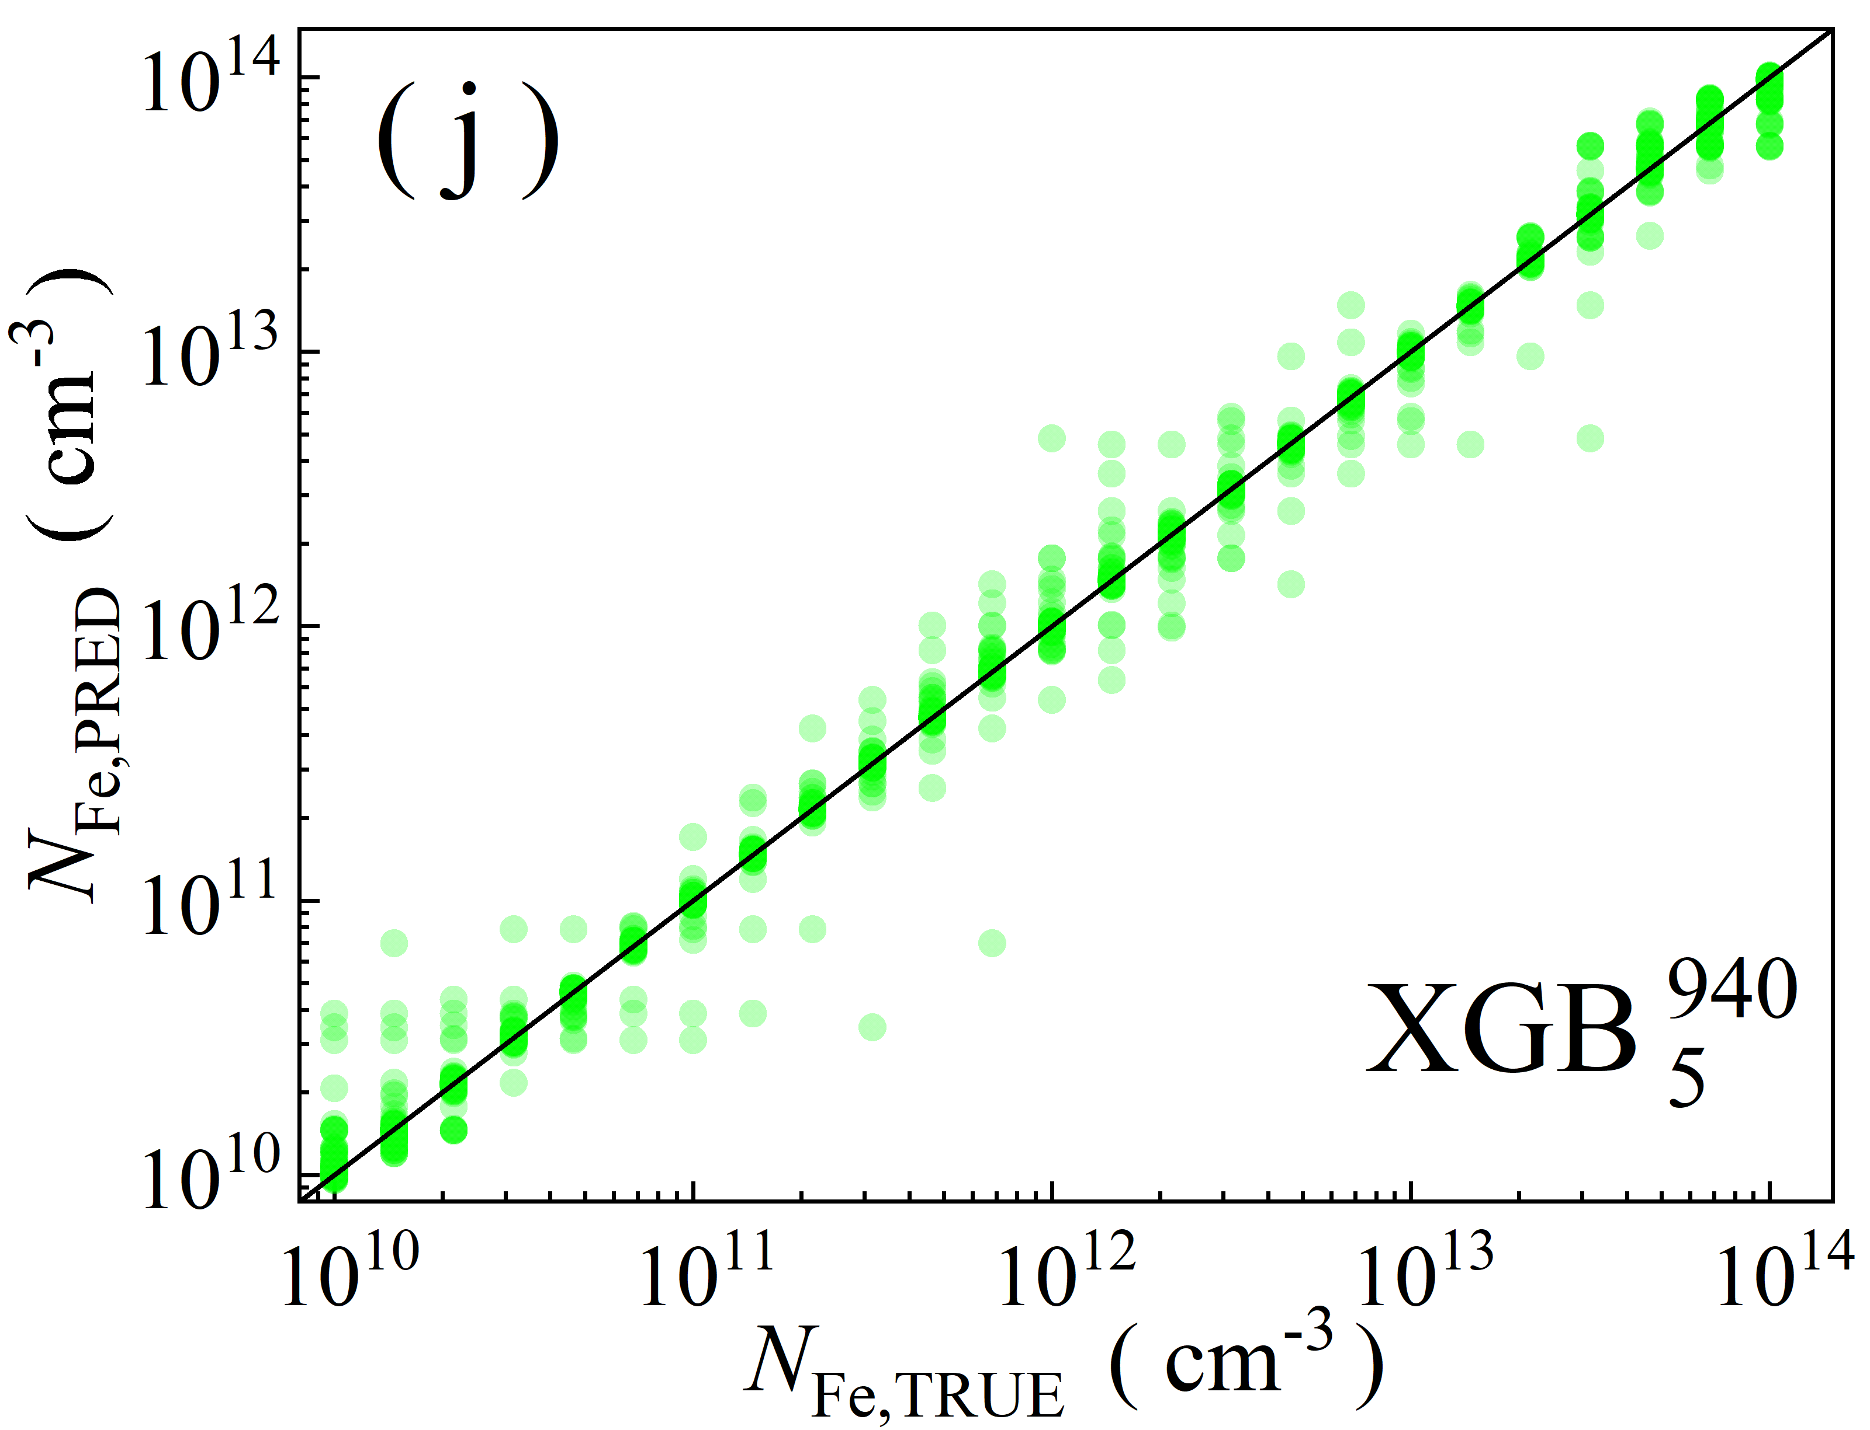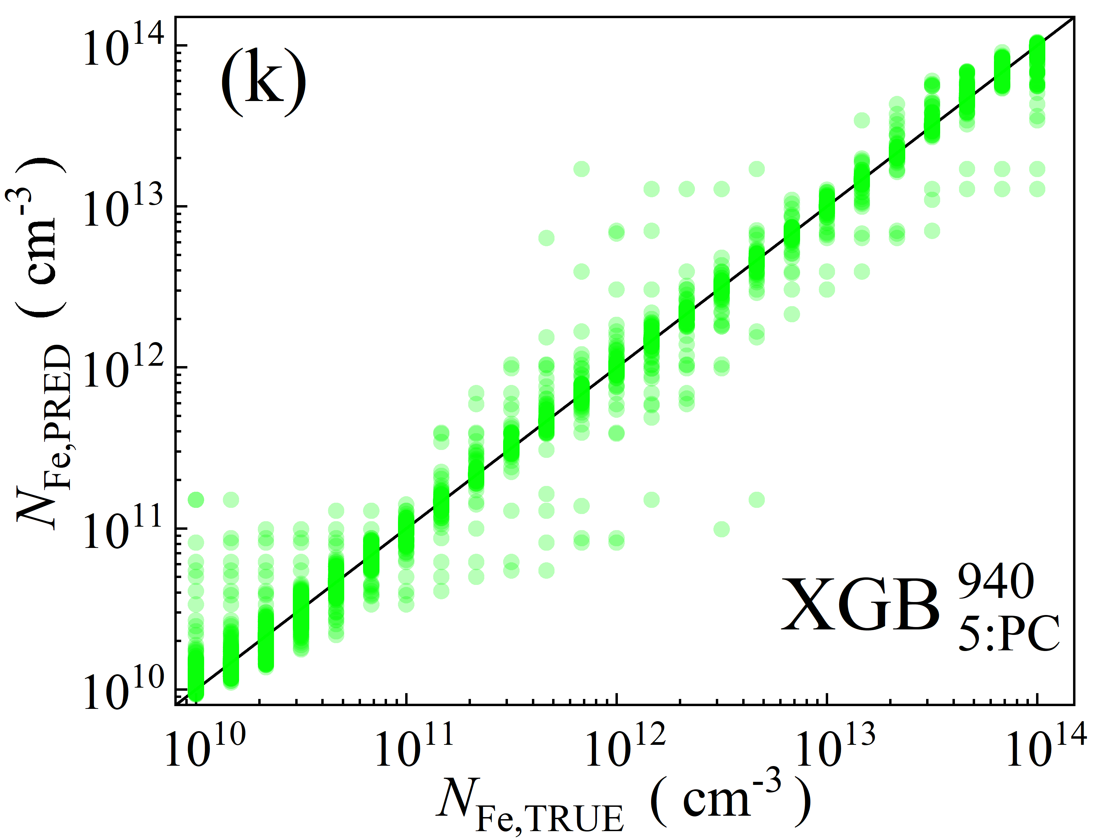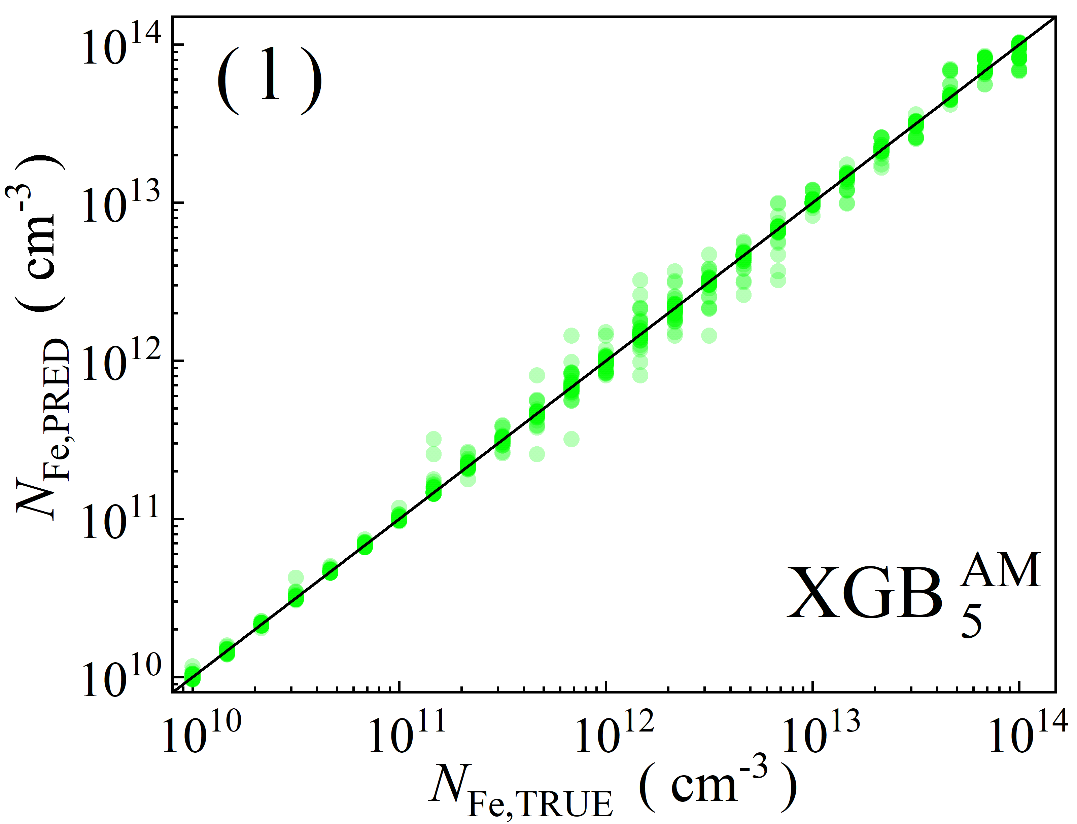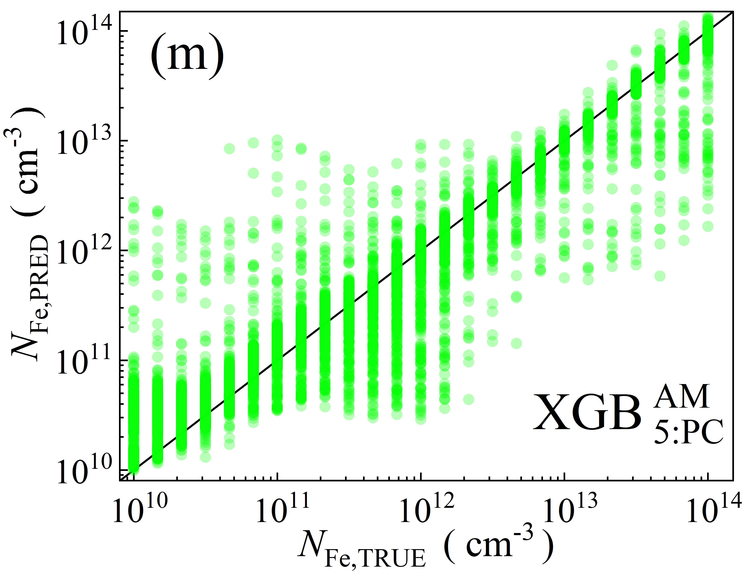

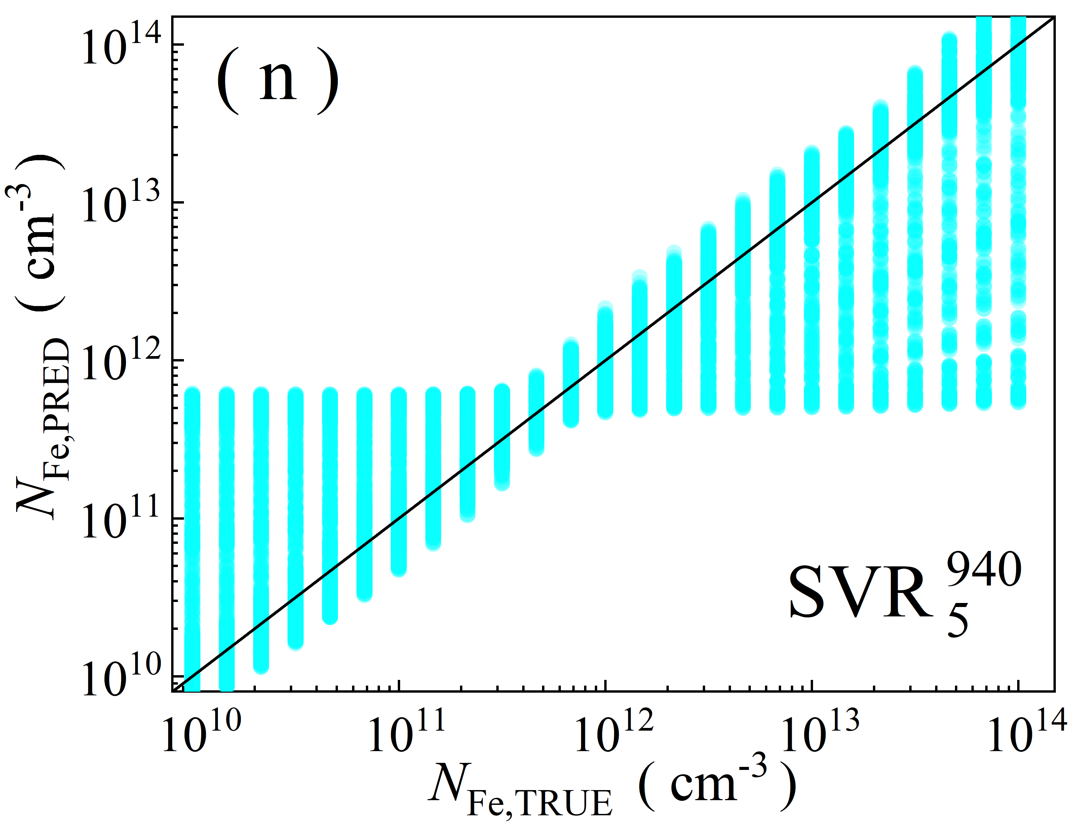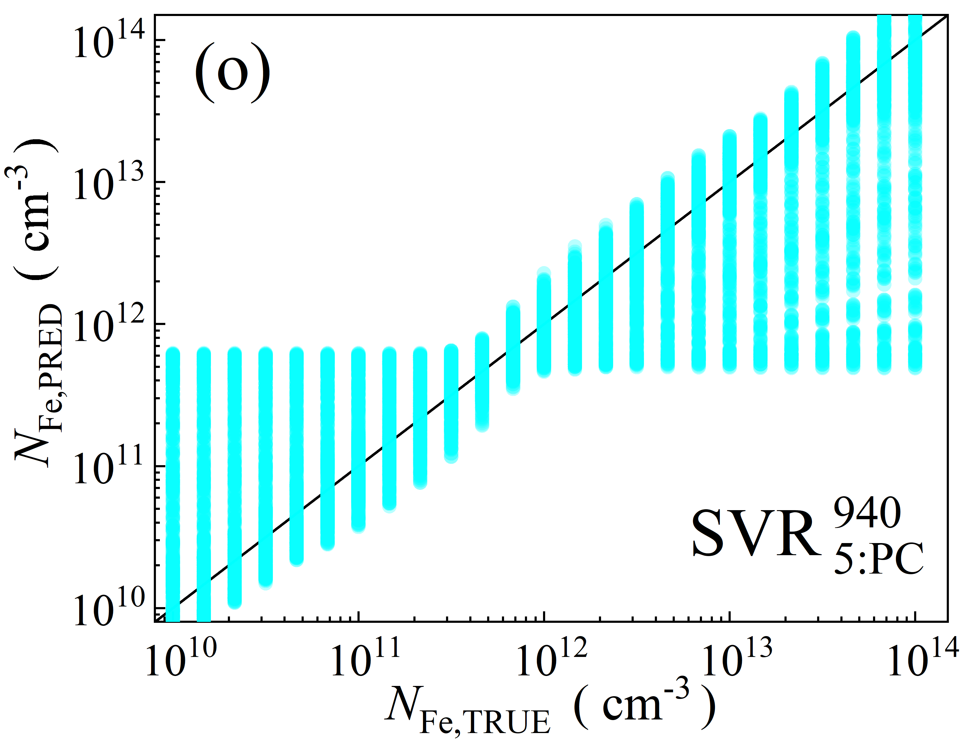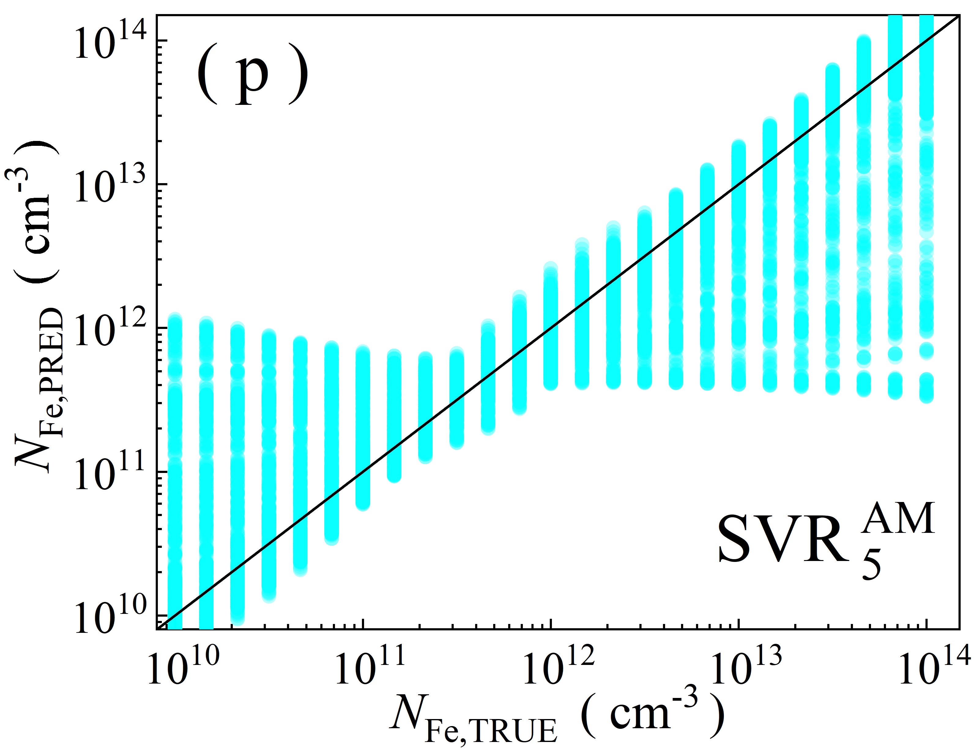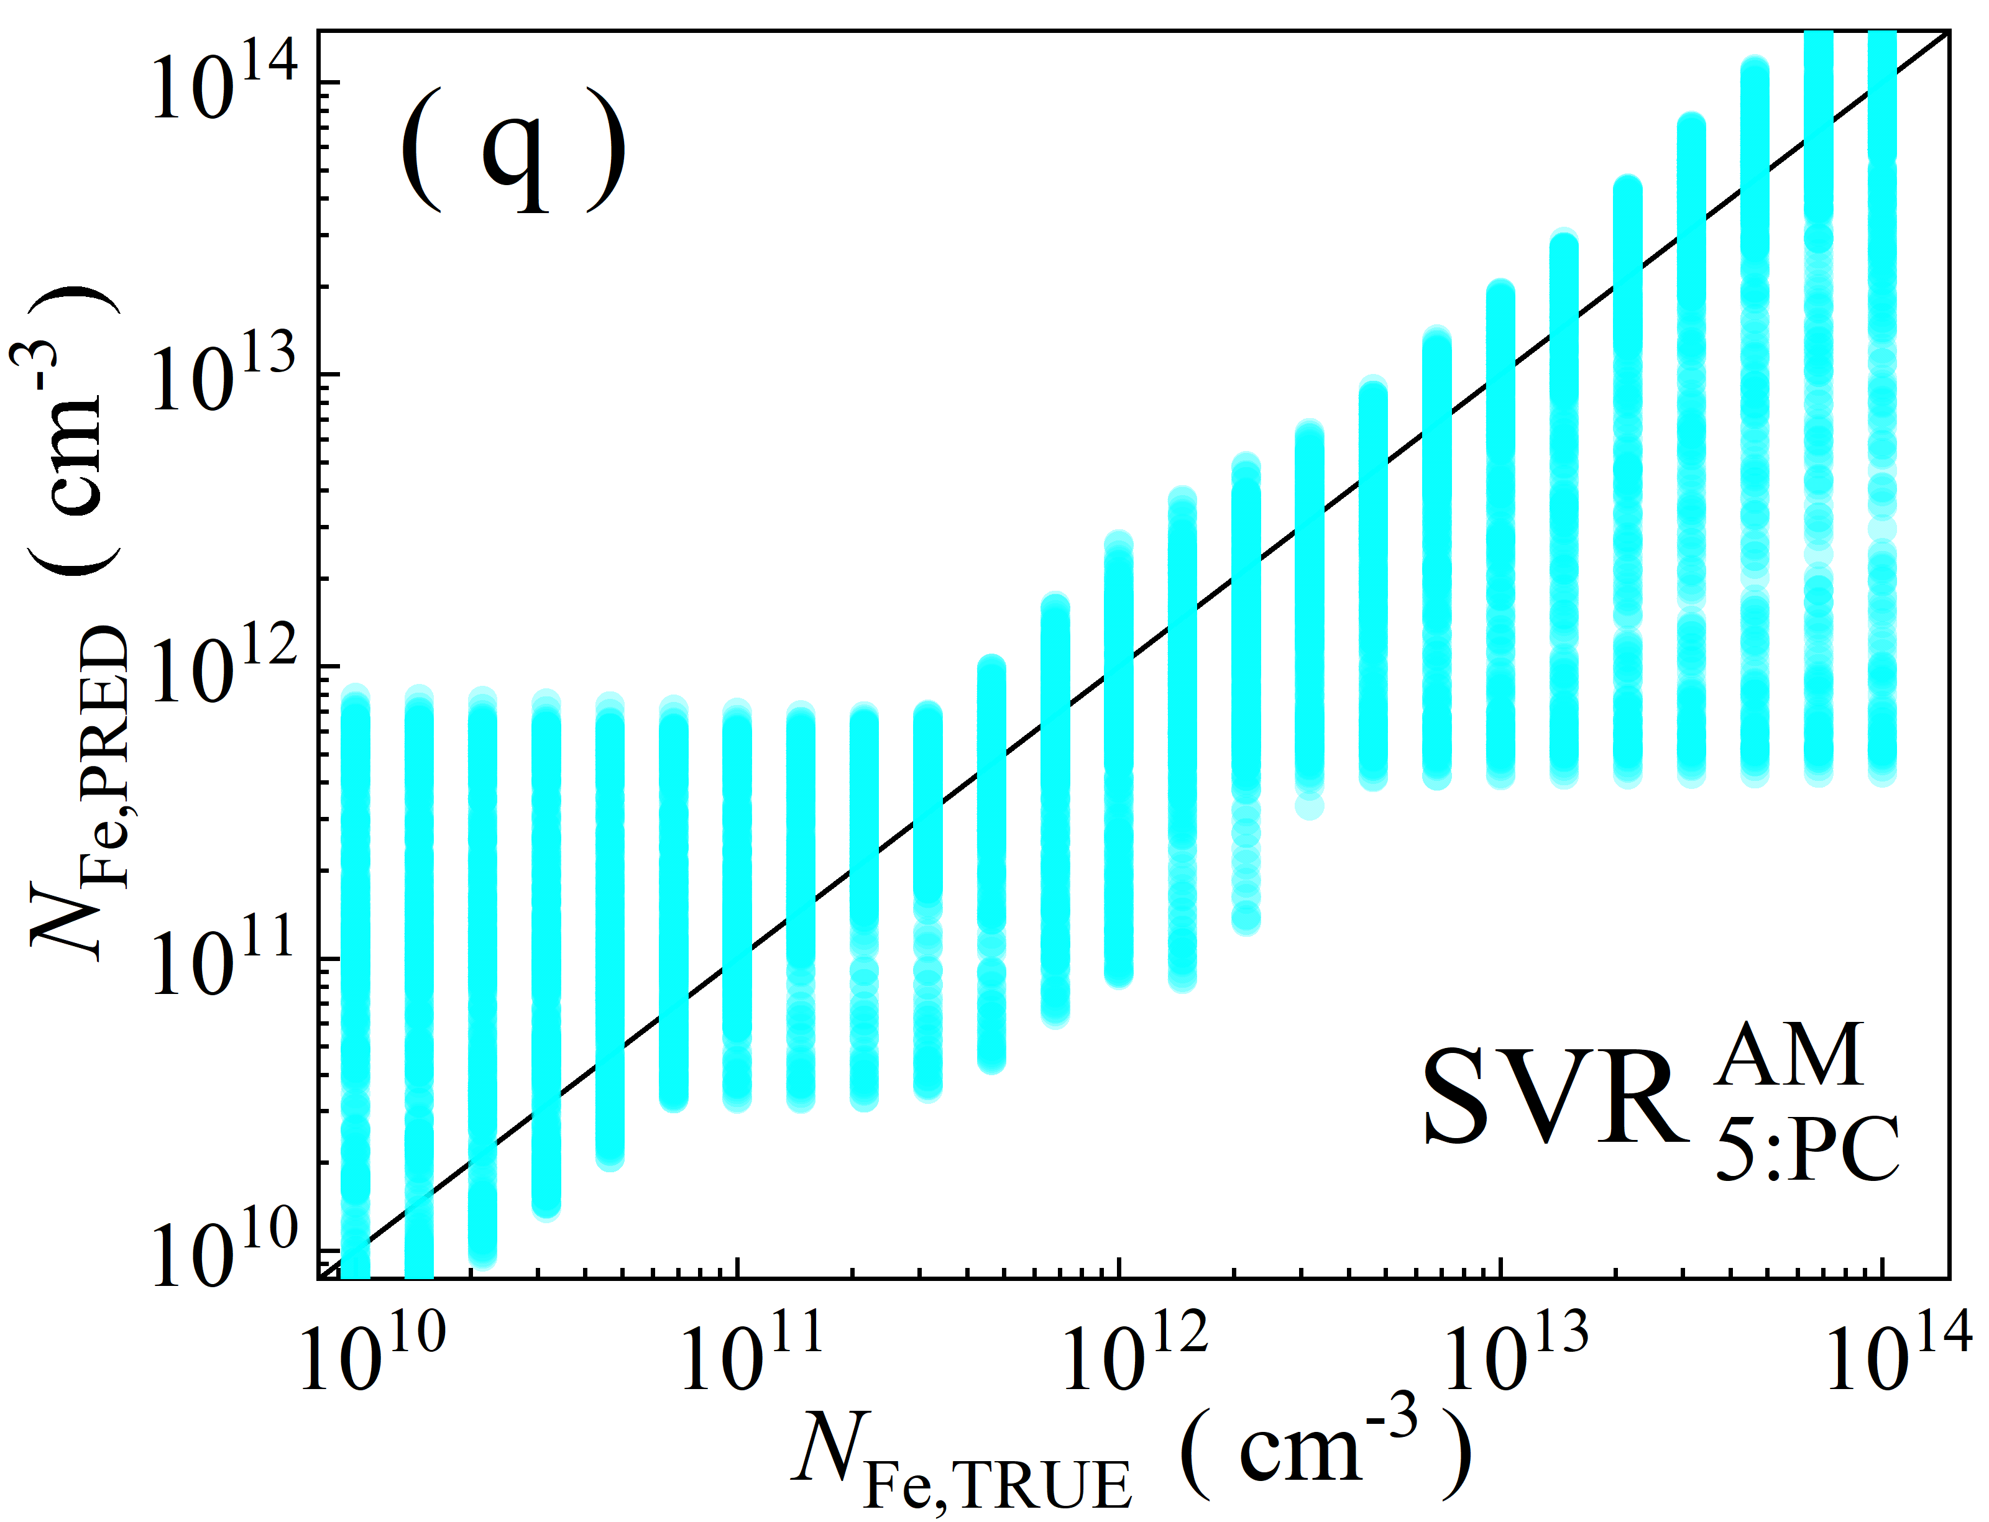

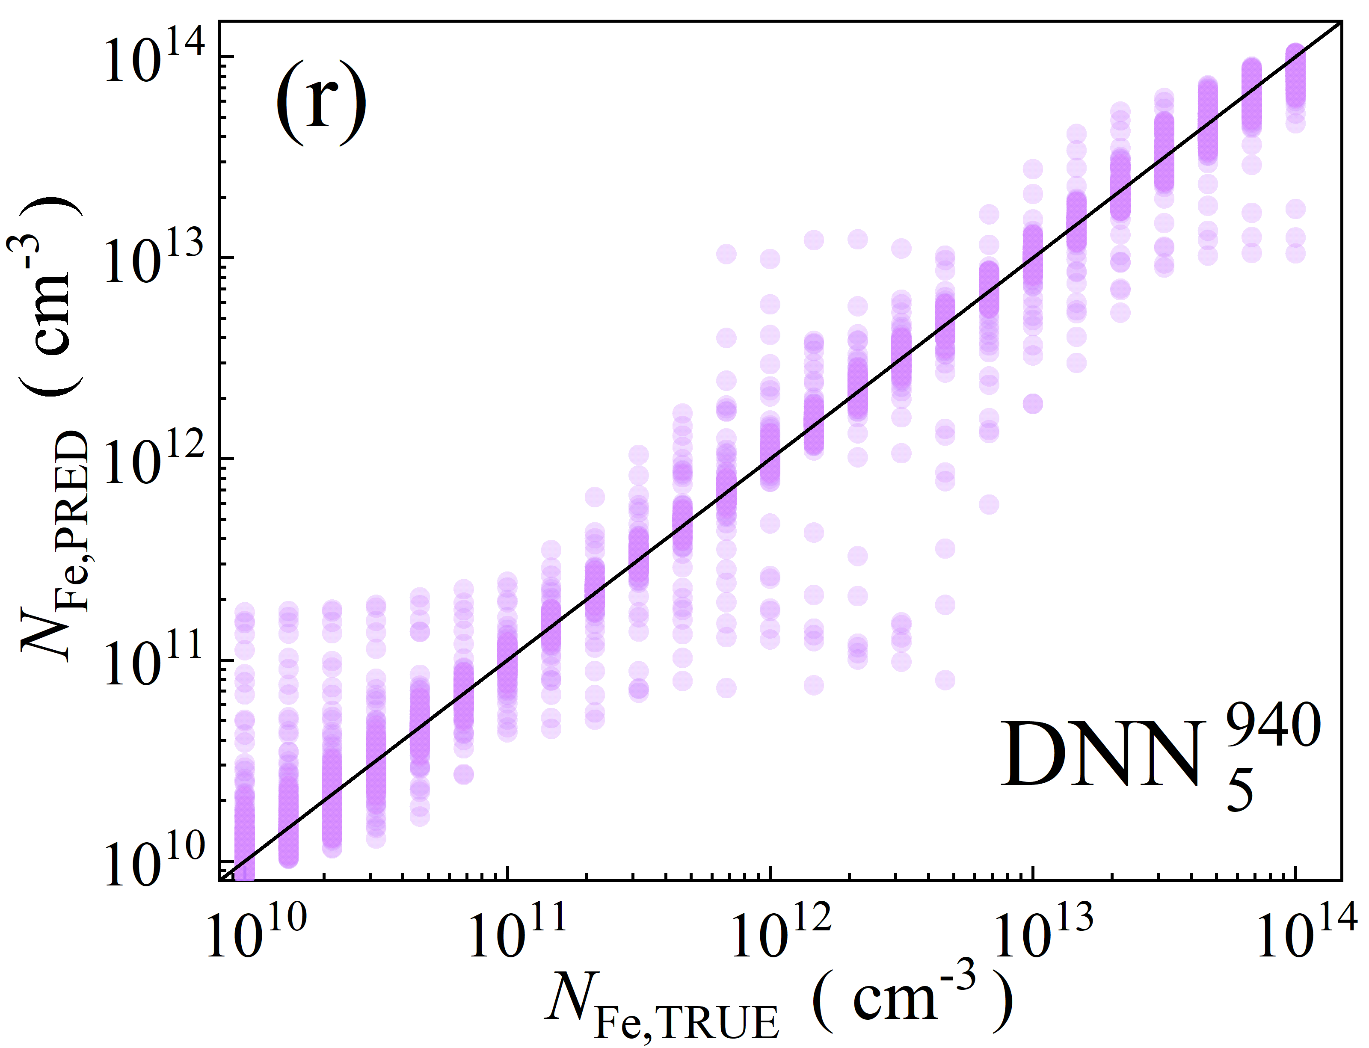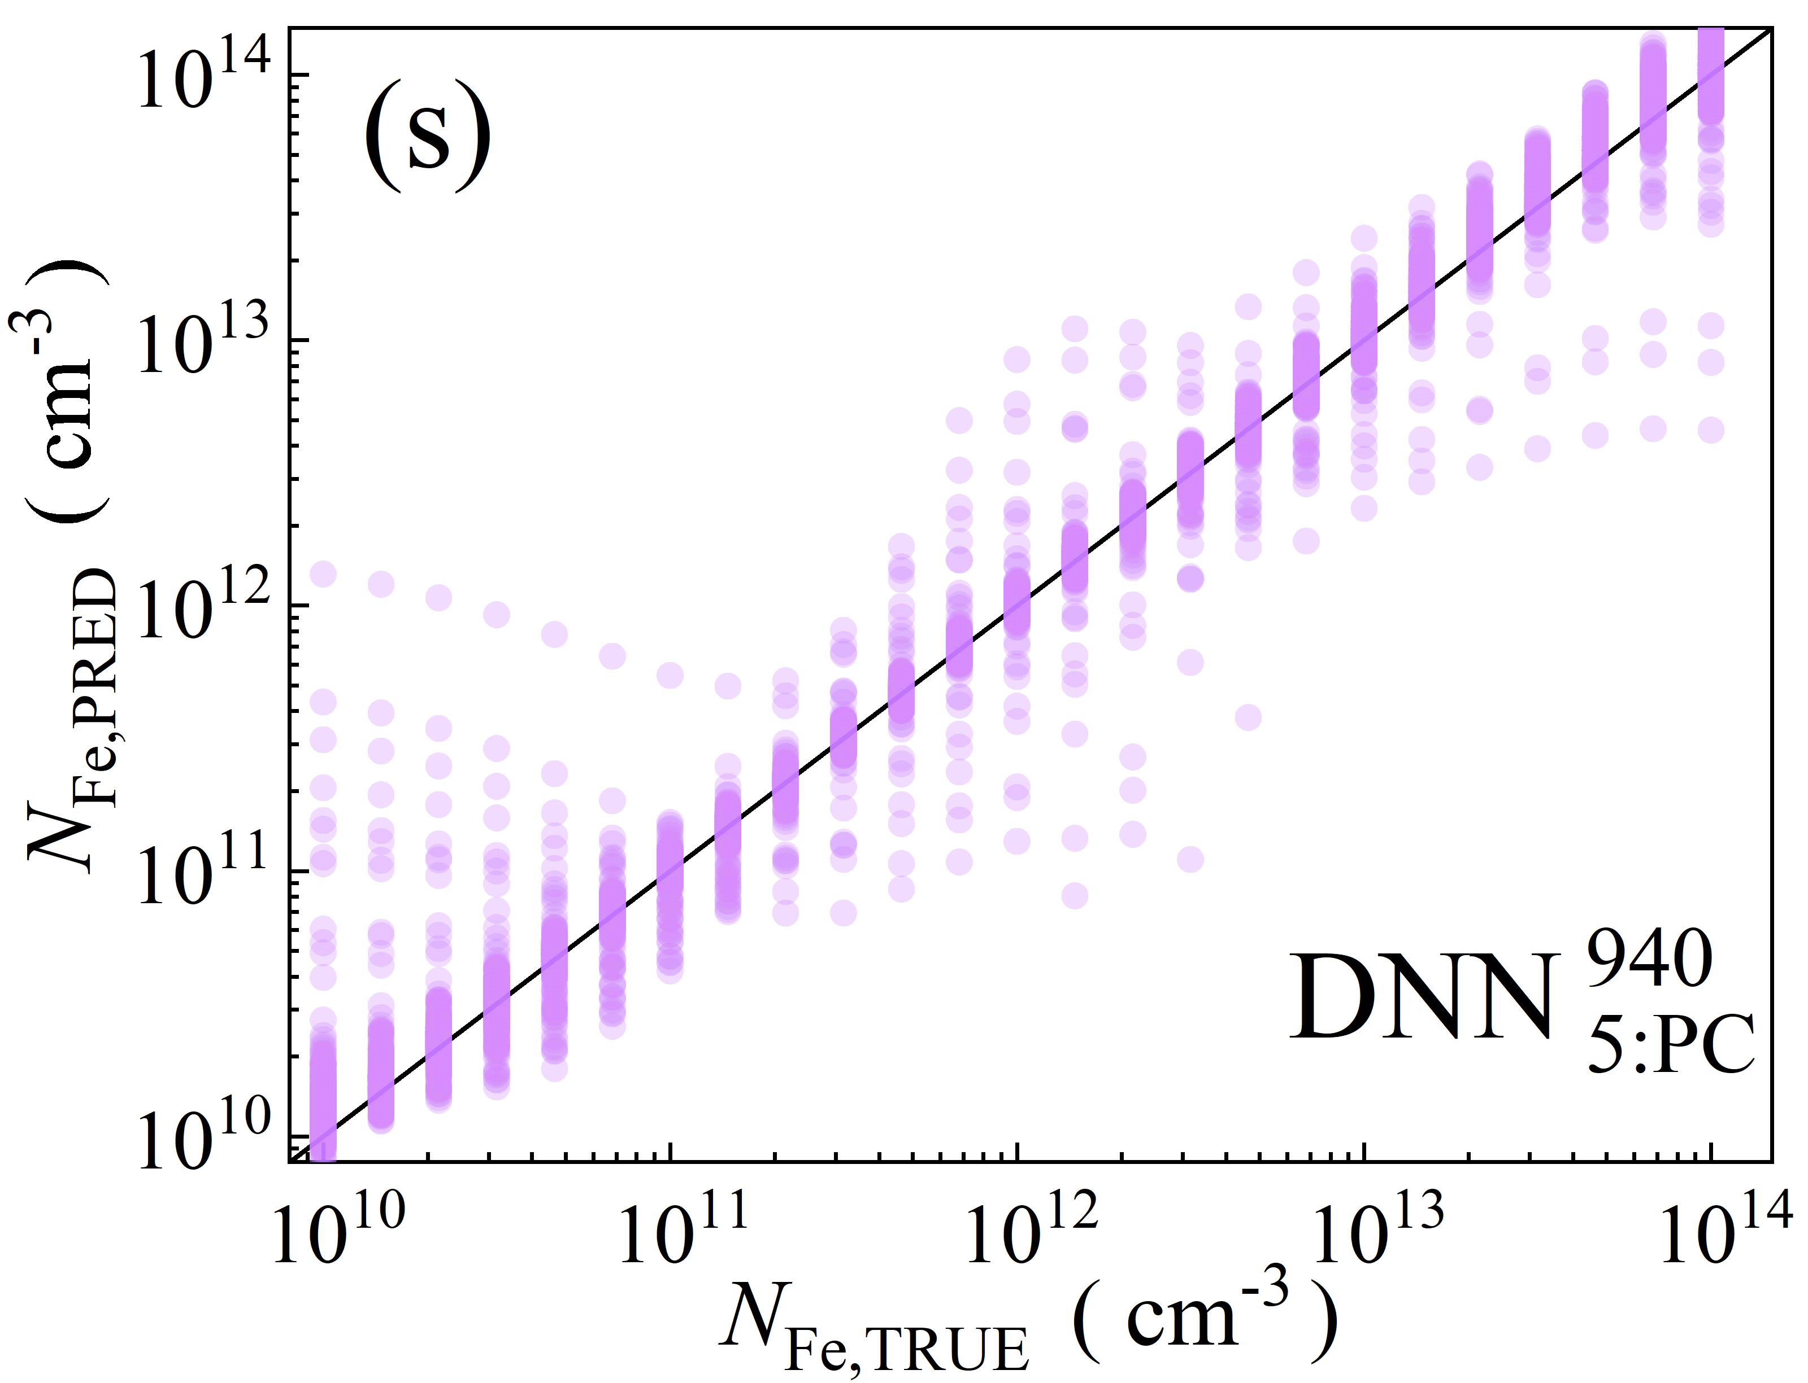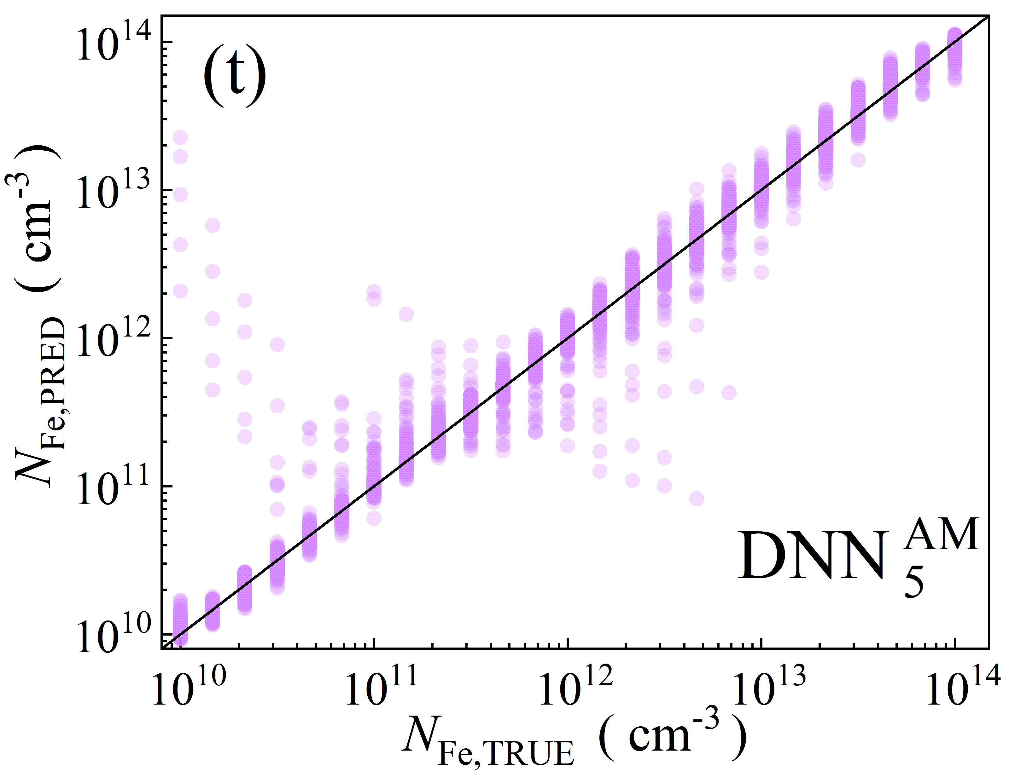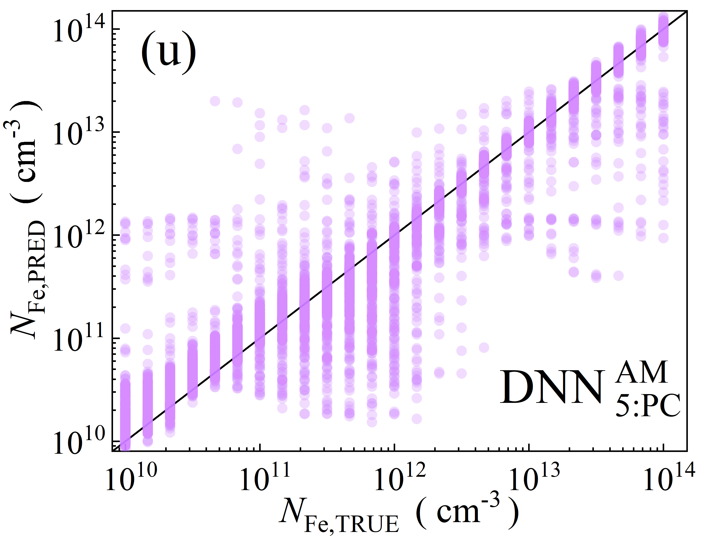

Fig.S4. Scatter plots of the iron concentrations between the reference values and ML predicted values for training phase in the case of 5D features. ML algorithms: RF (a-d), GB (e-i), XGB (j-m), SVR (n-q), DNN (r-u). The data are obtained for monochromatic (a, b, e, f, j, k, n, o, r, s) and AM1.5 (c, d, h, i, l, m, p, q, t, u) illuminations. PCA was used for the panels b, d, f, i, k, m, o, q, s, and u. The black lines are the identify lines servings as the references.

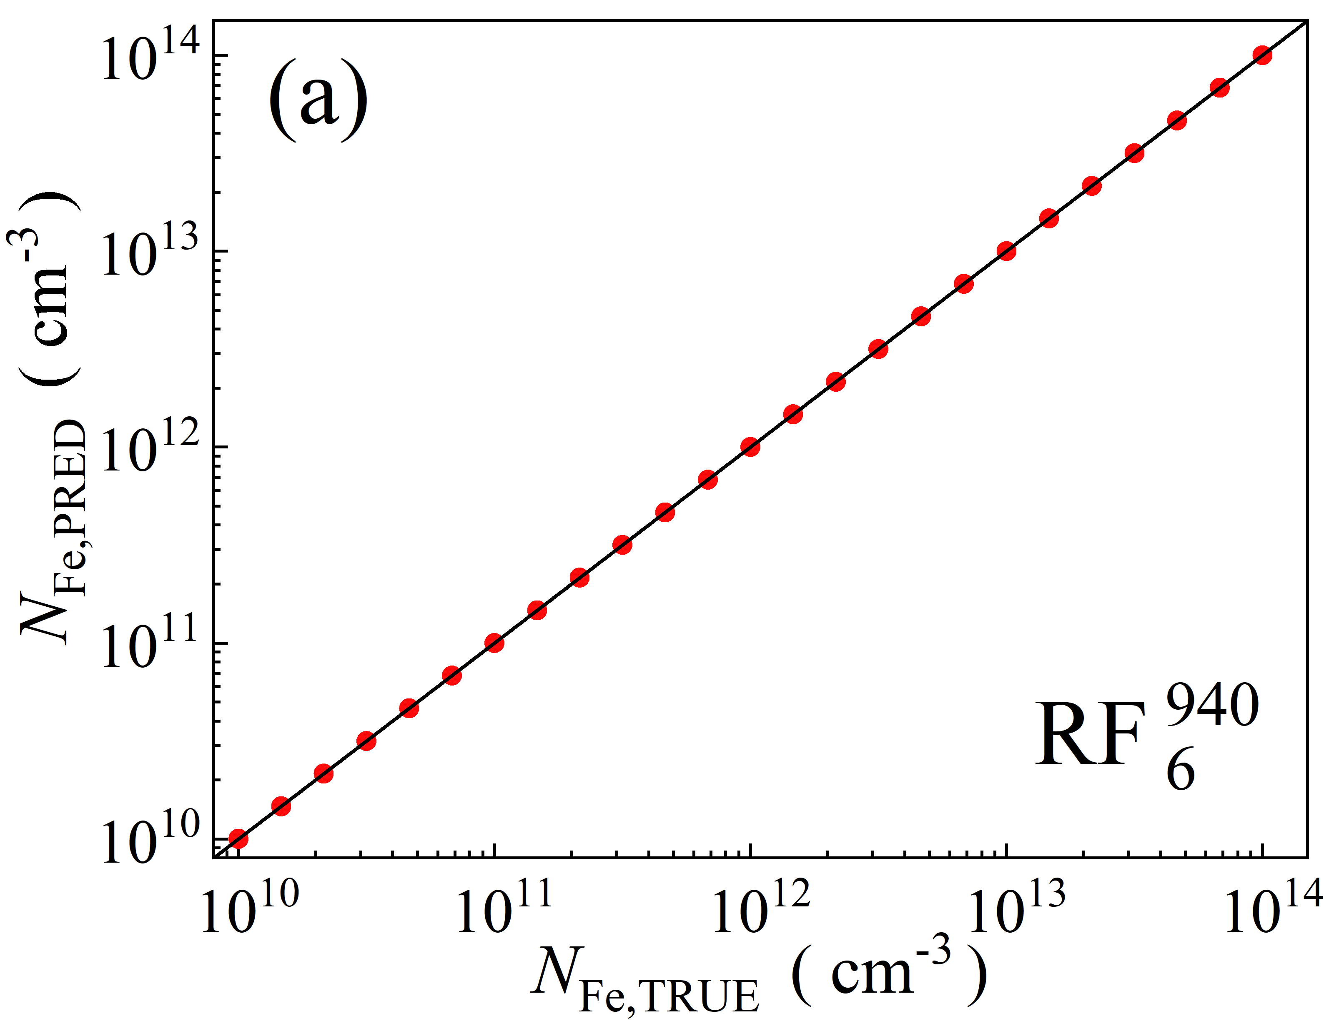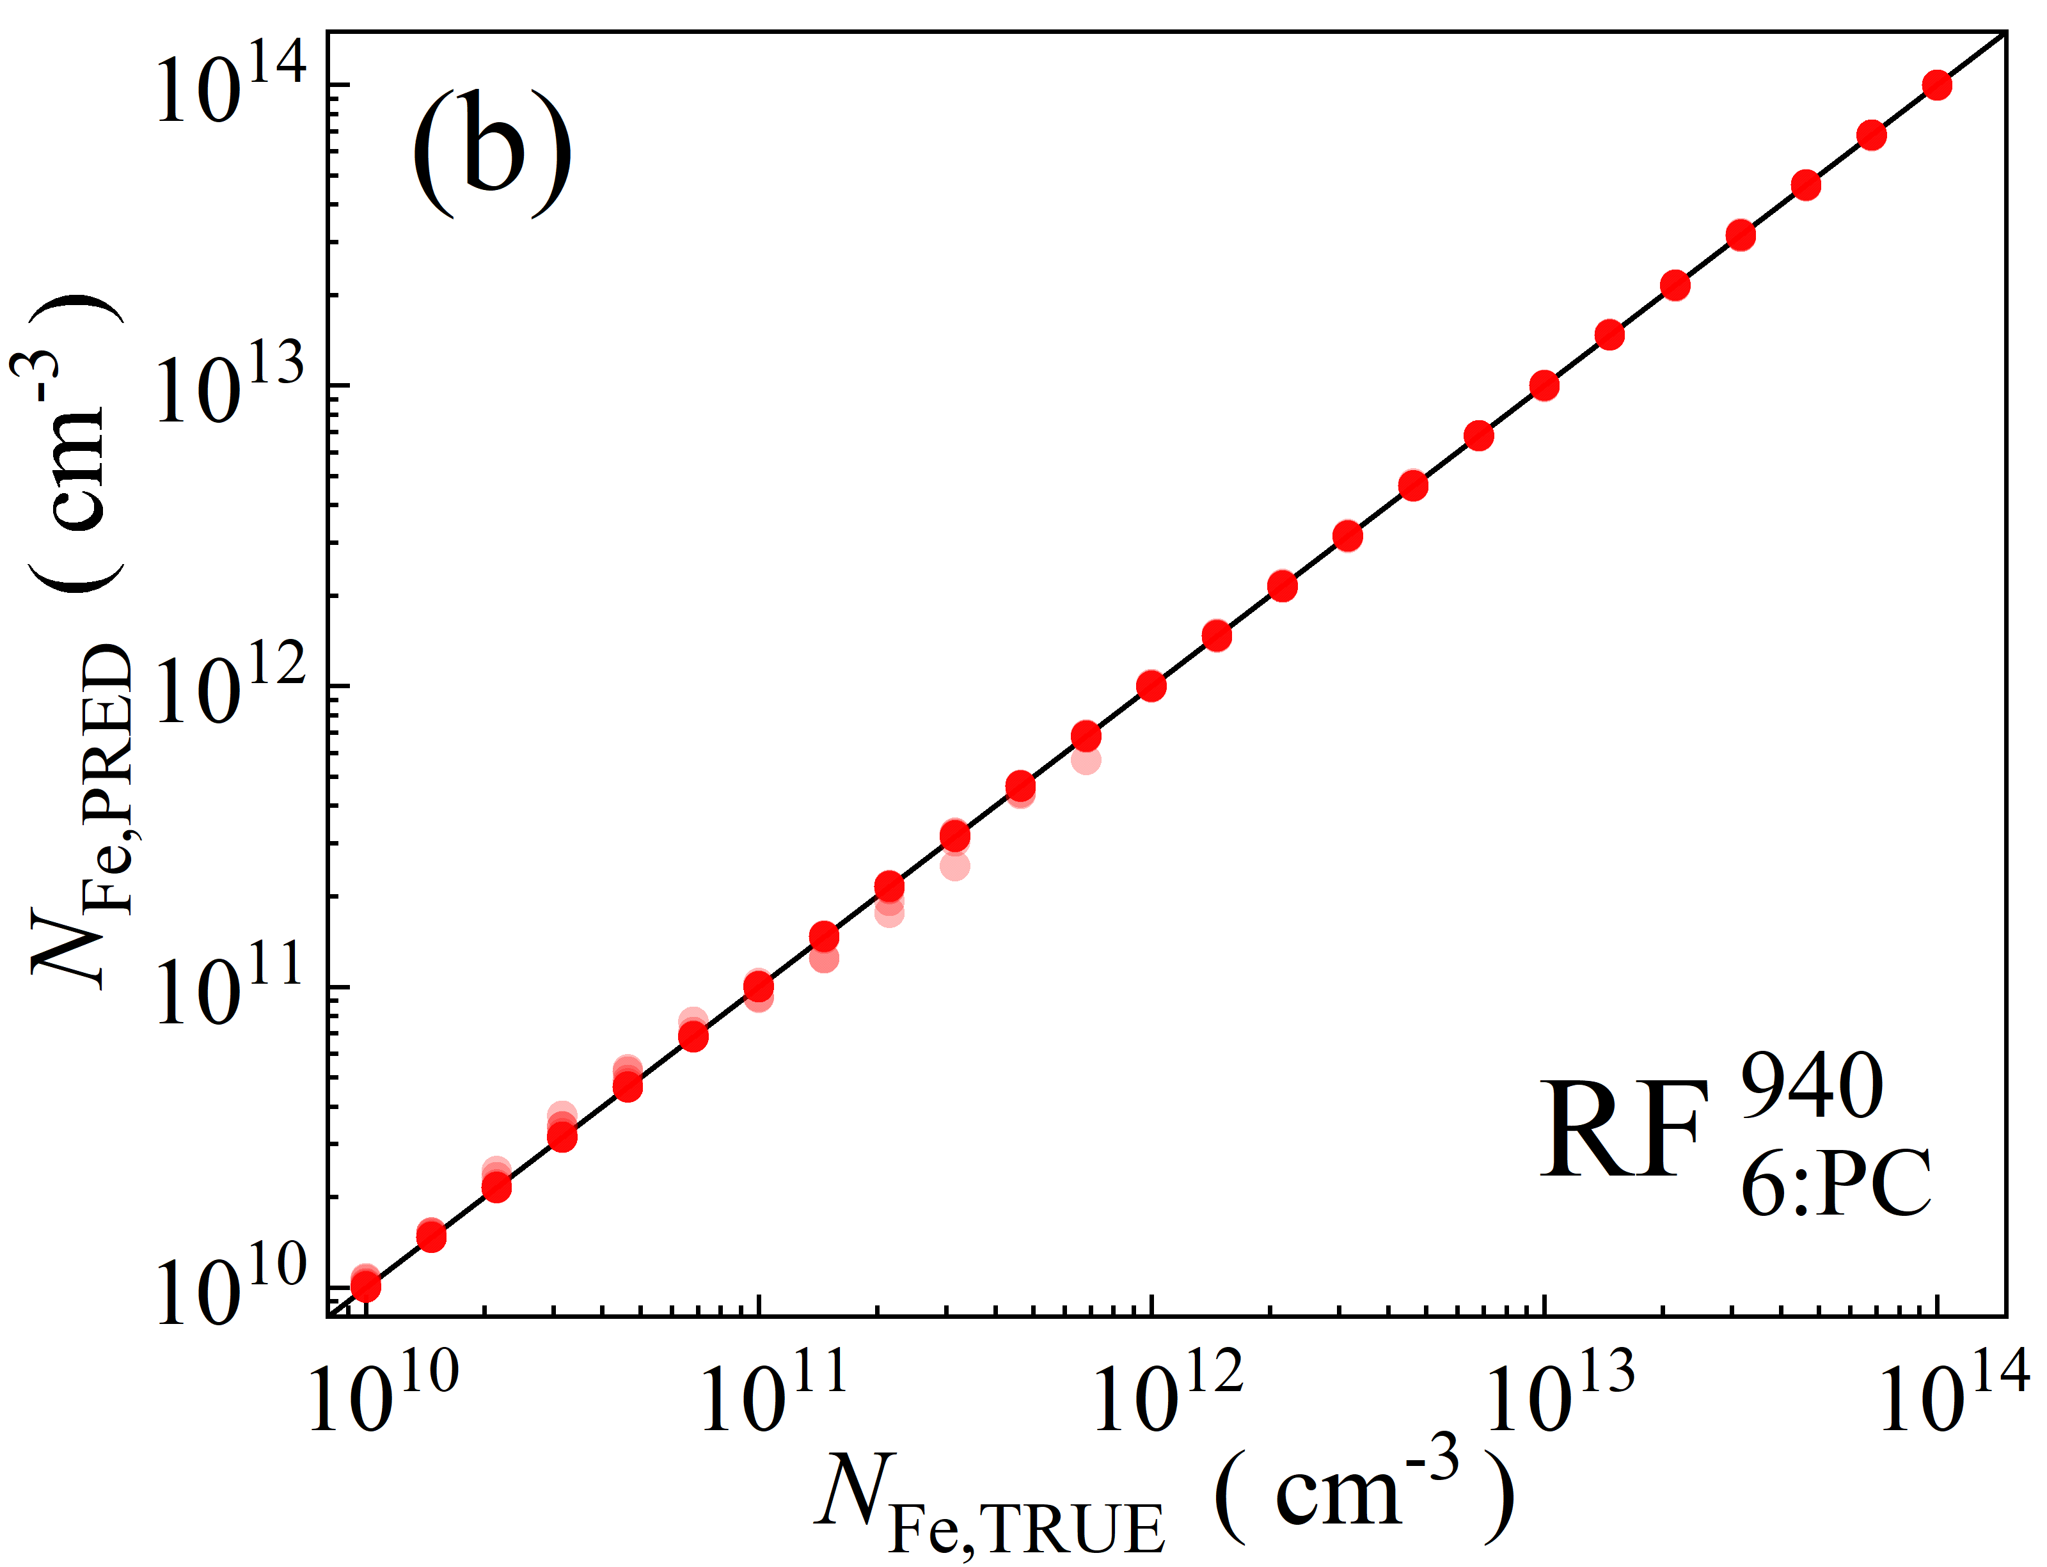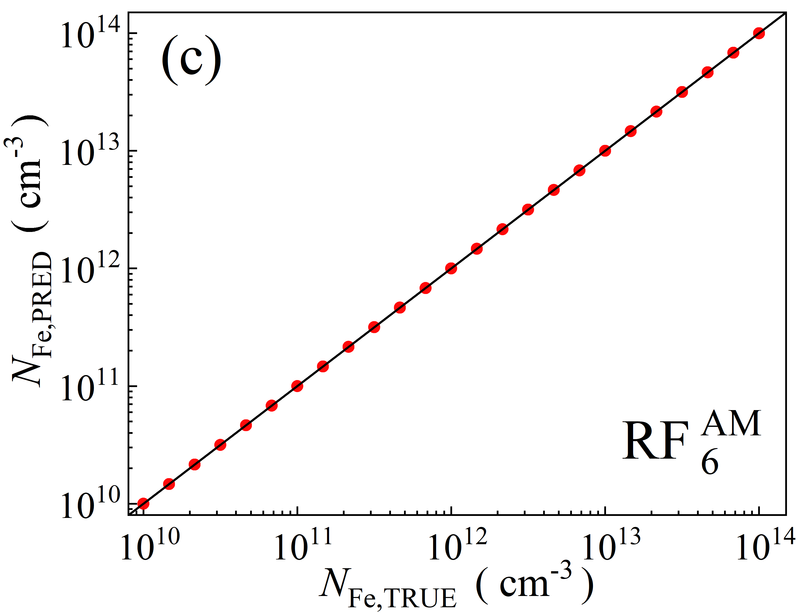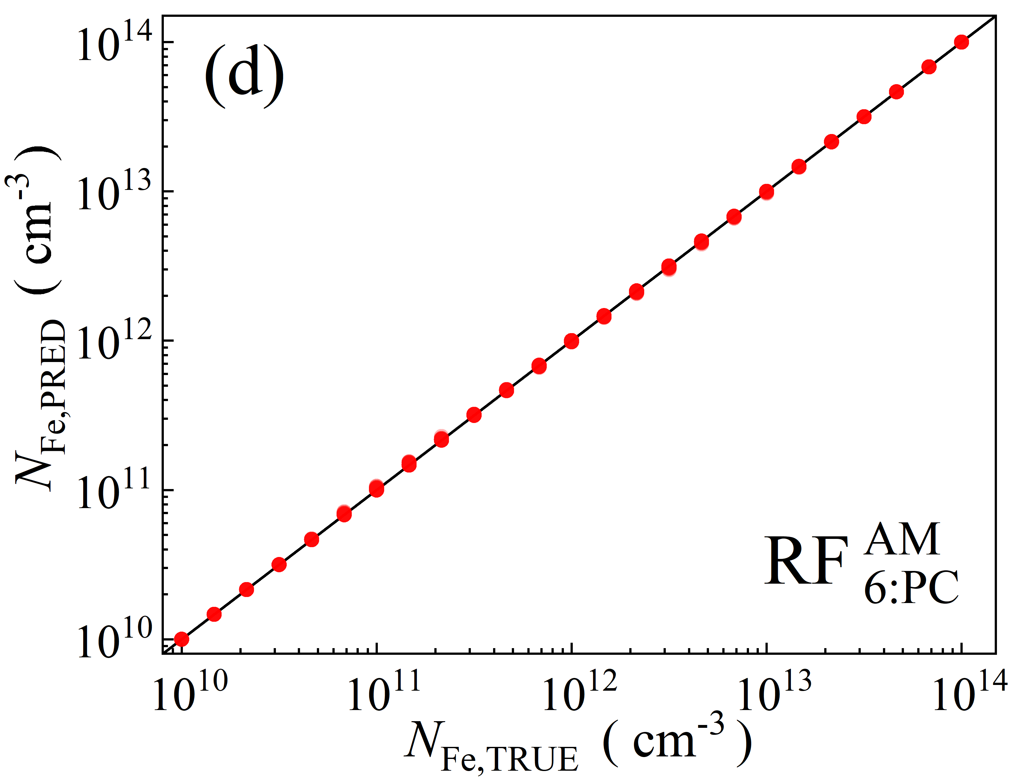

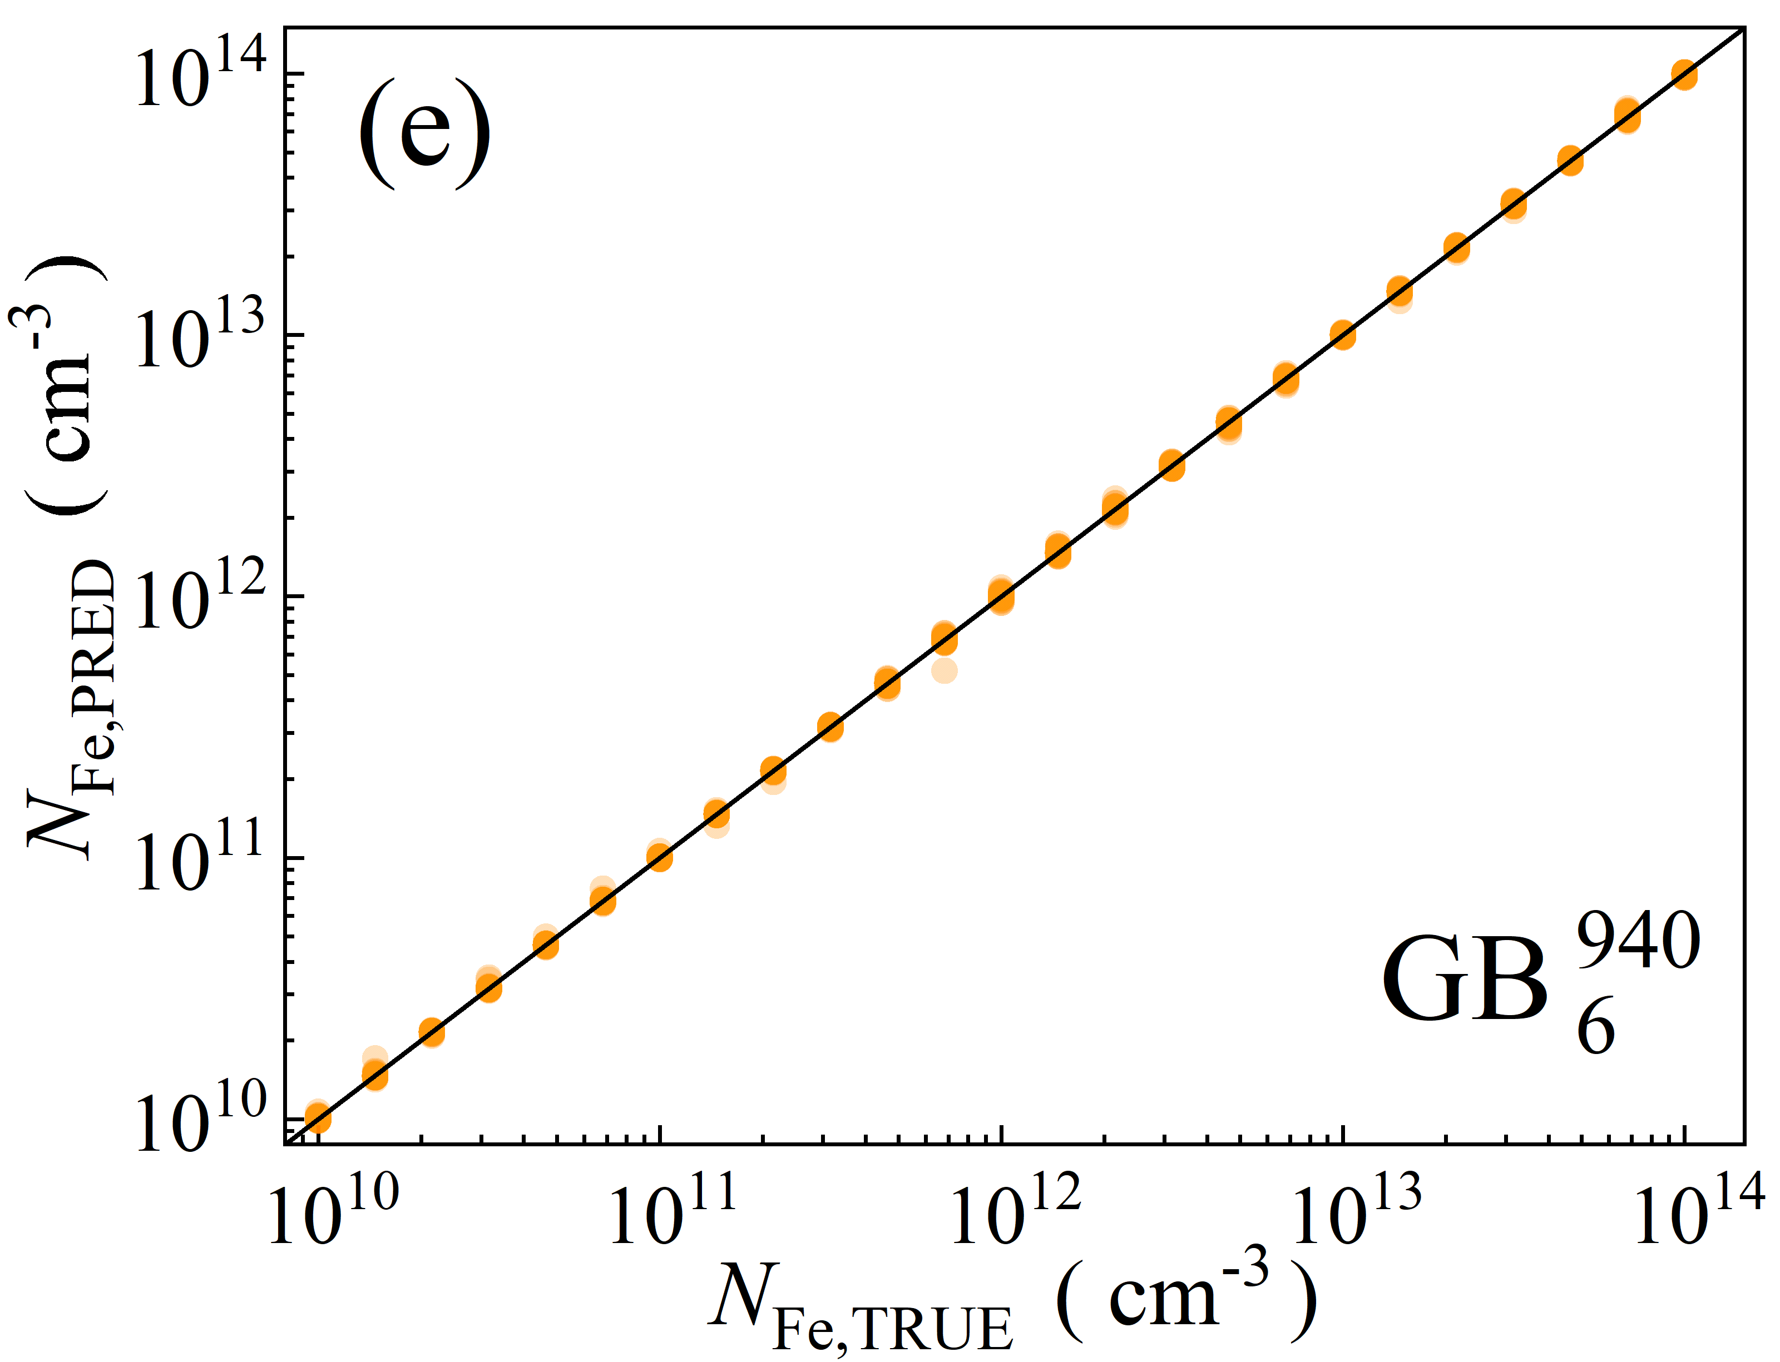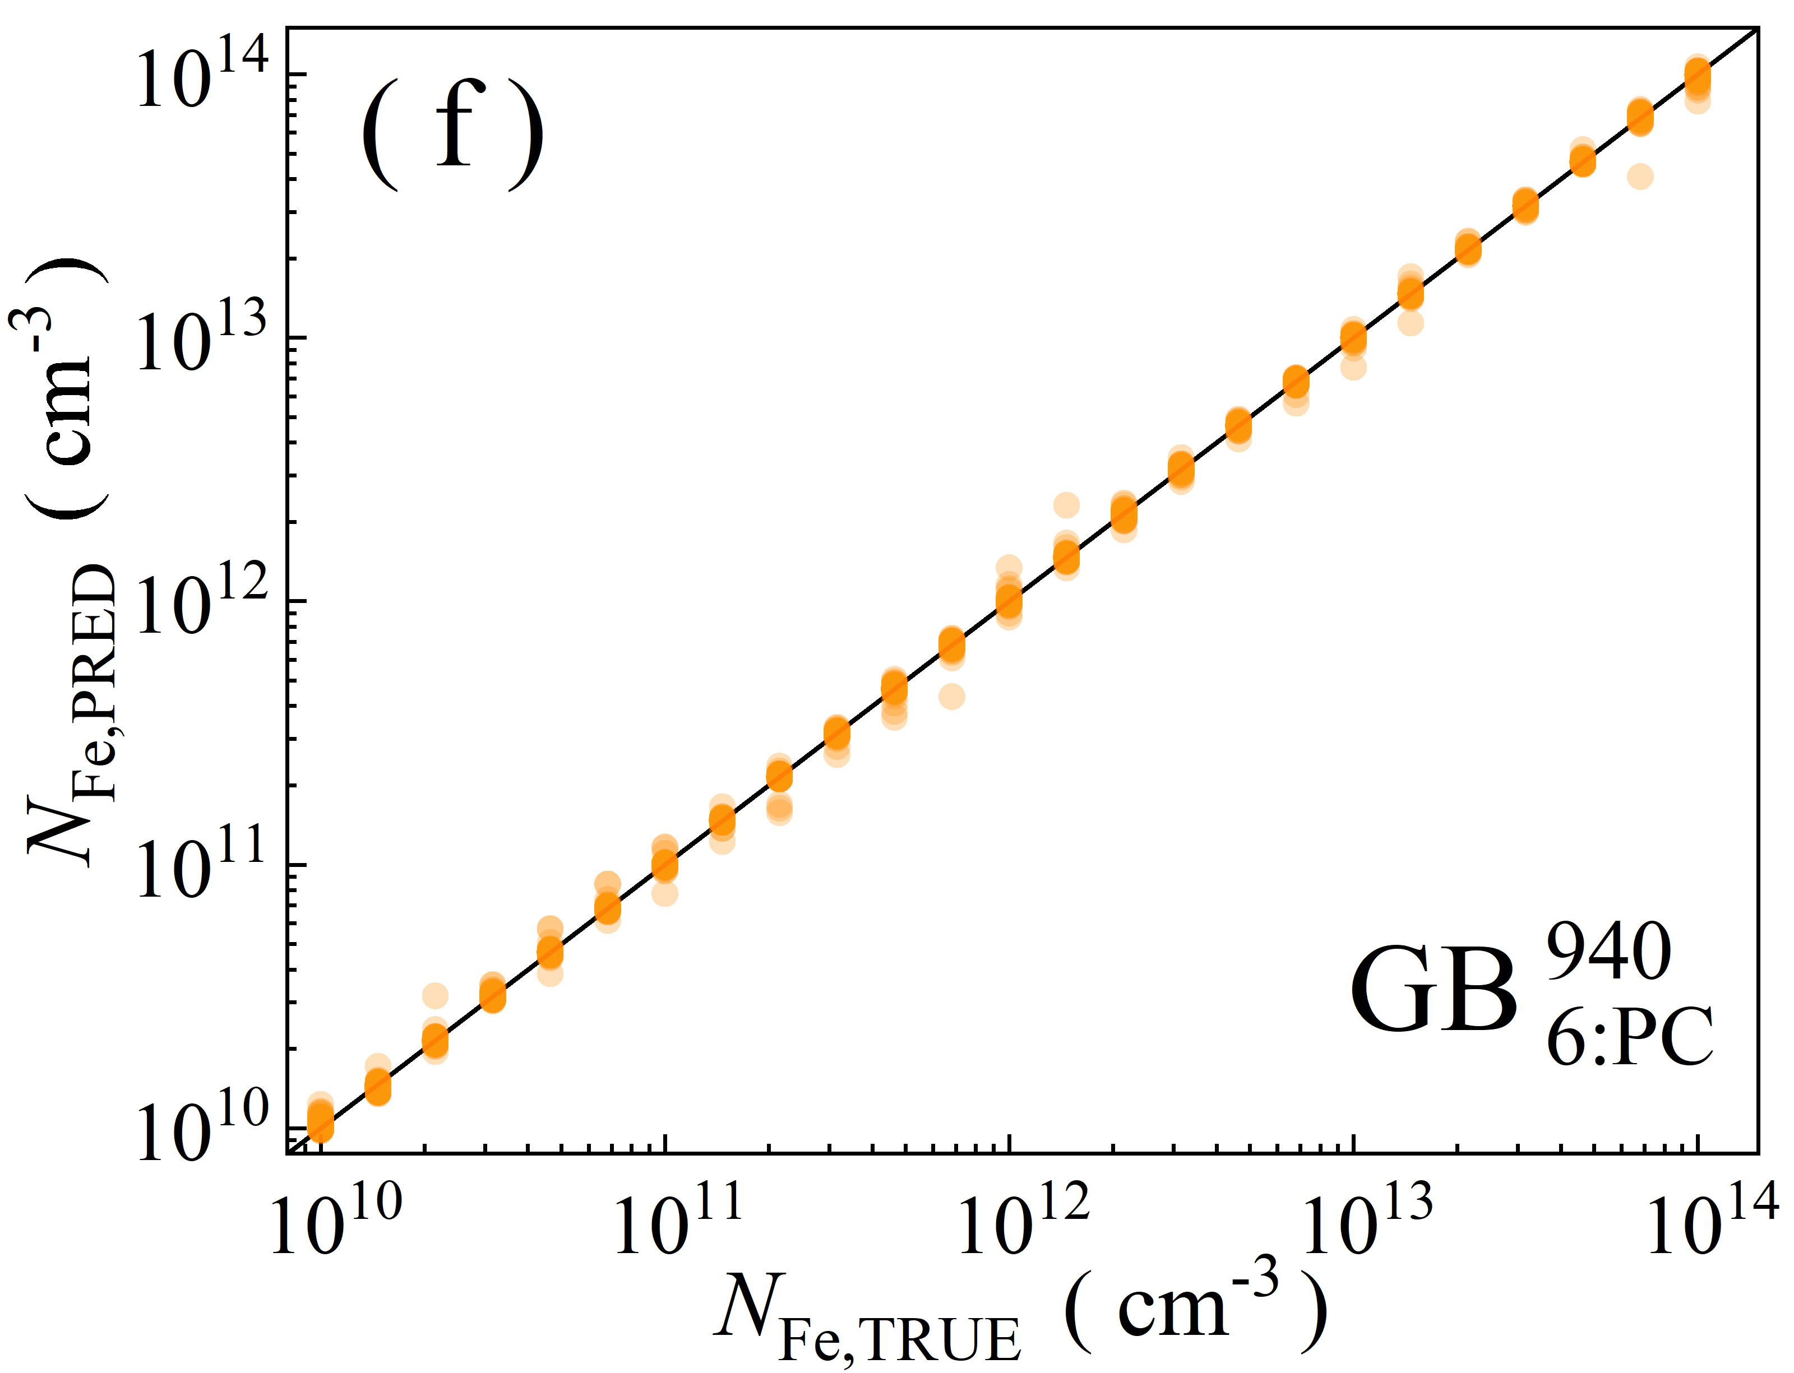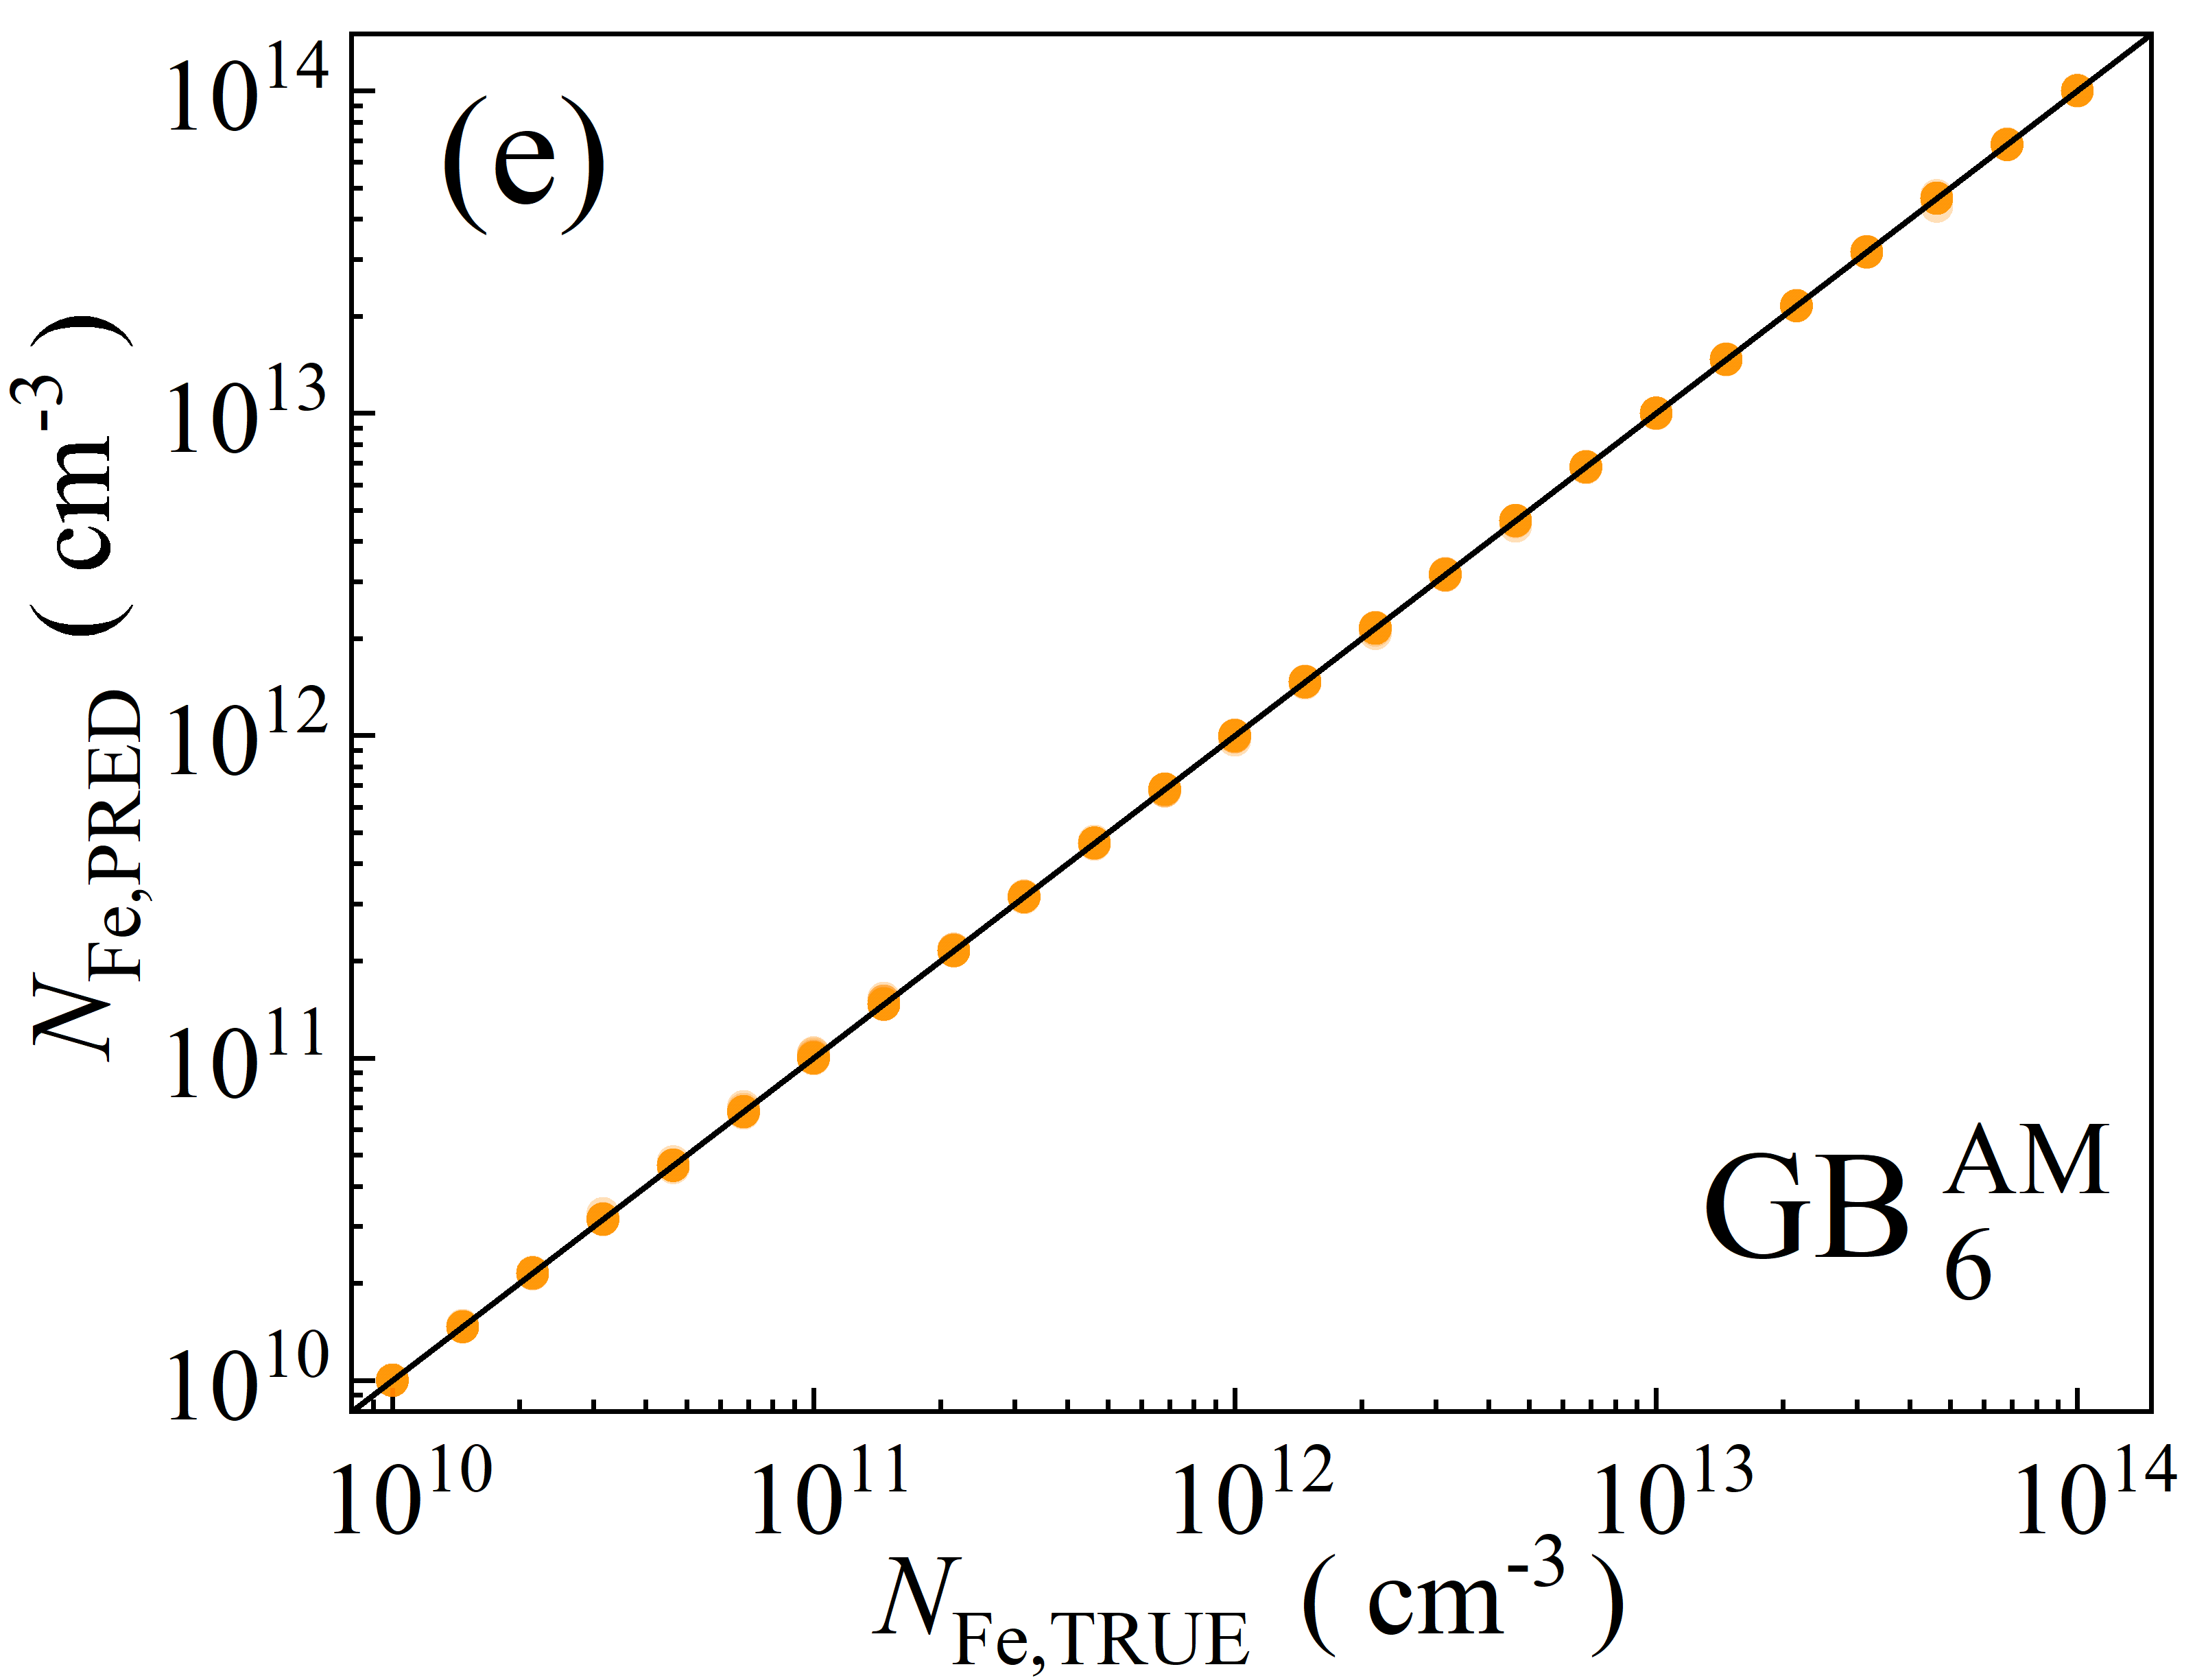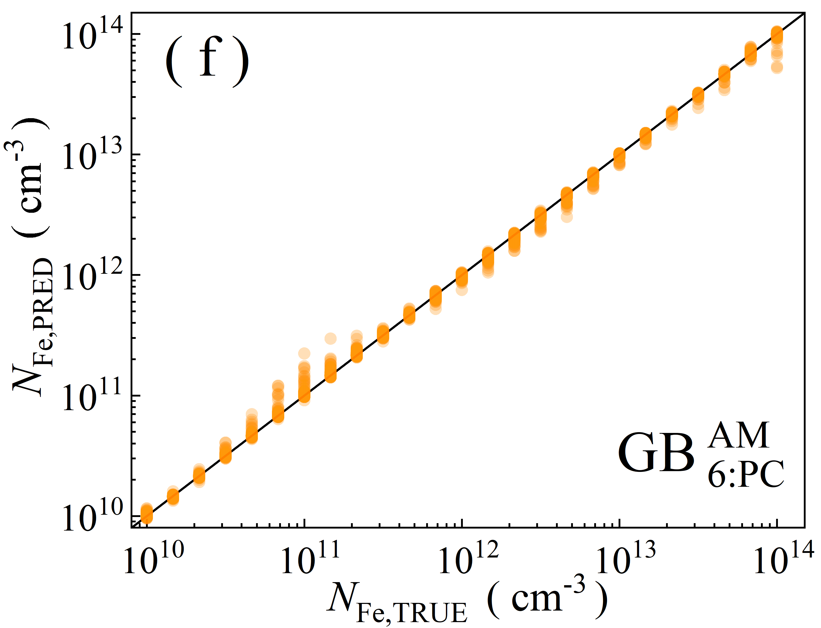

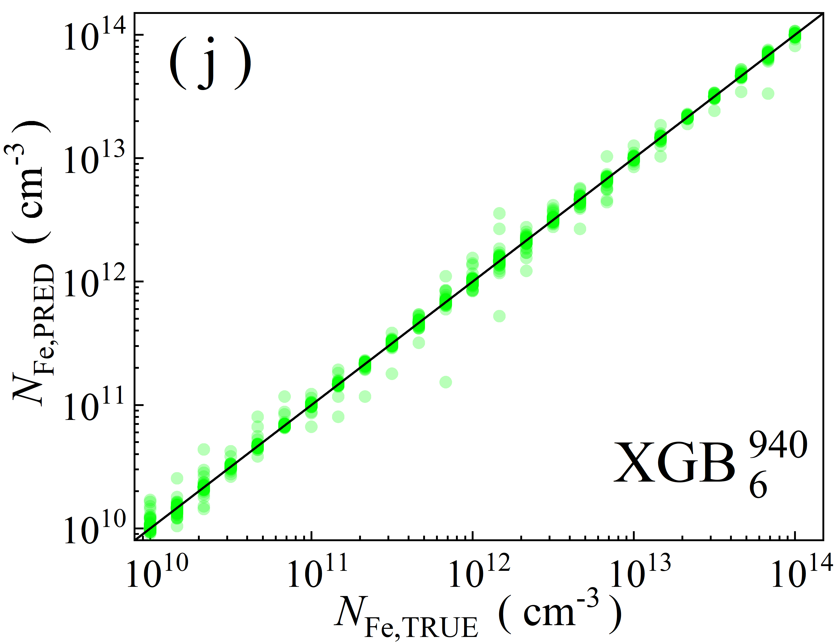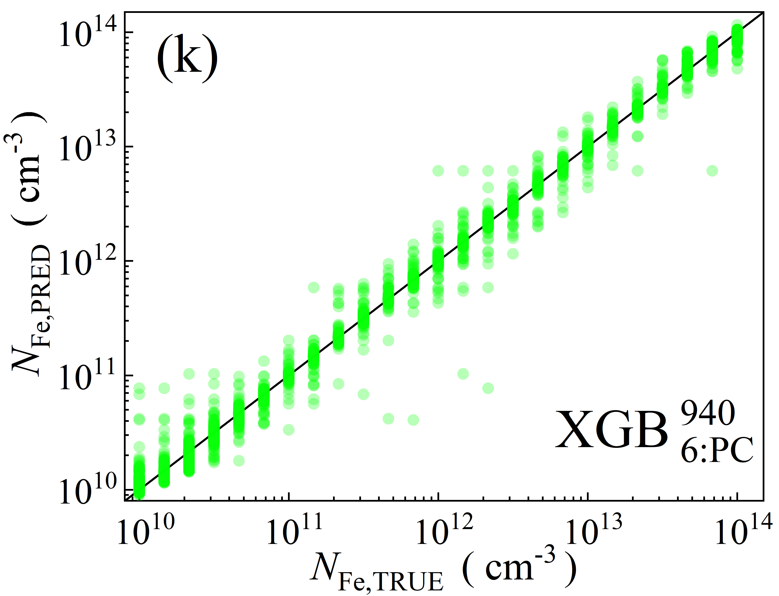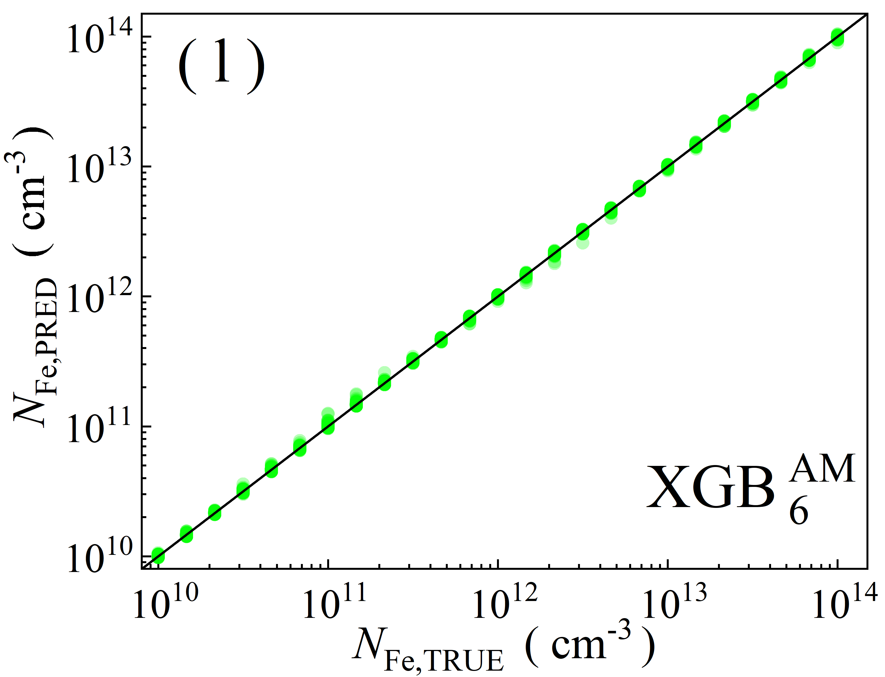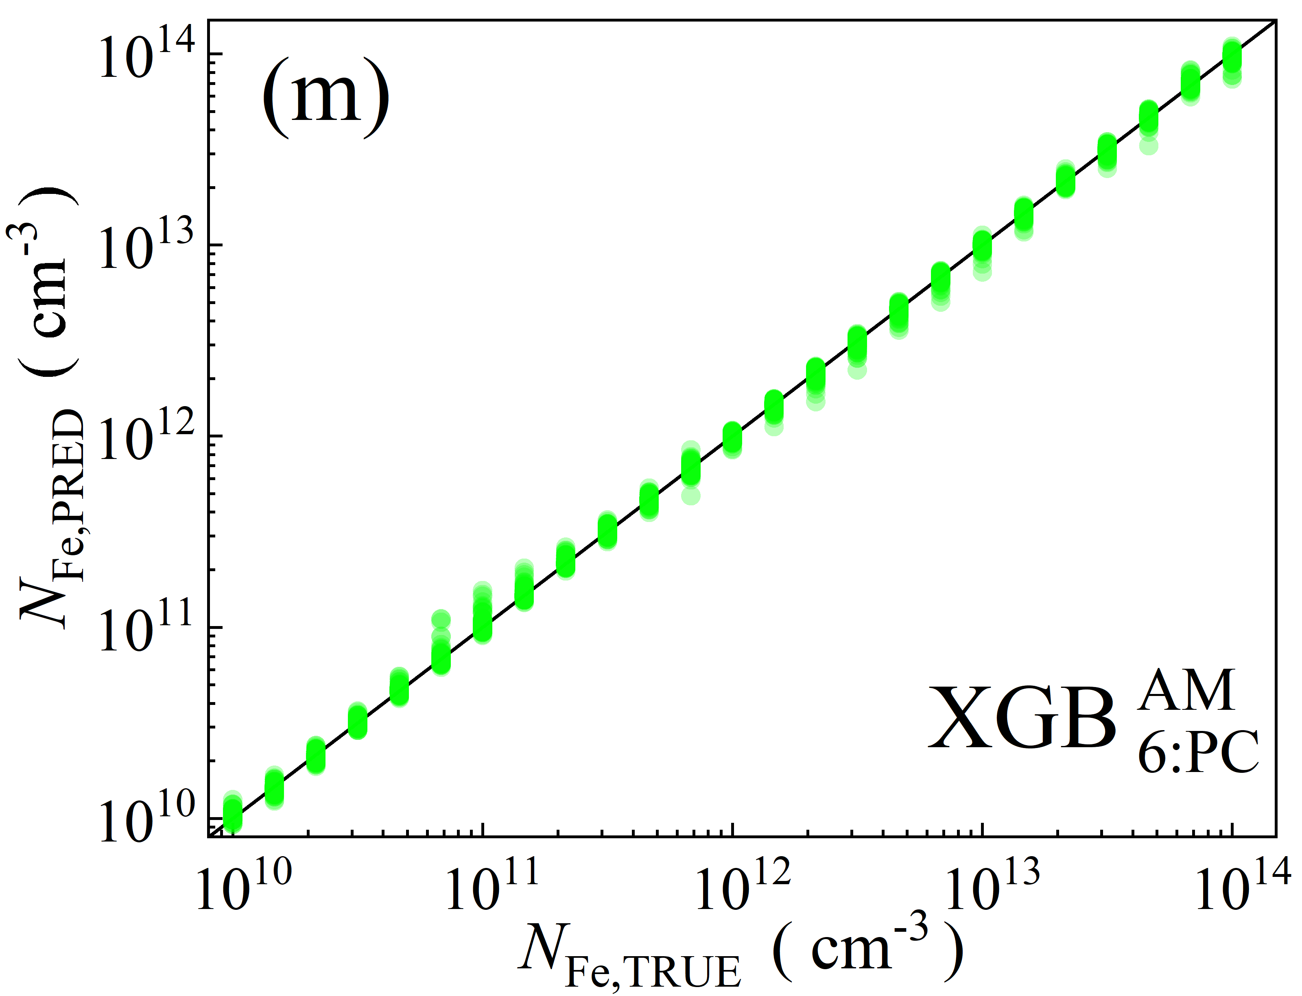

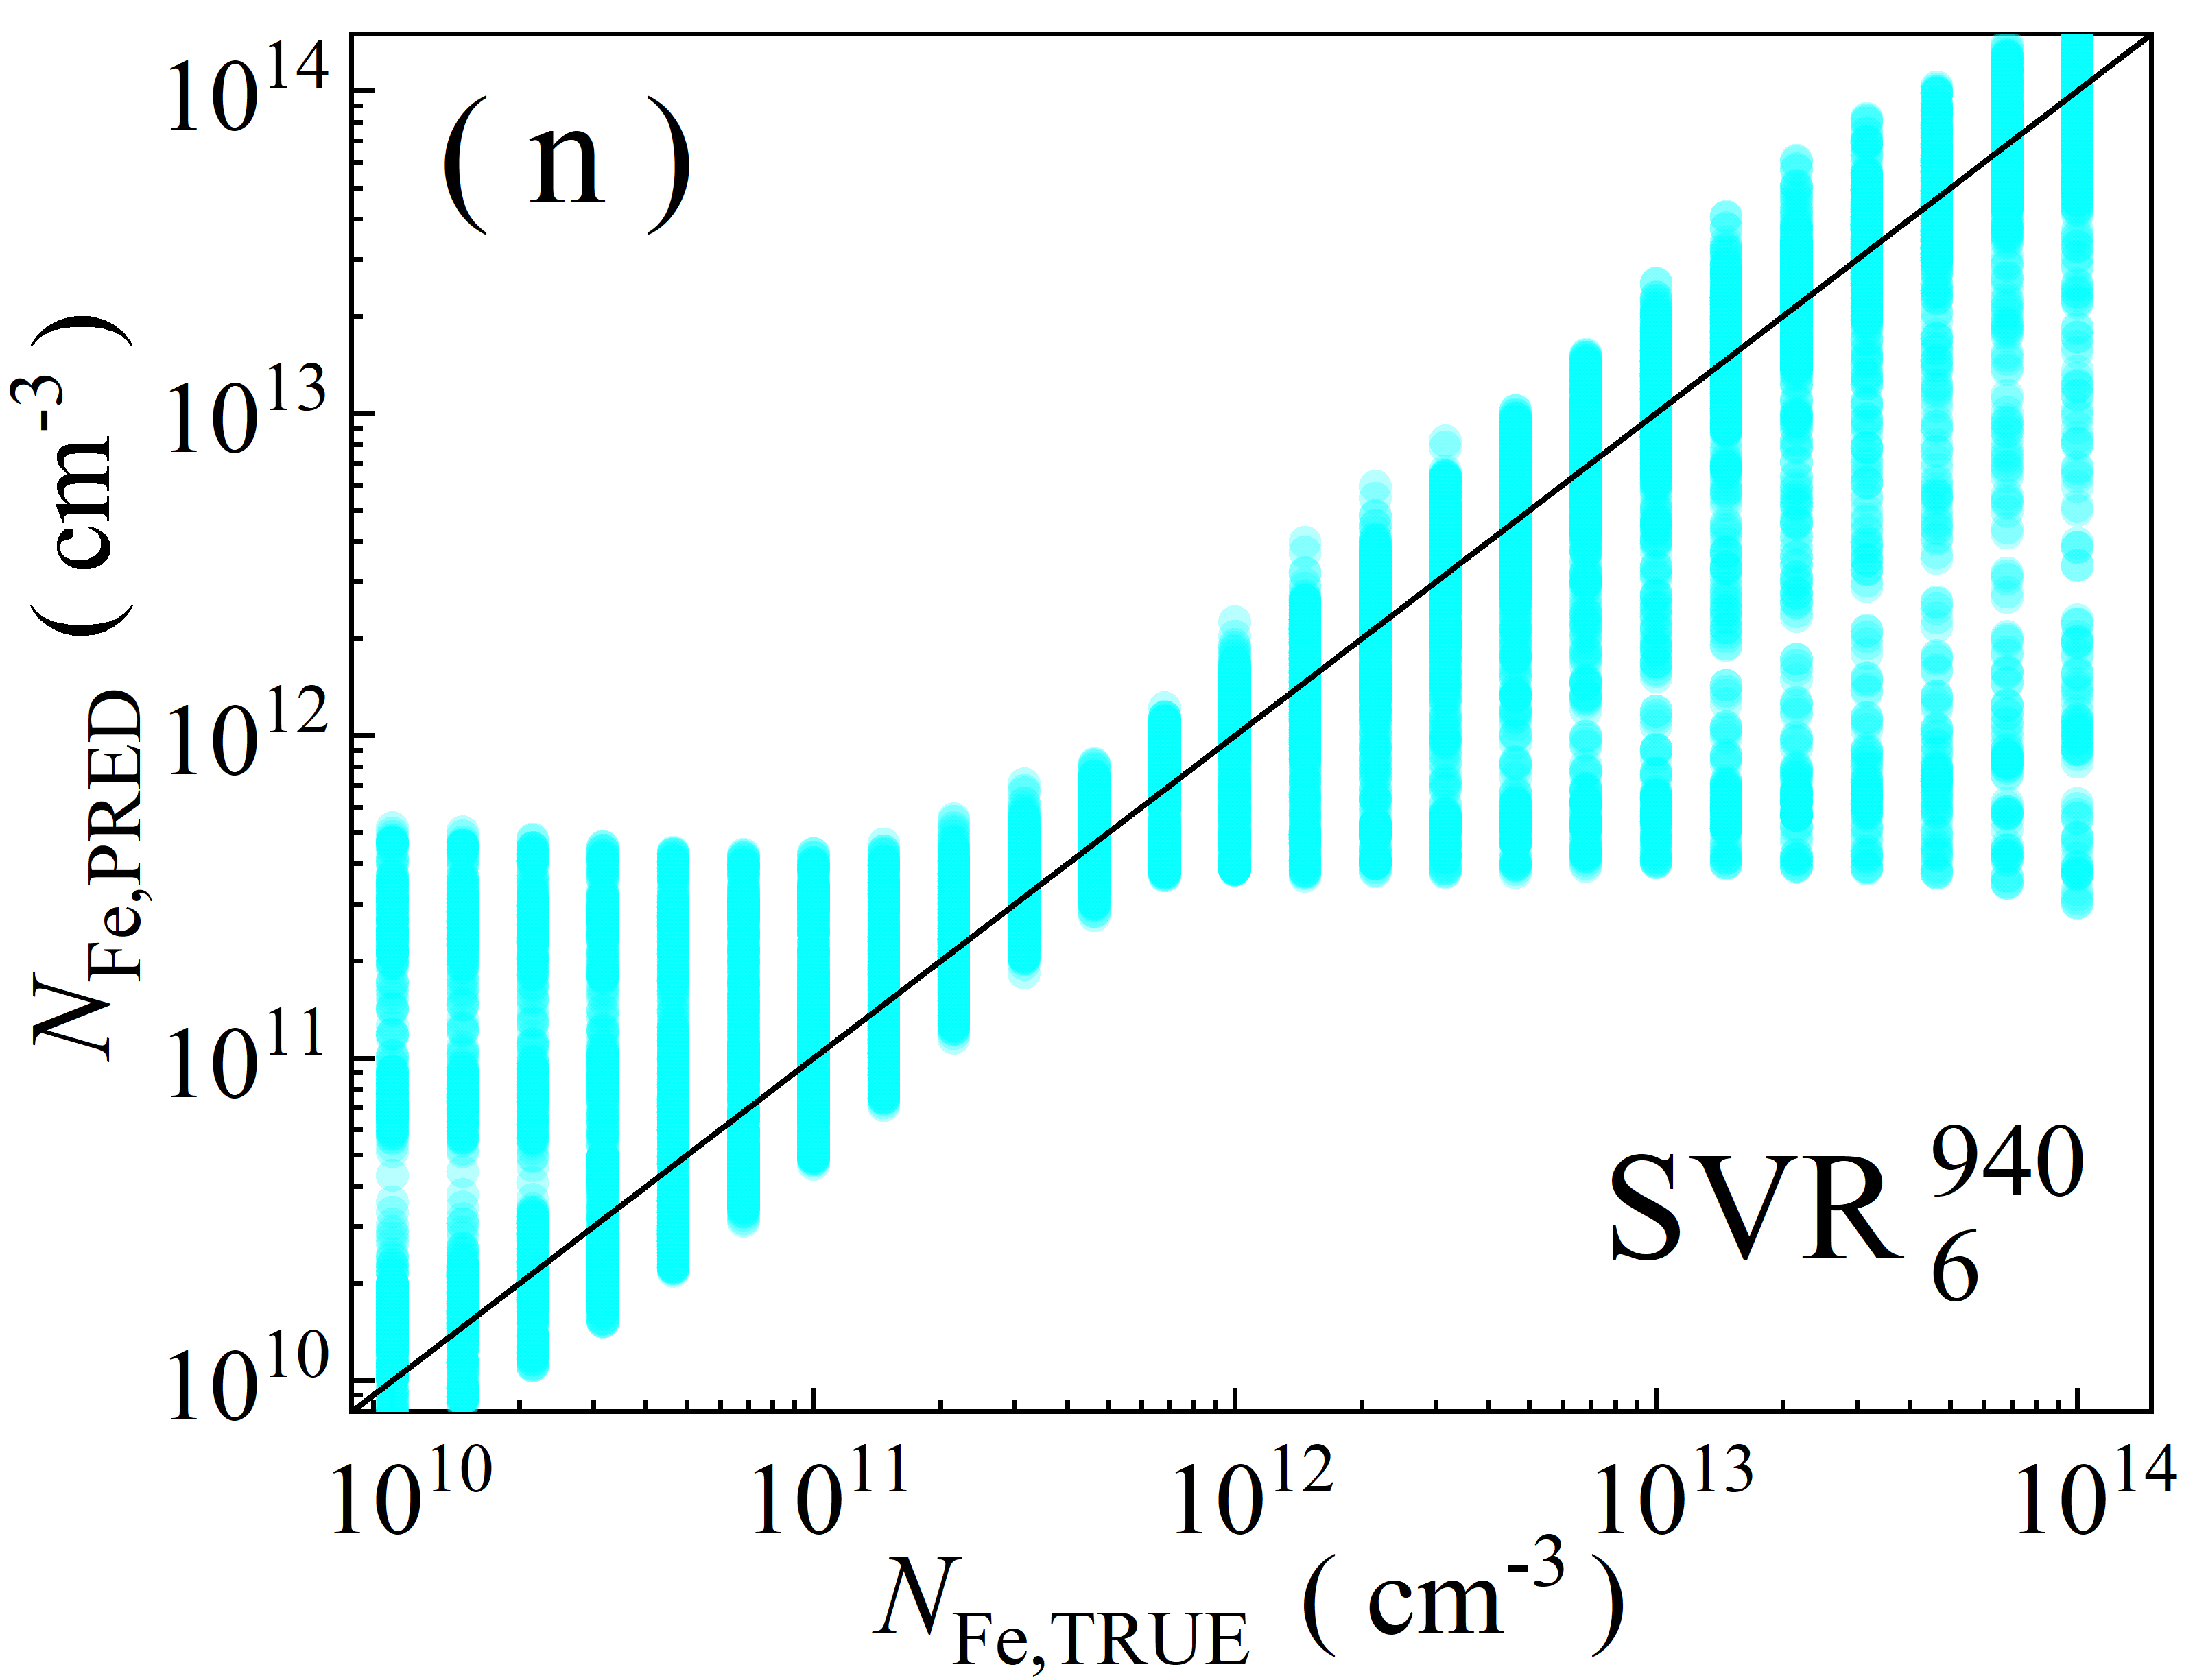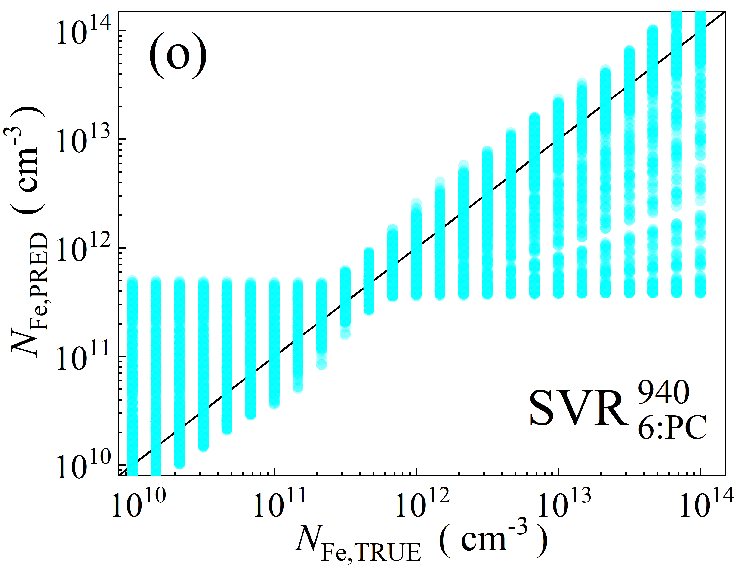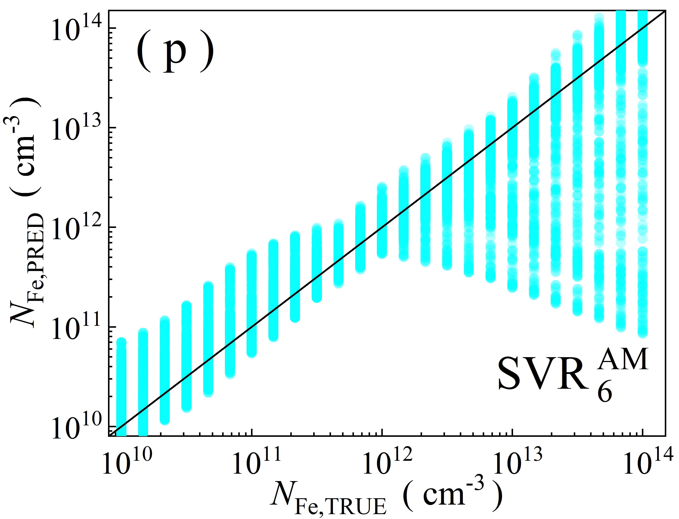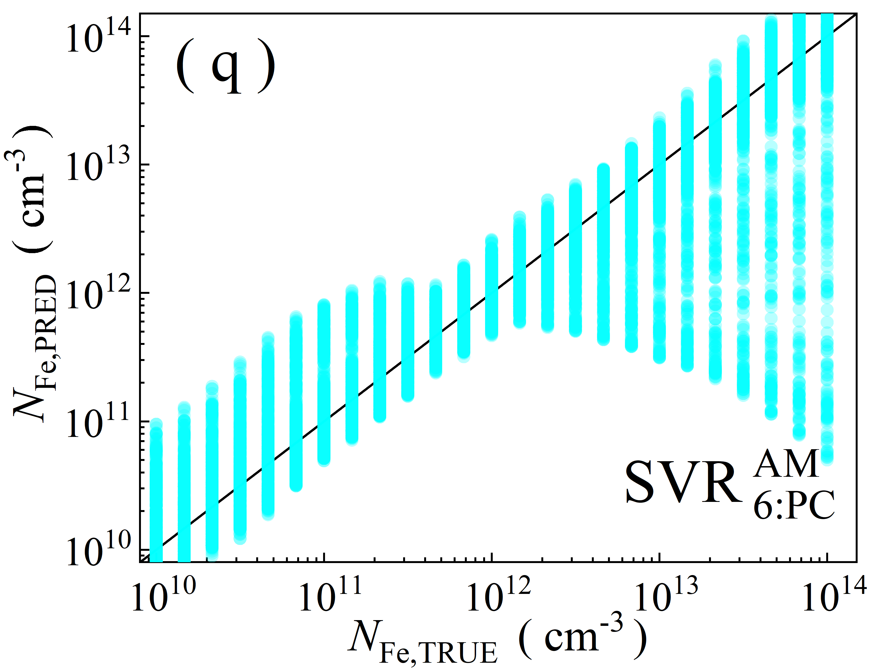

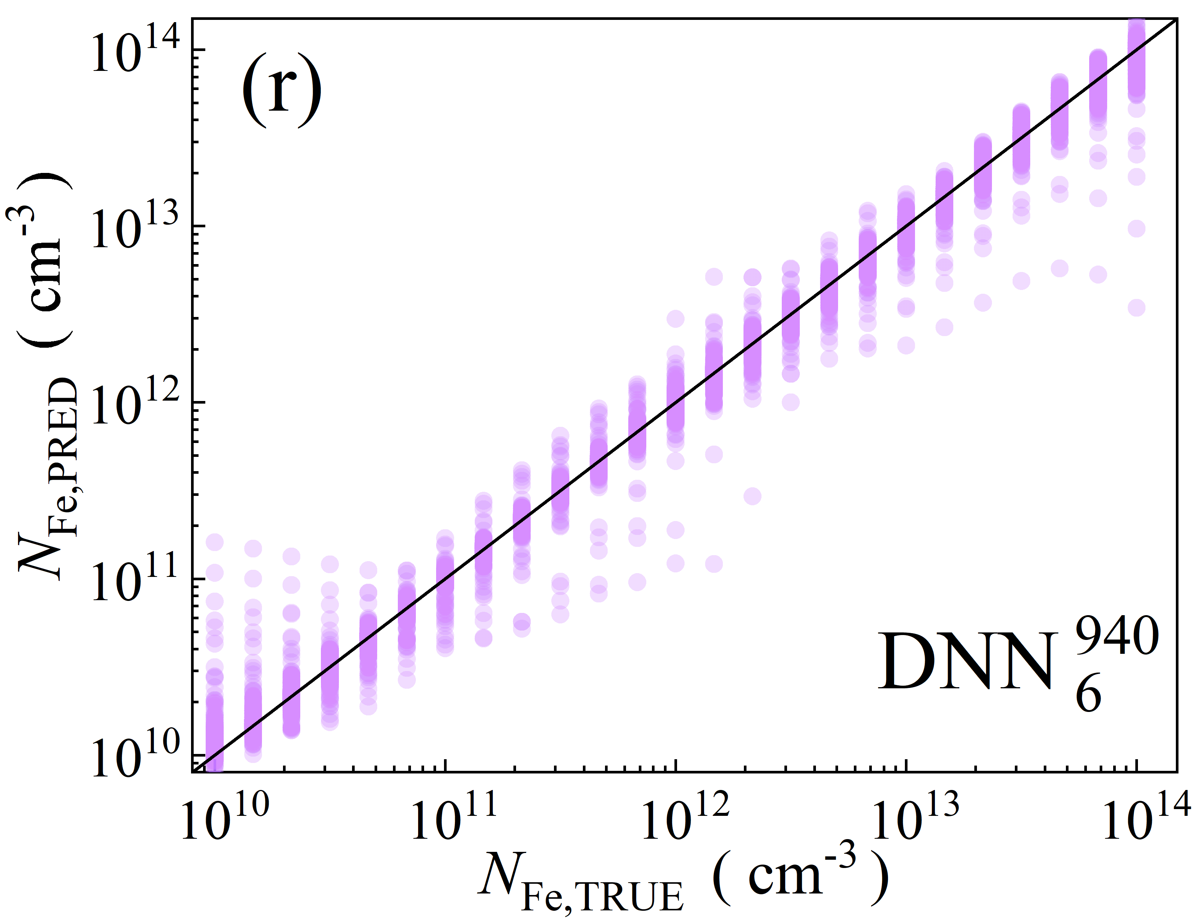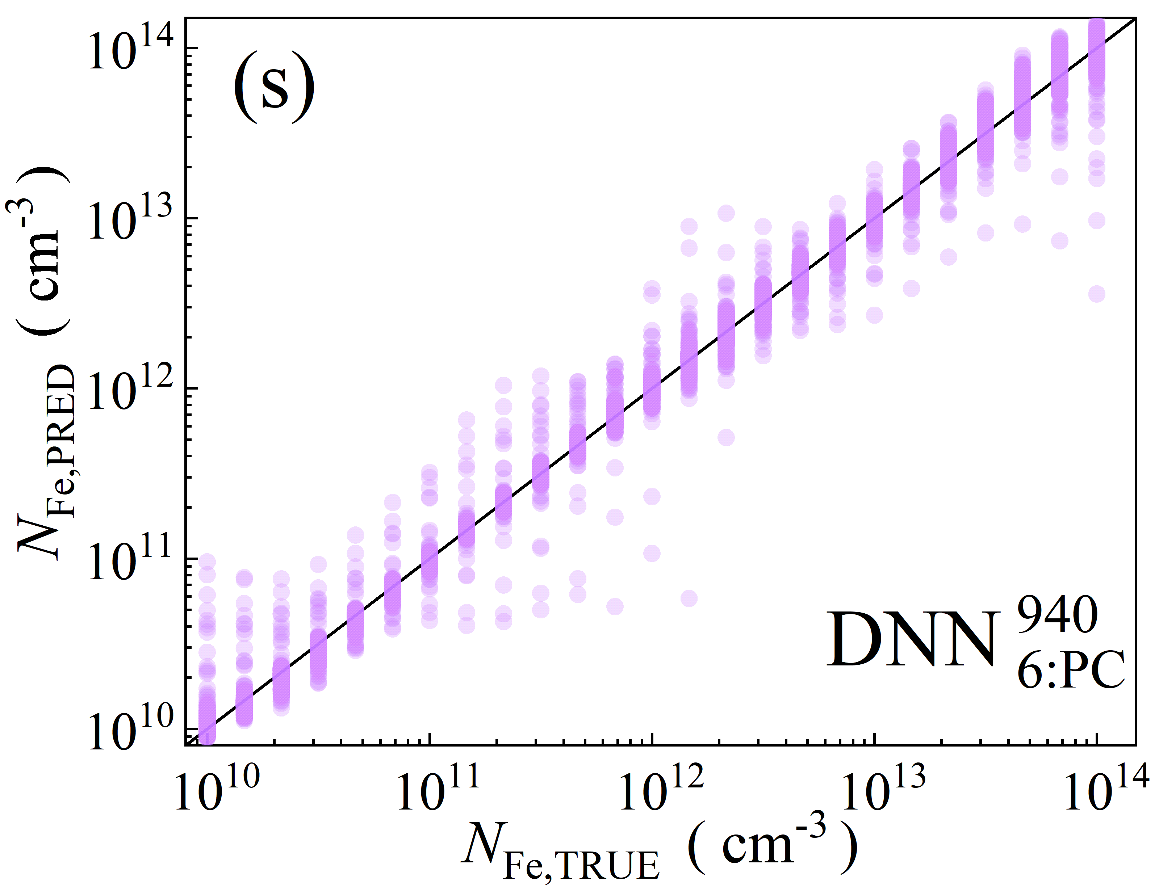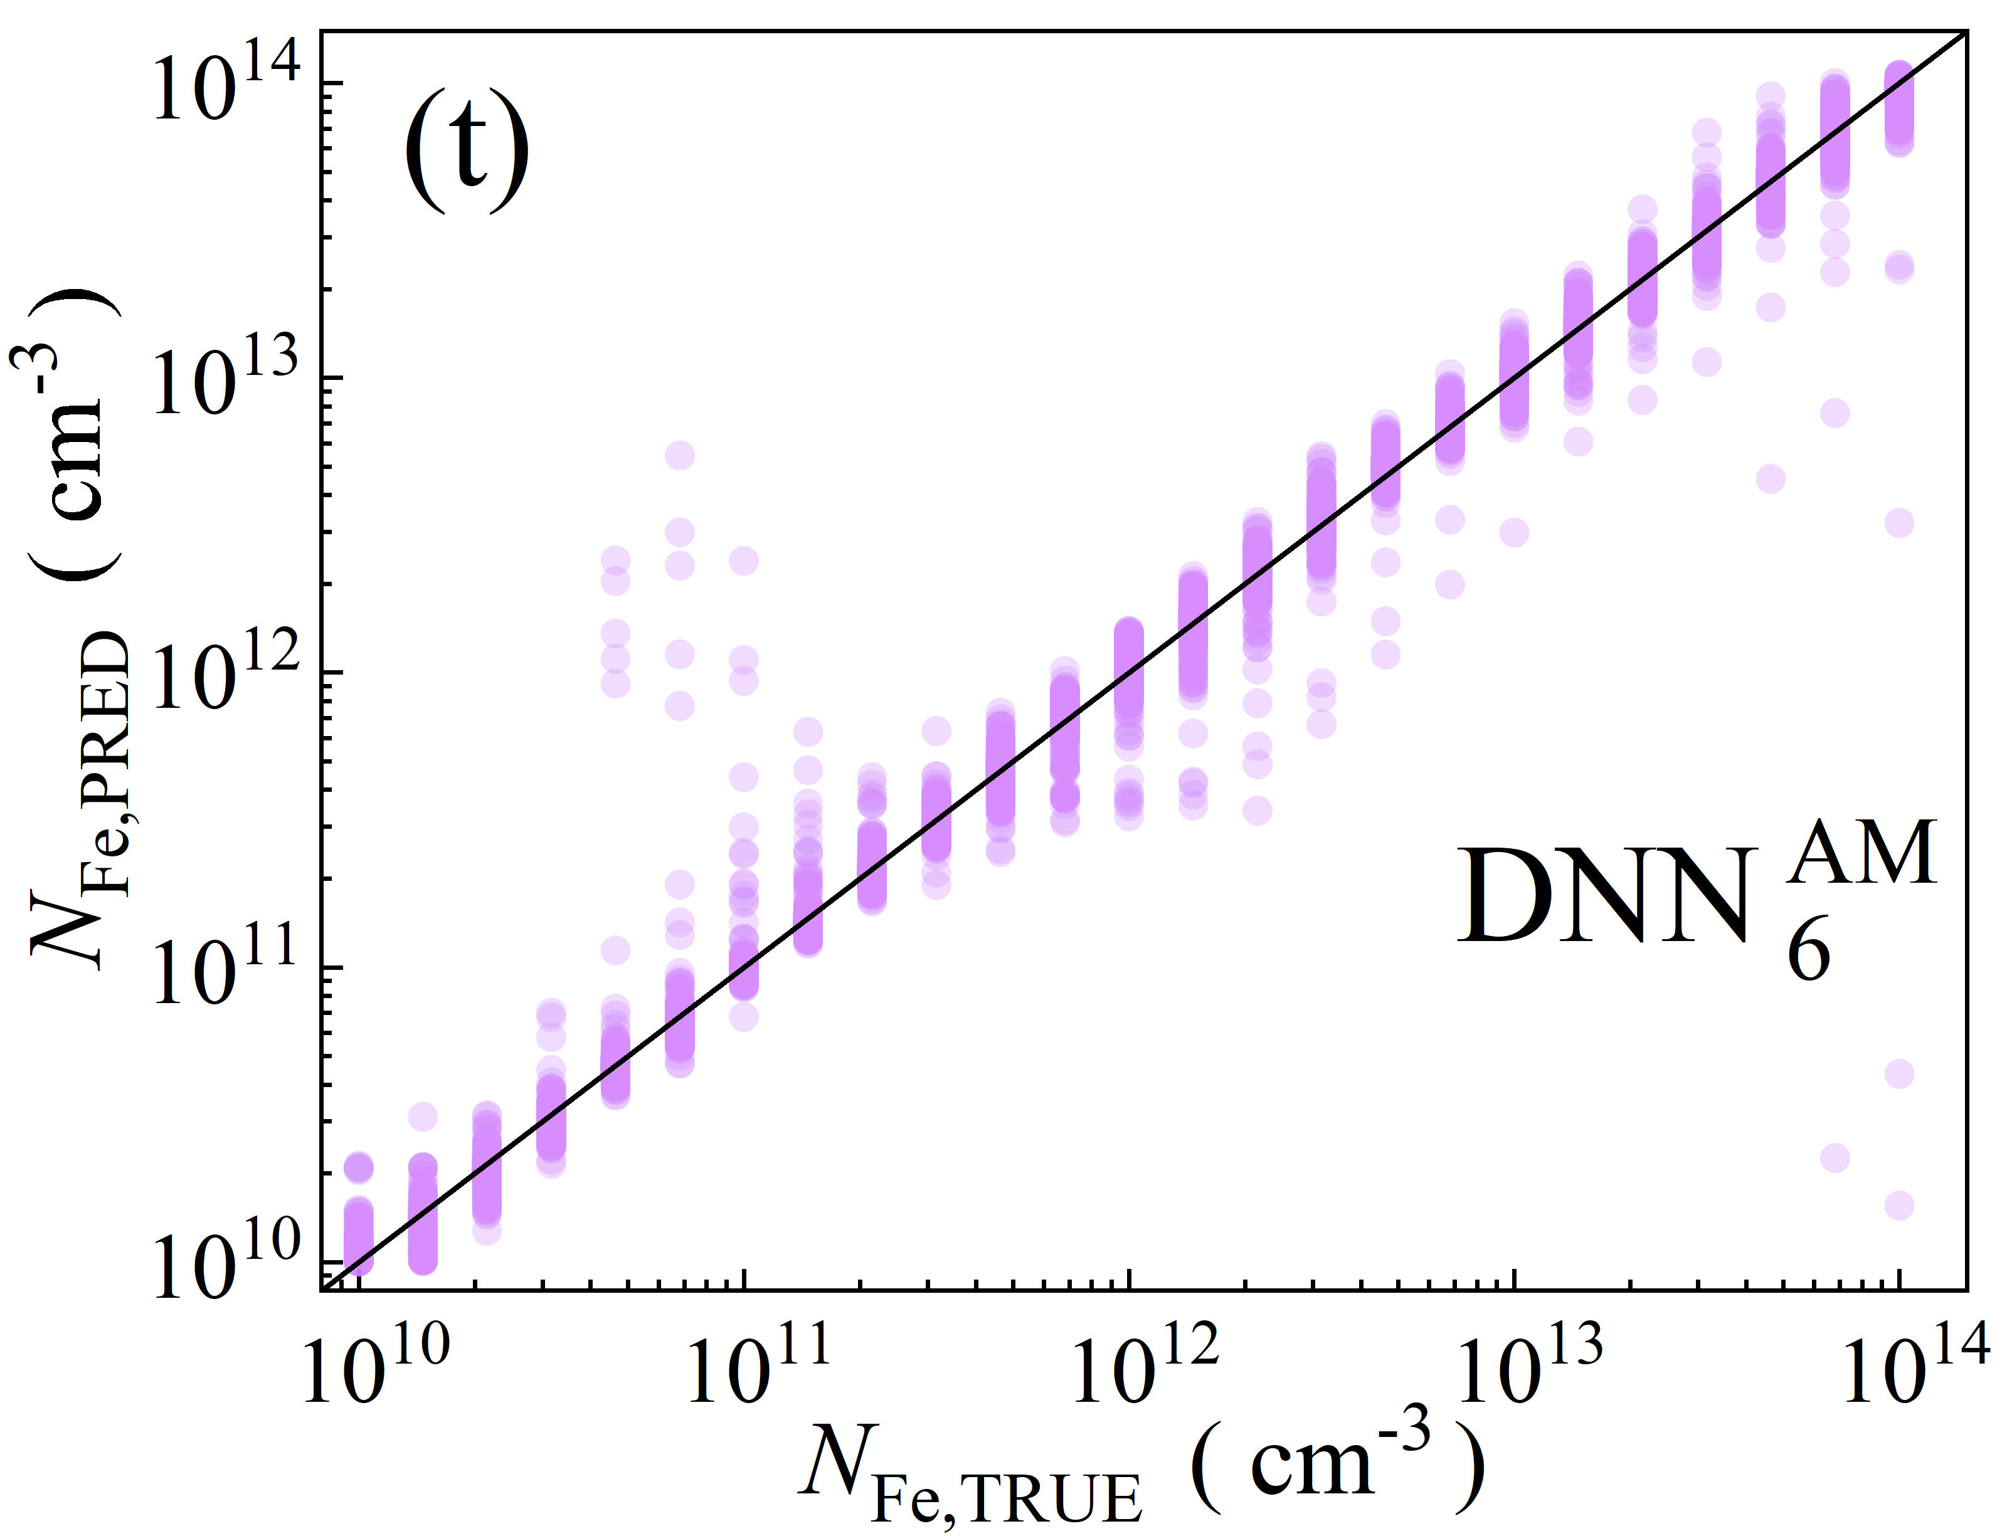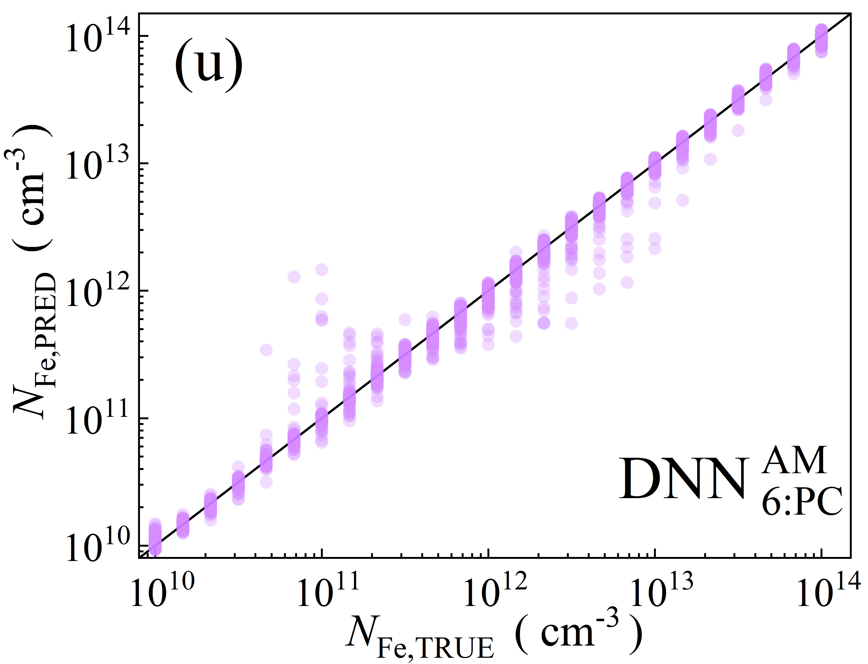

Fig.S5. Scatter plots of the iron concentrations between the reference values and ML predicted values for training phase in the case of 6D features. ML algorithms: RF (a-d), GB (e-i), XGB (j-m), SVR (n-q), DNN (r-u). The data are obtained for monochromatic (a, b, e, f, j, k, n, o, r, s) and AM1.5 (c, d, h, i, l, m, p, q, t, u) illuminations. PCA was used for the panels b, d, f, i, k, m, o, q, s, and u. The black lines are the identify lines servings as the references.

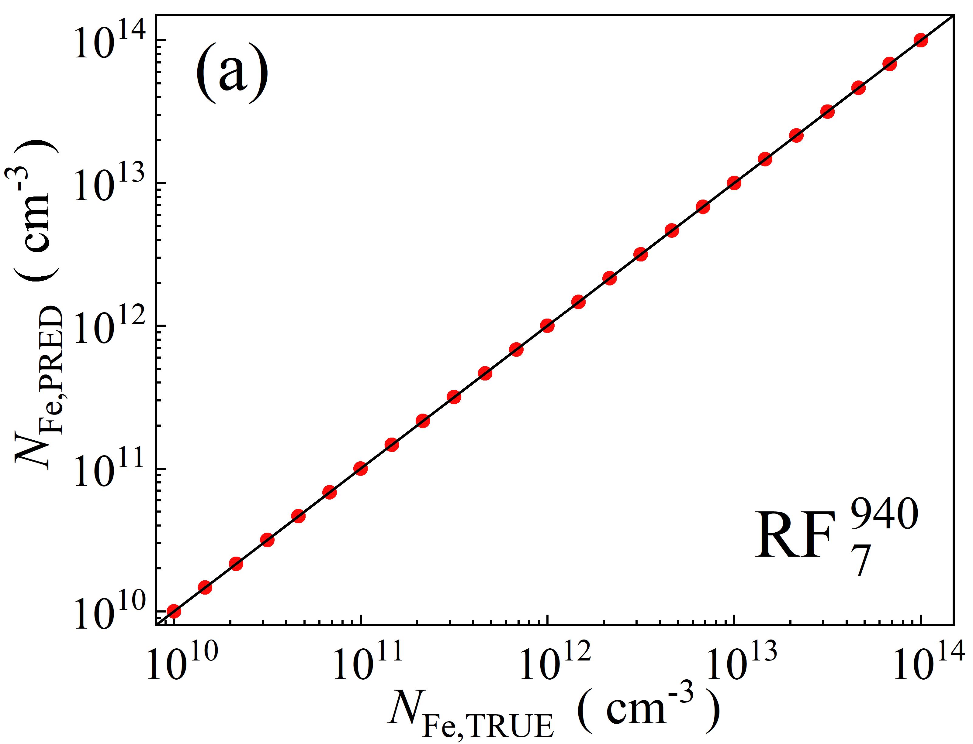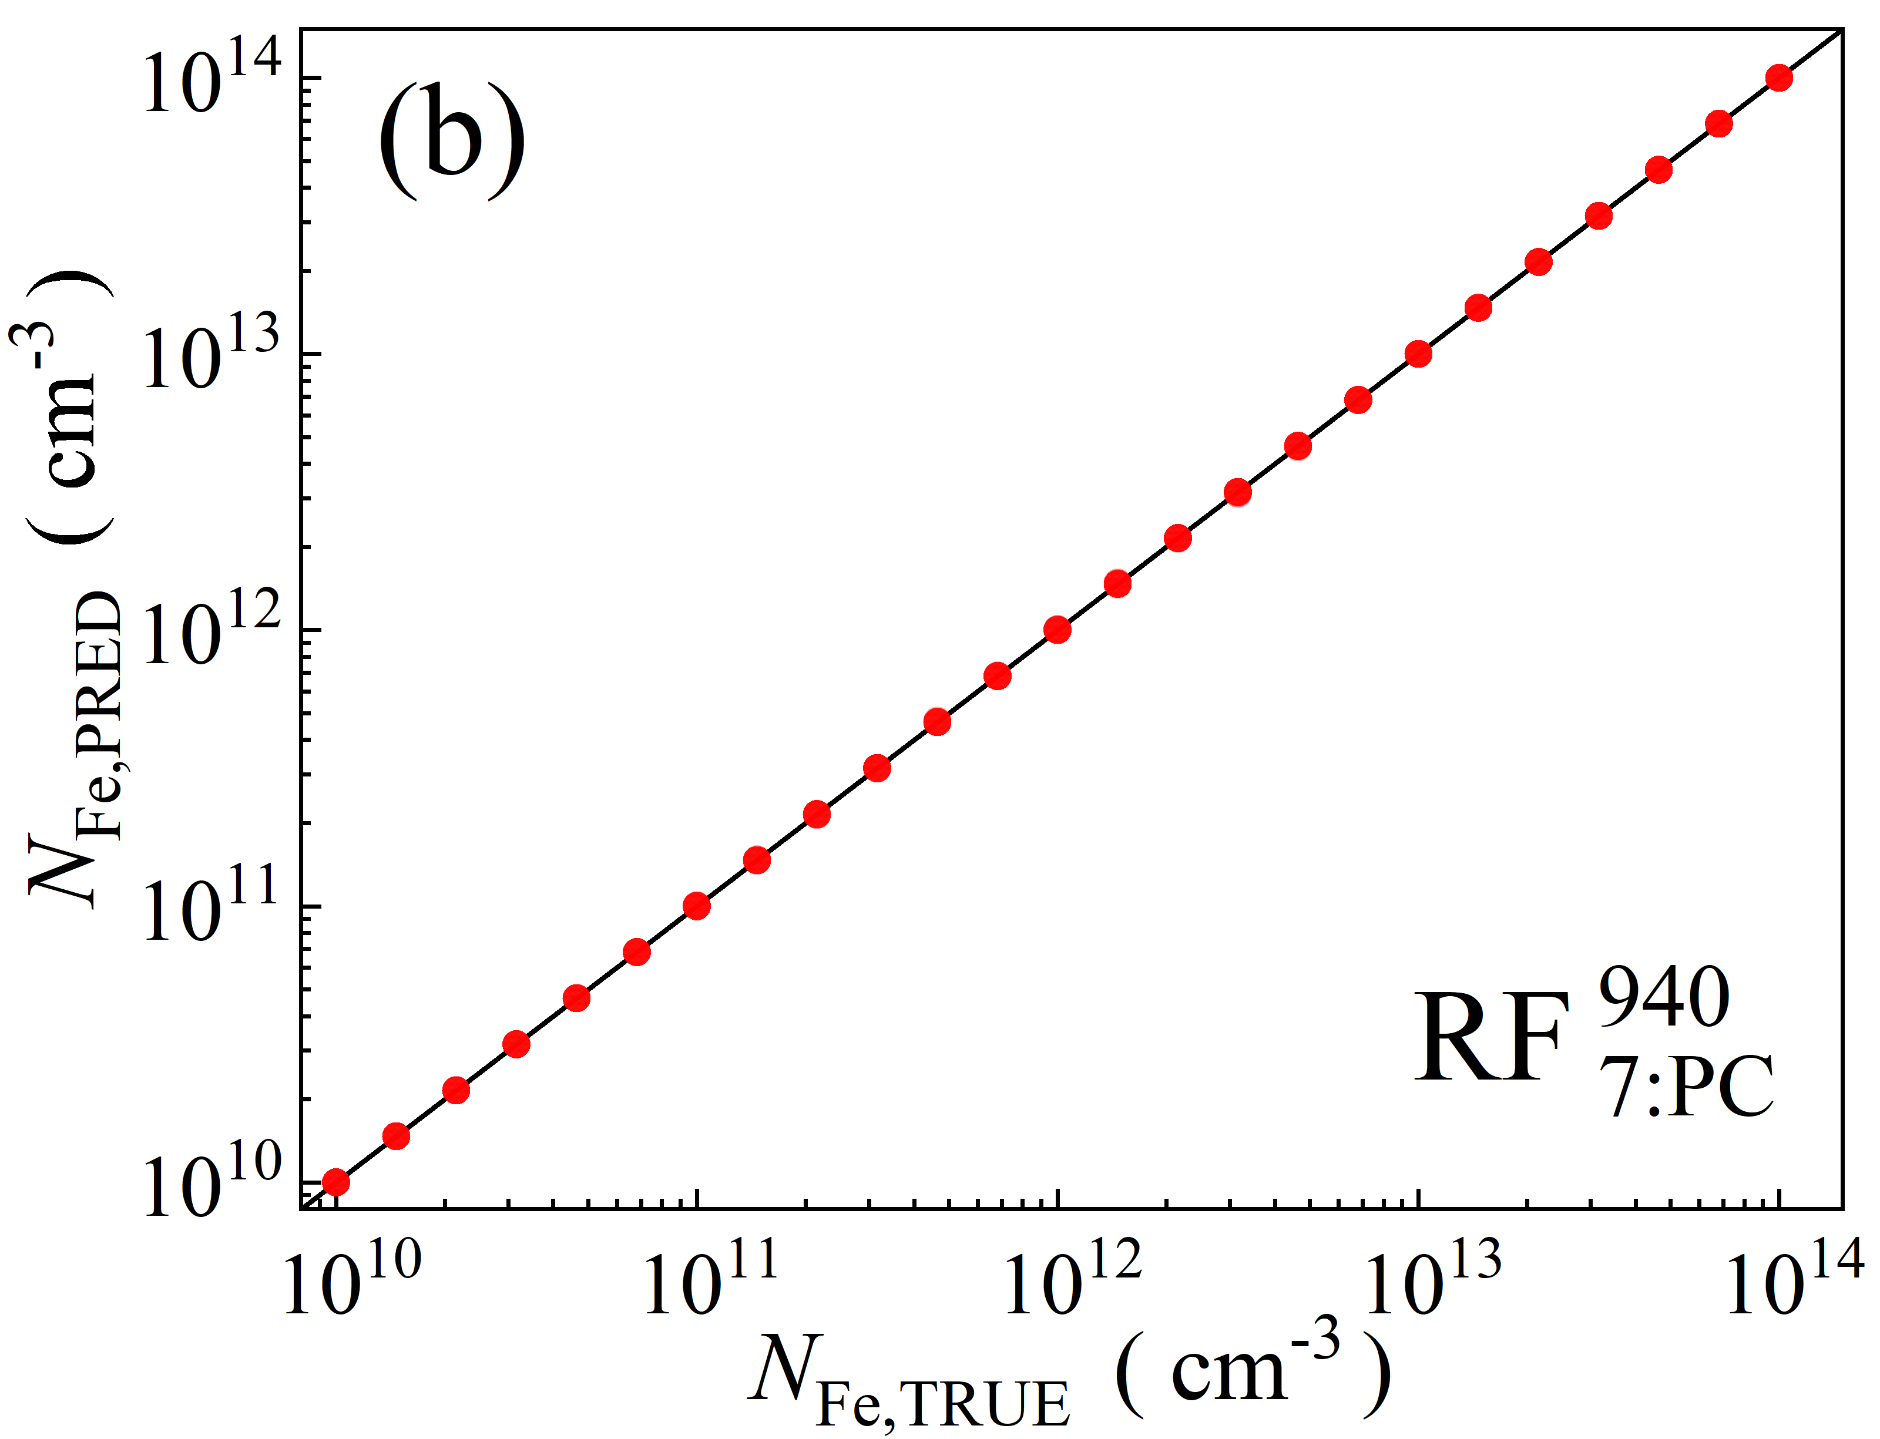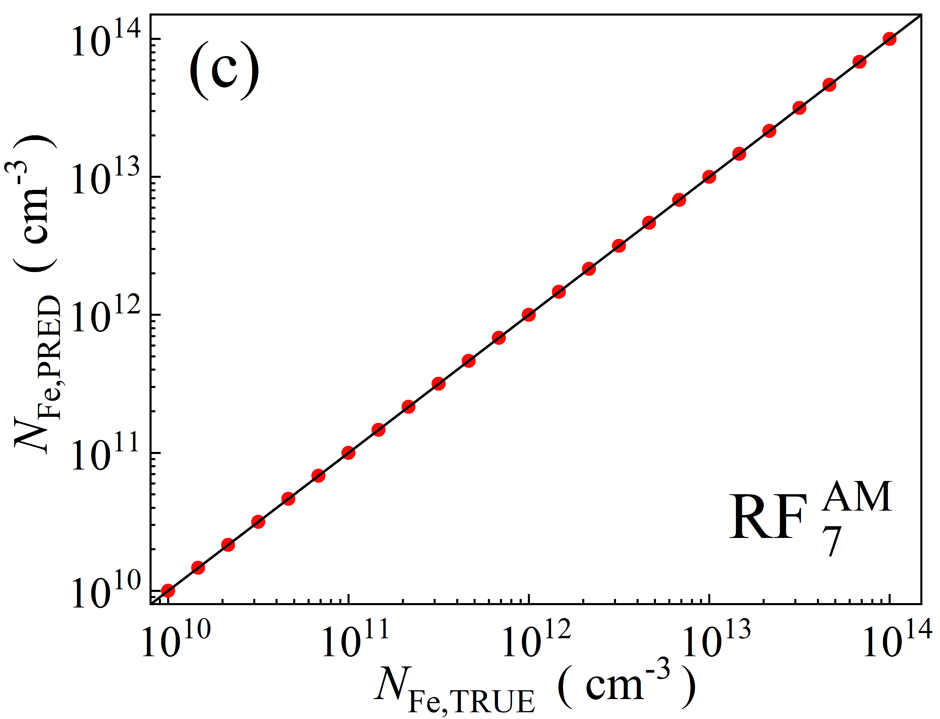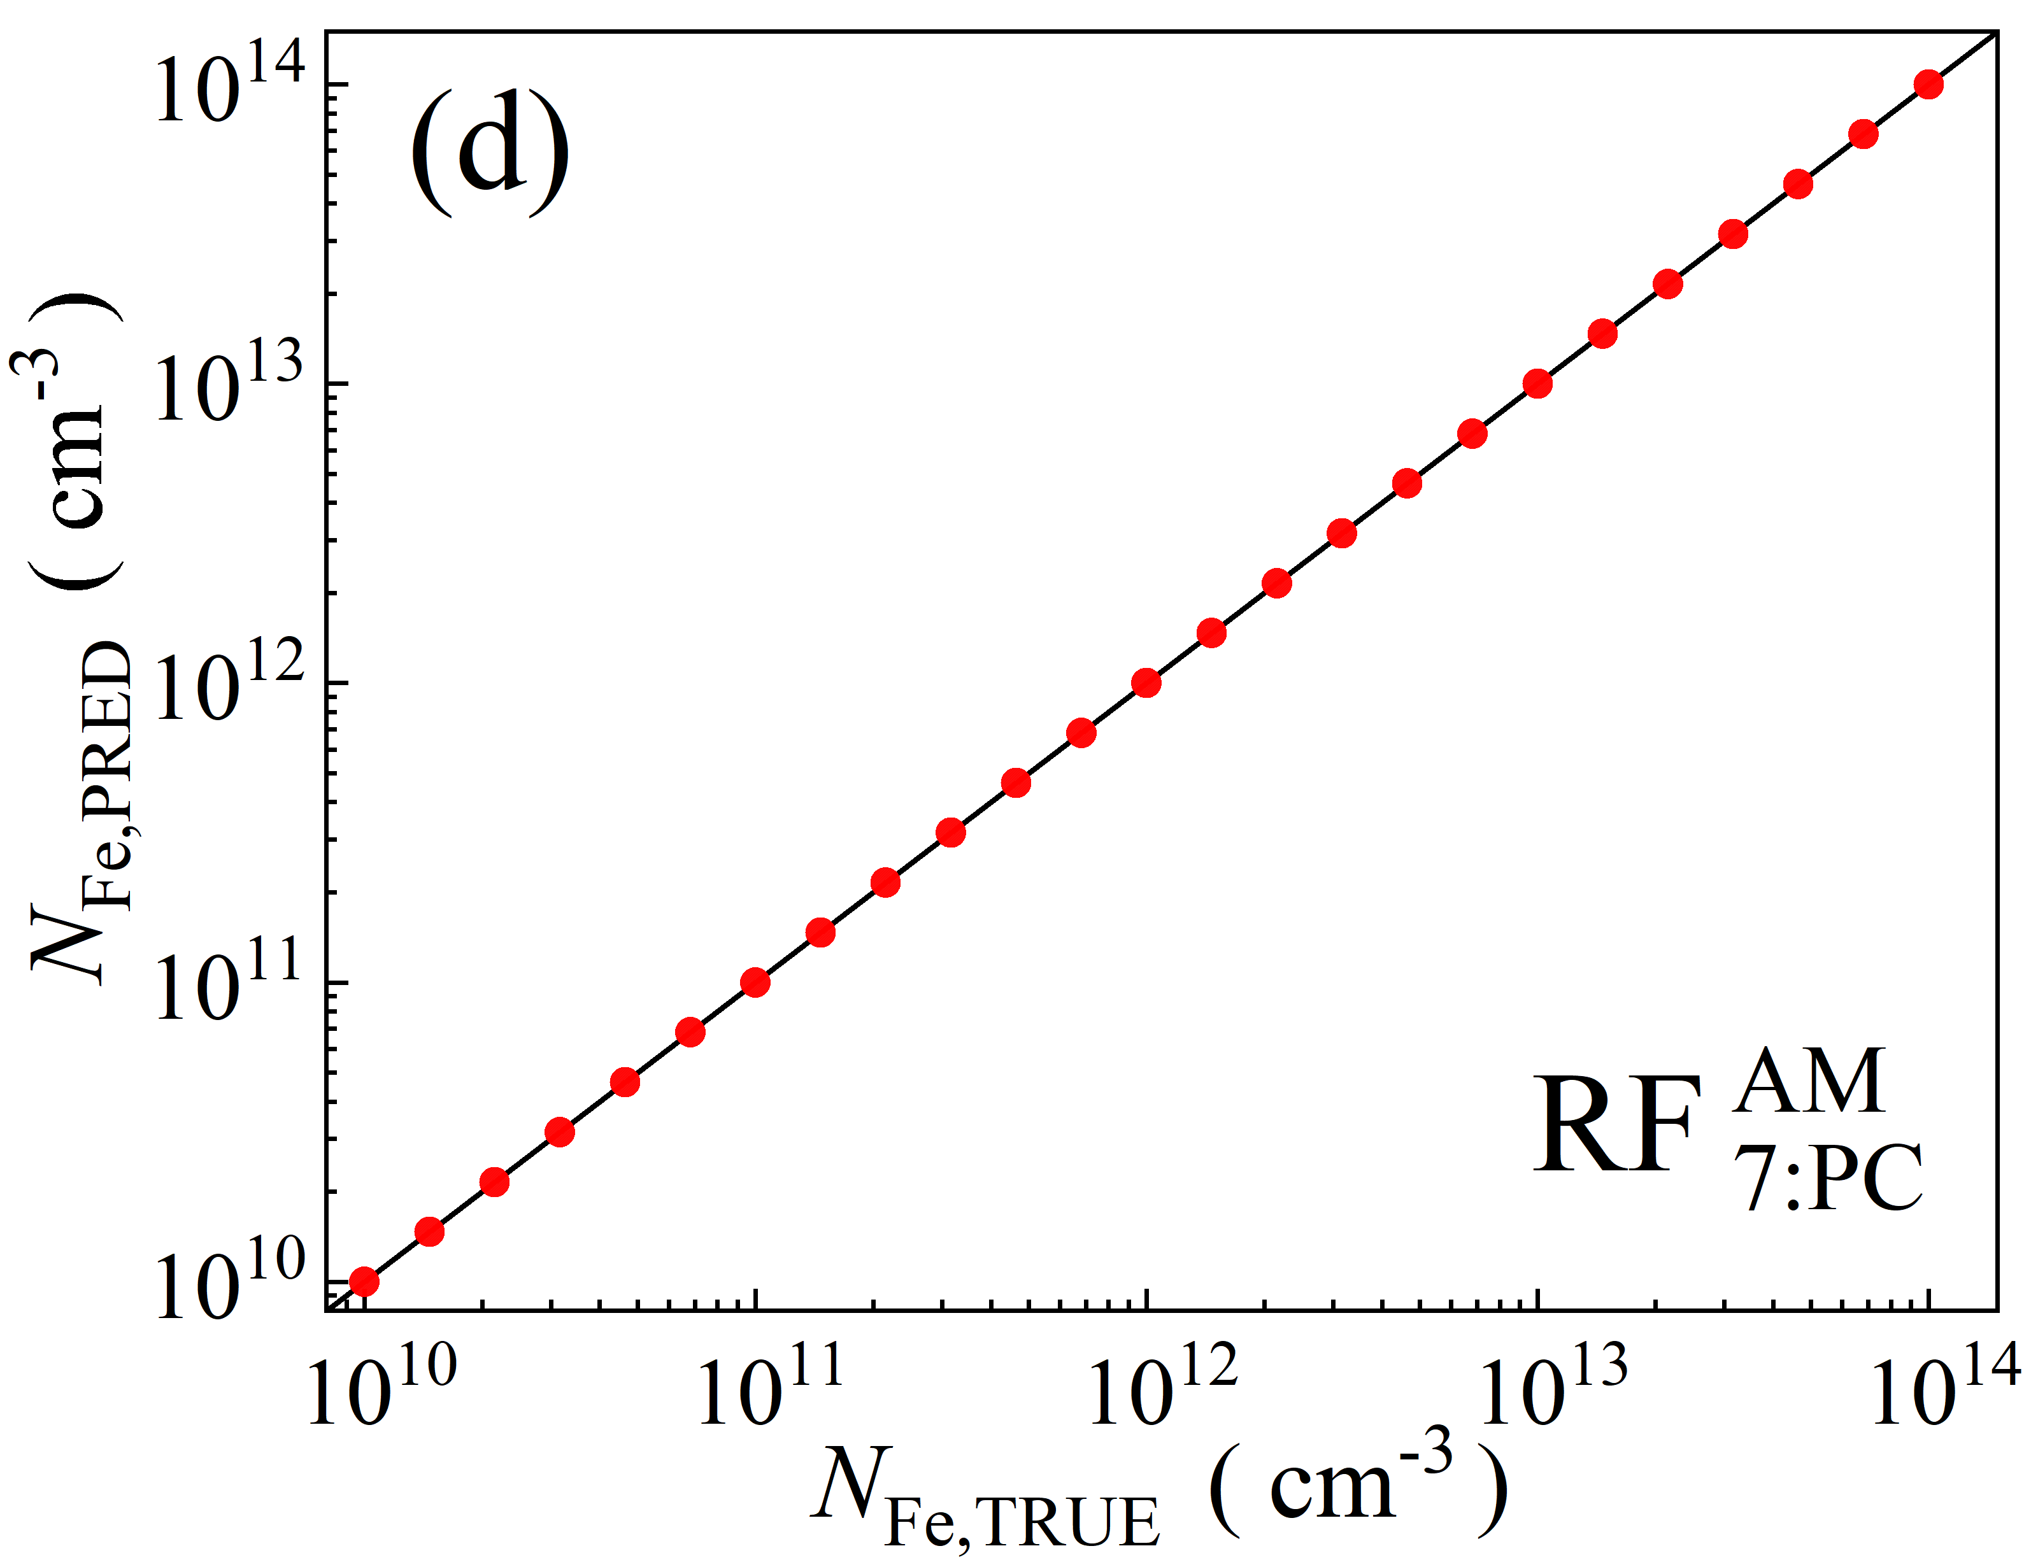

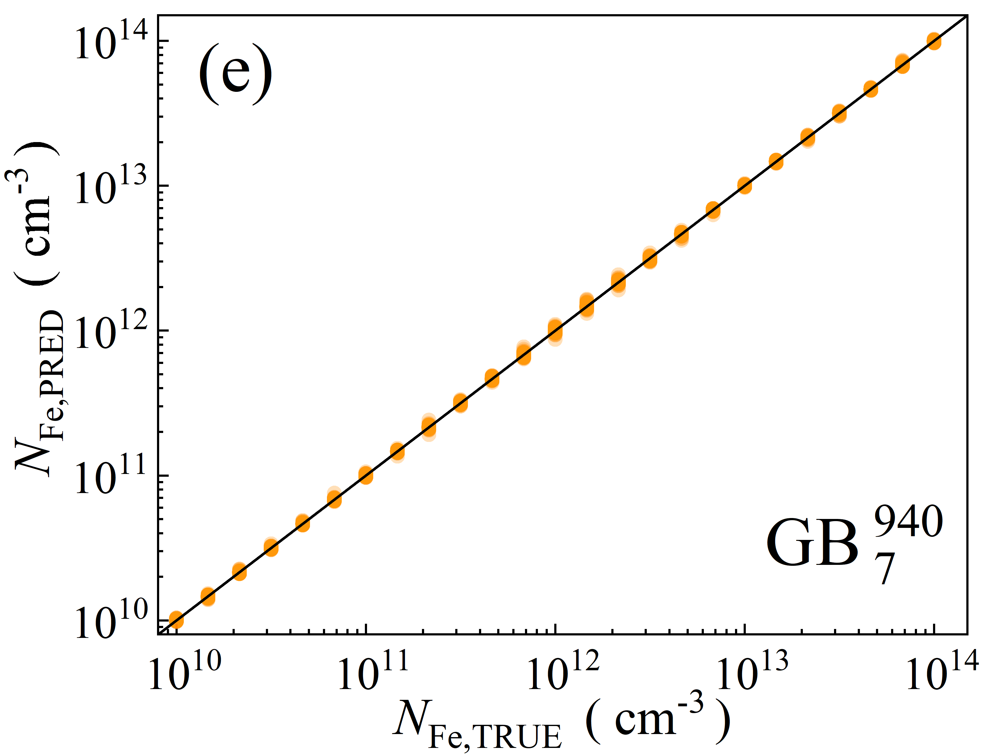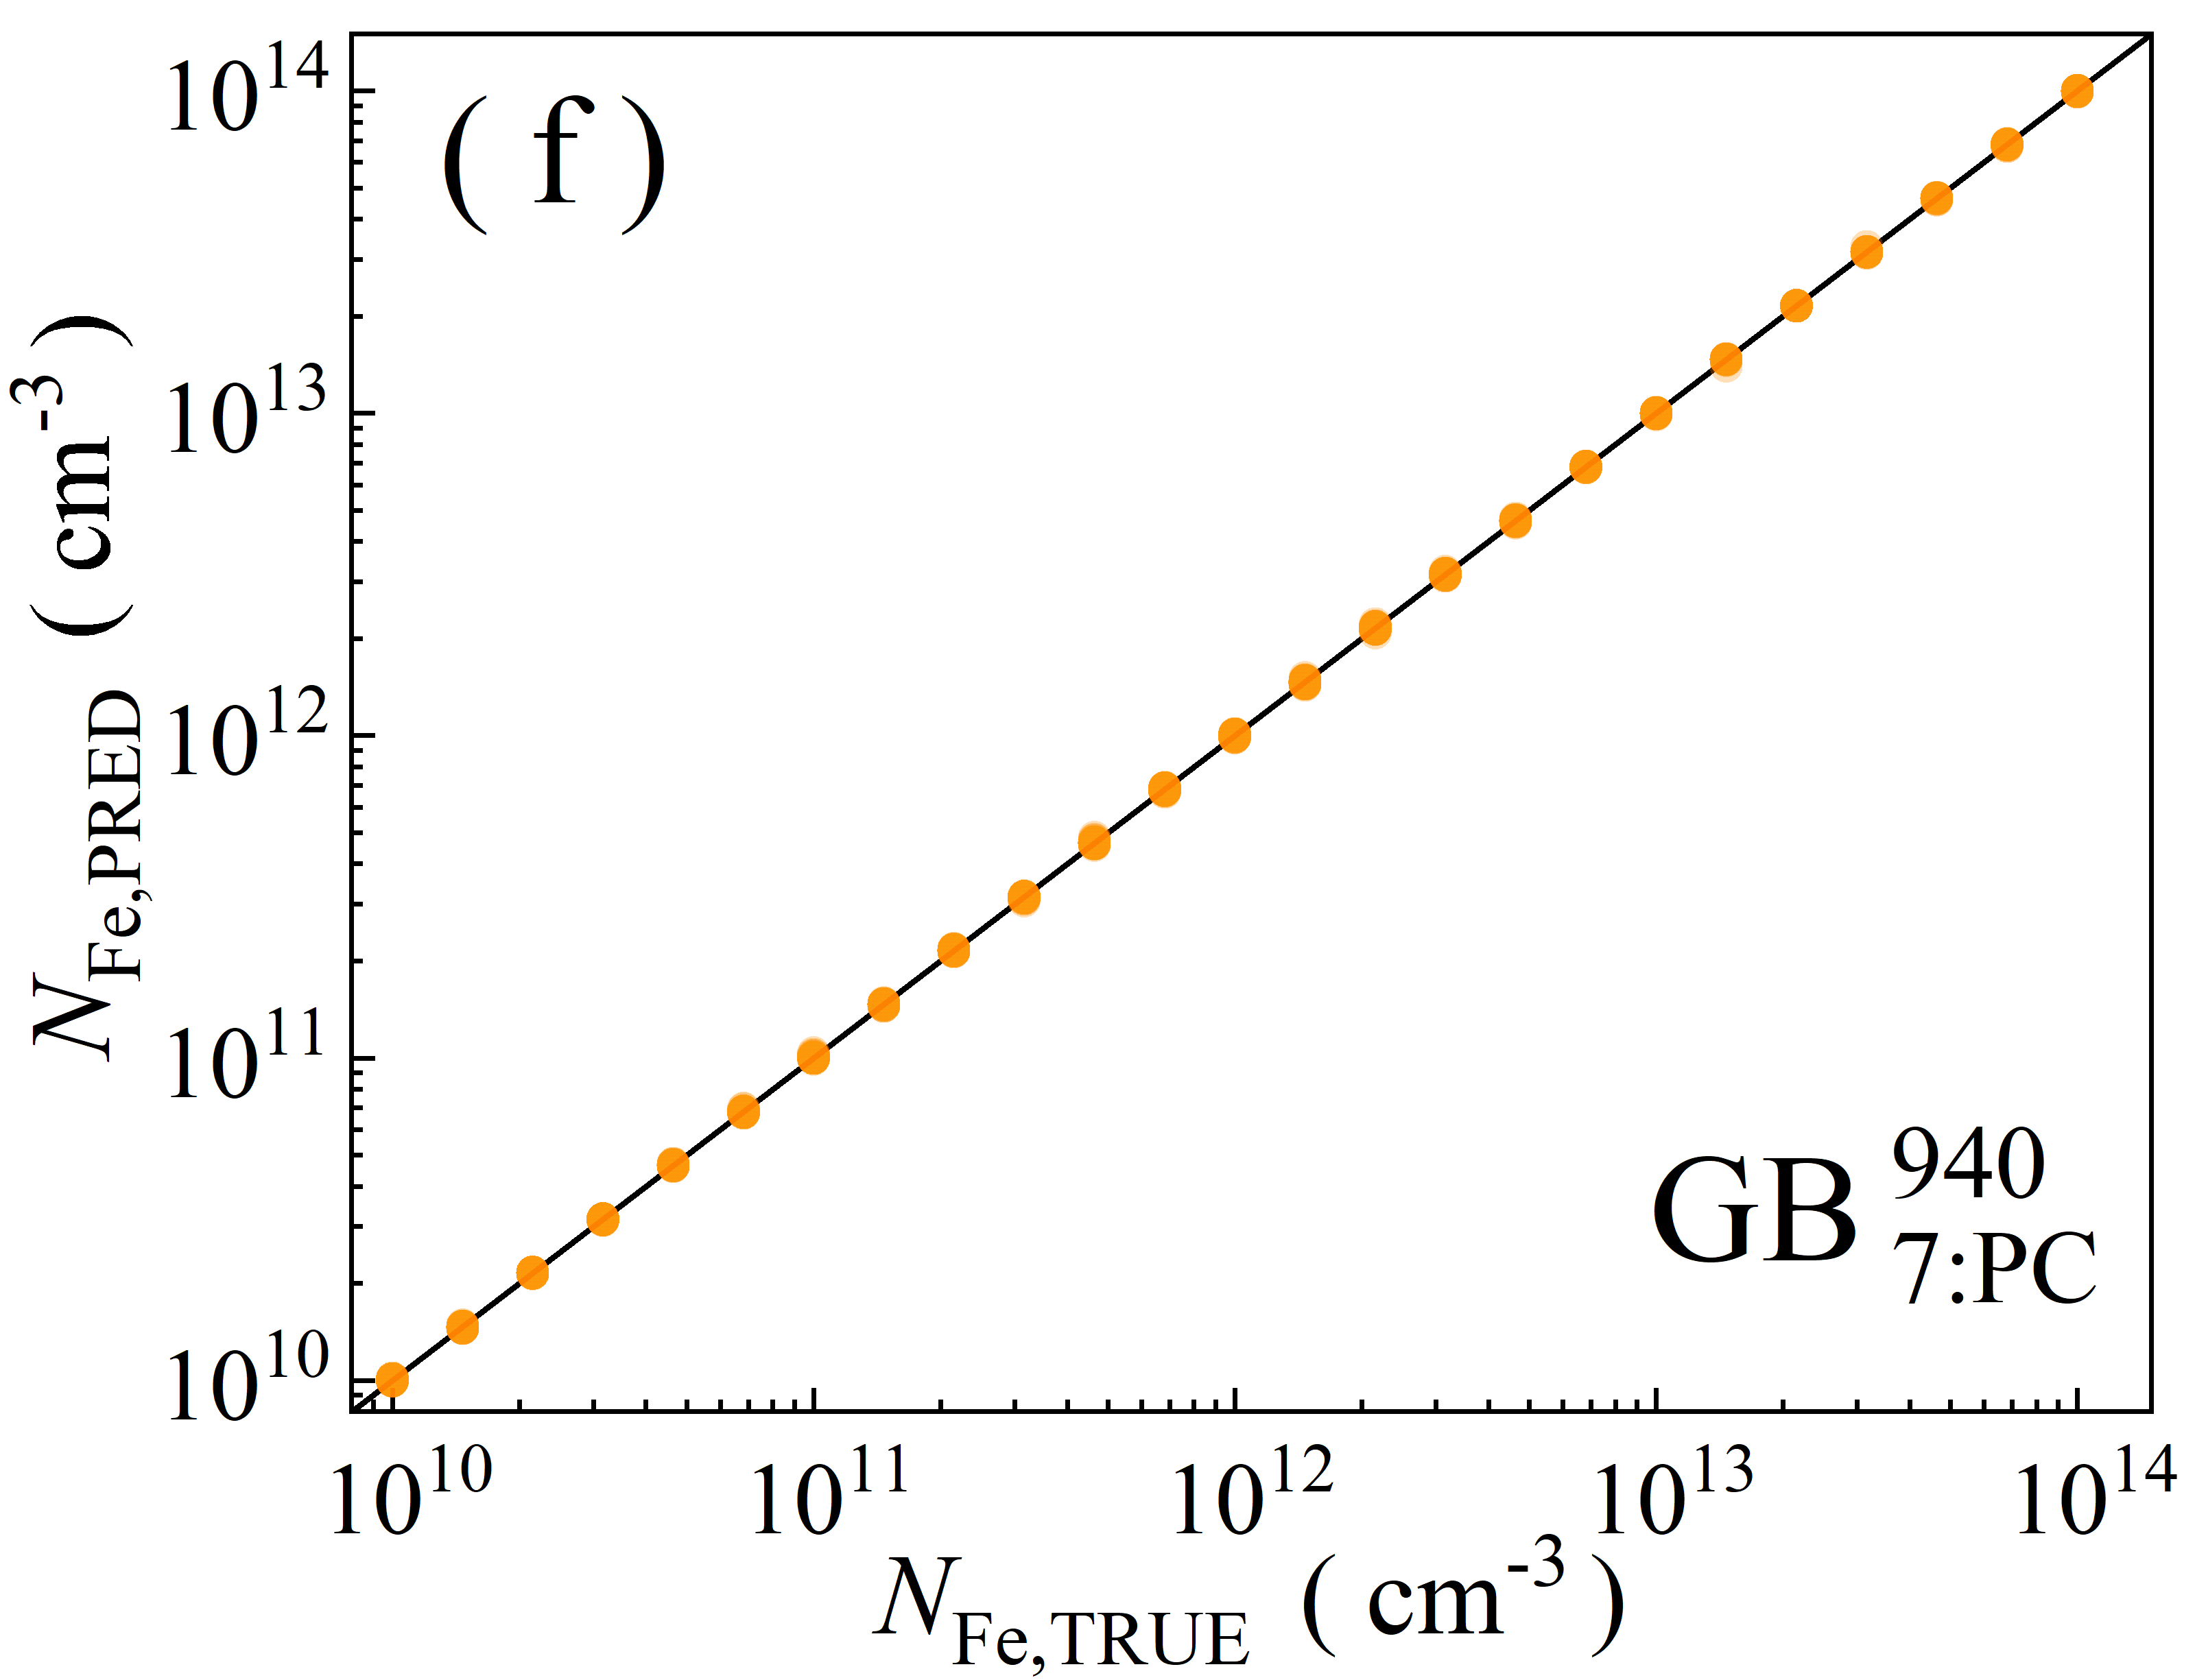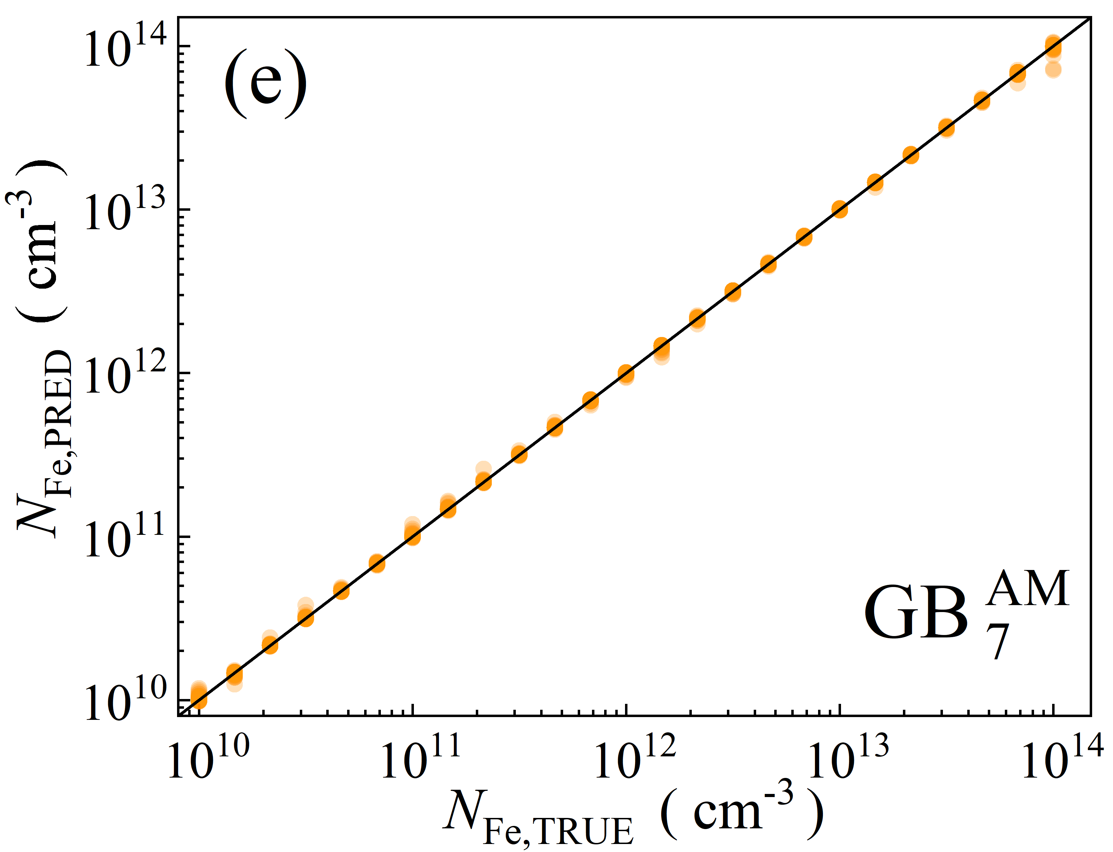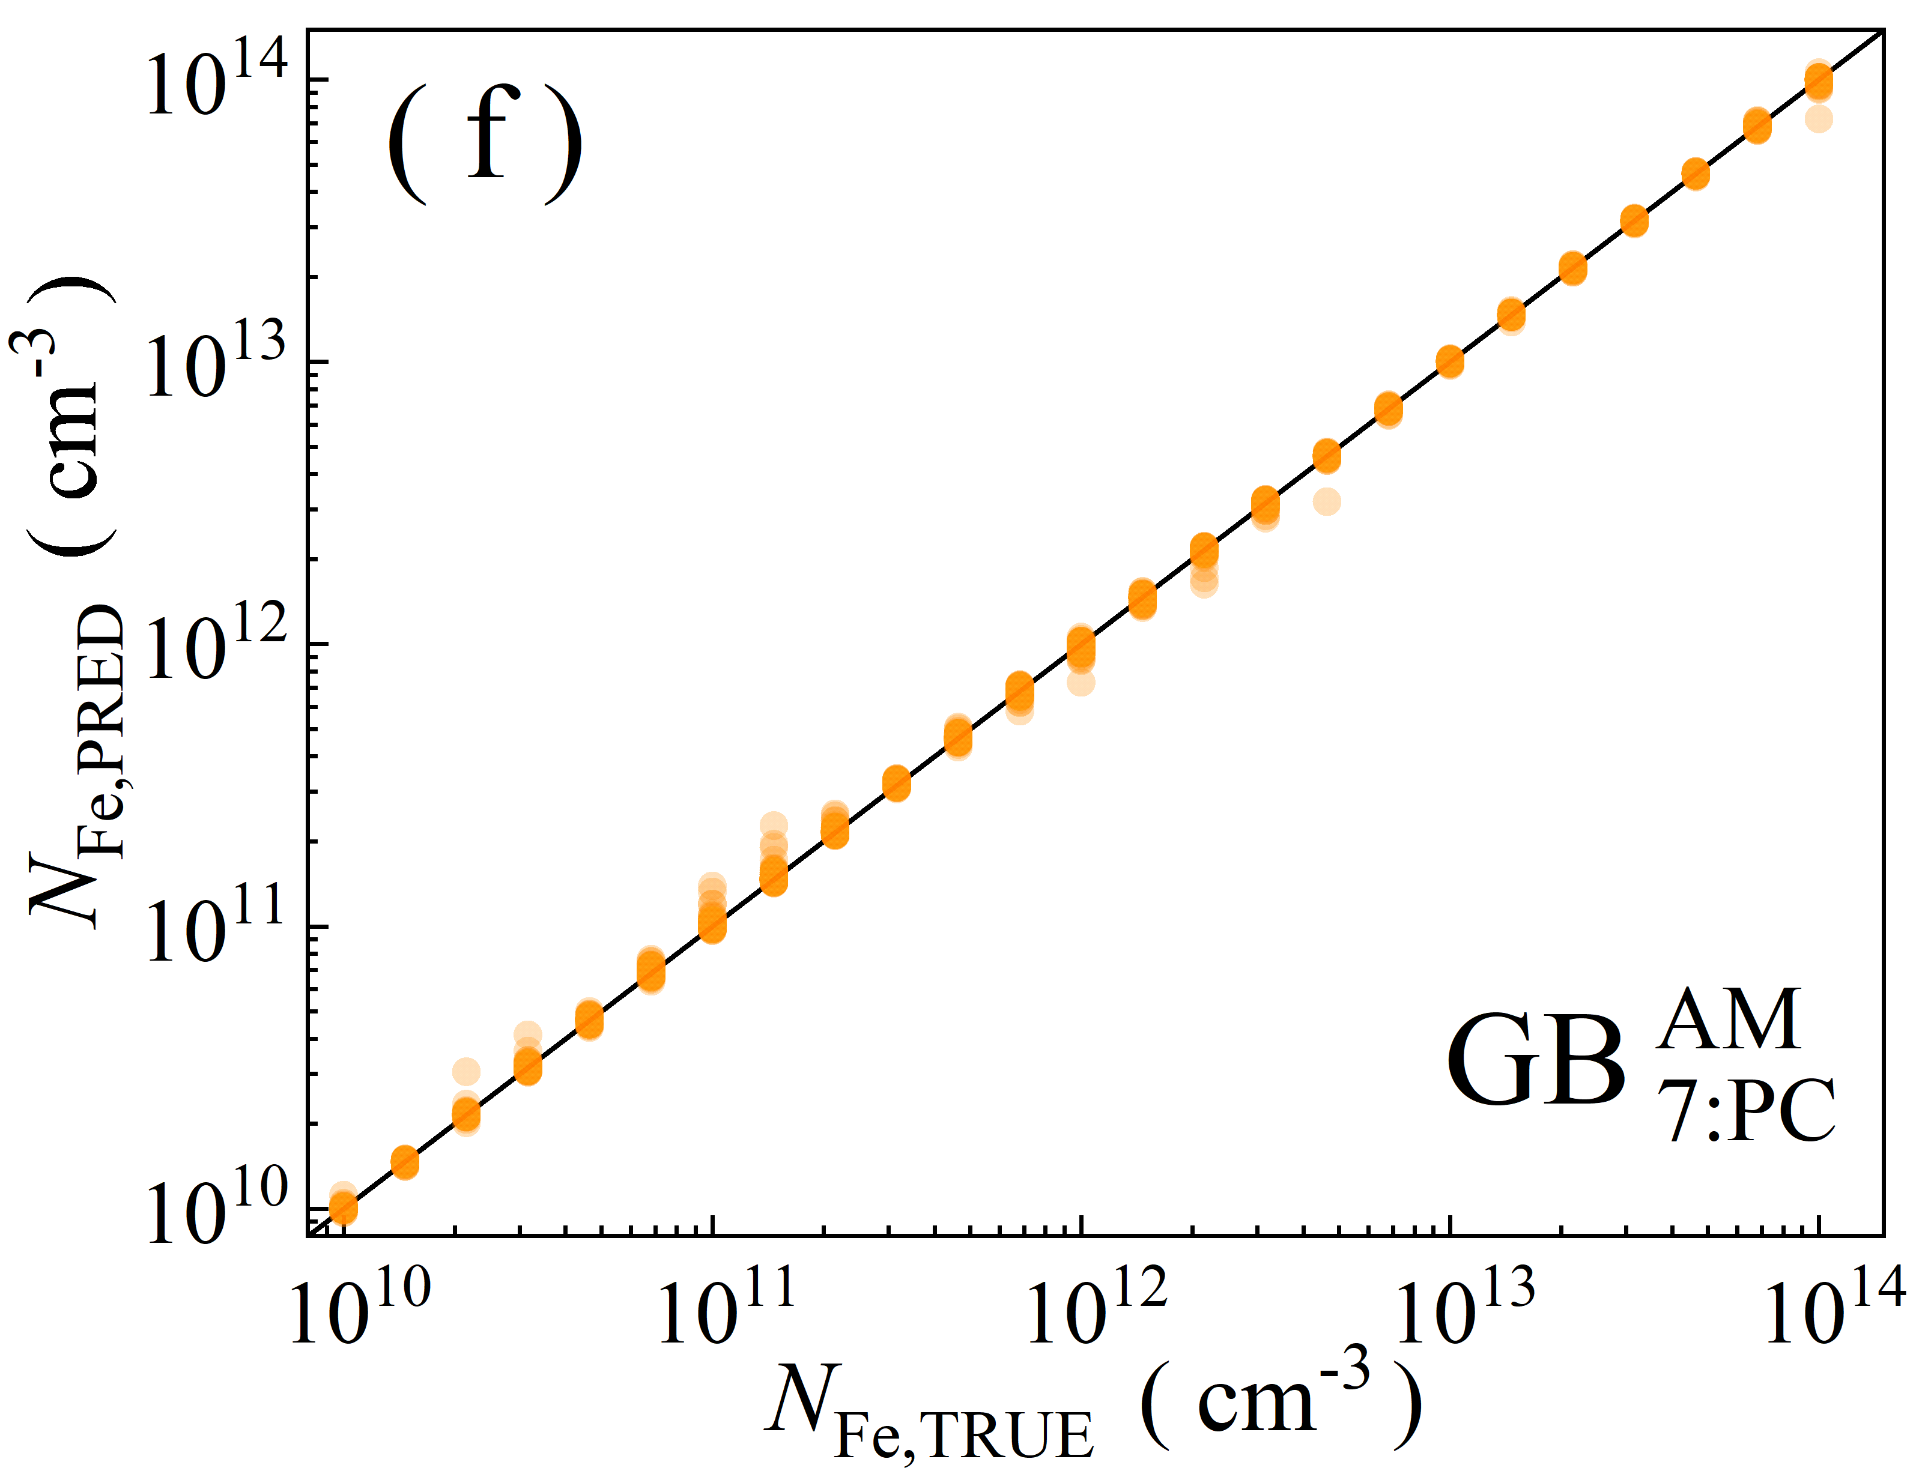

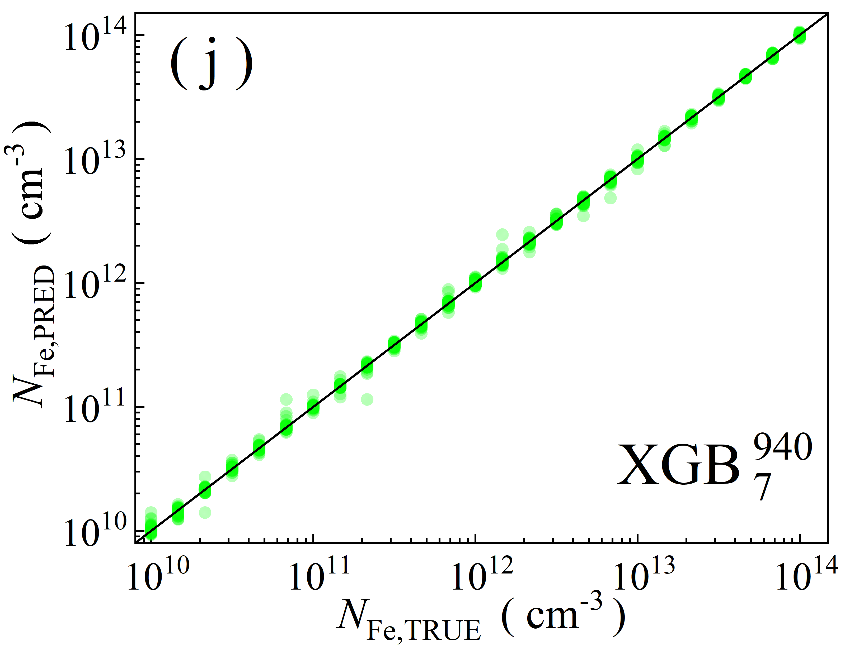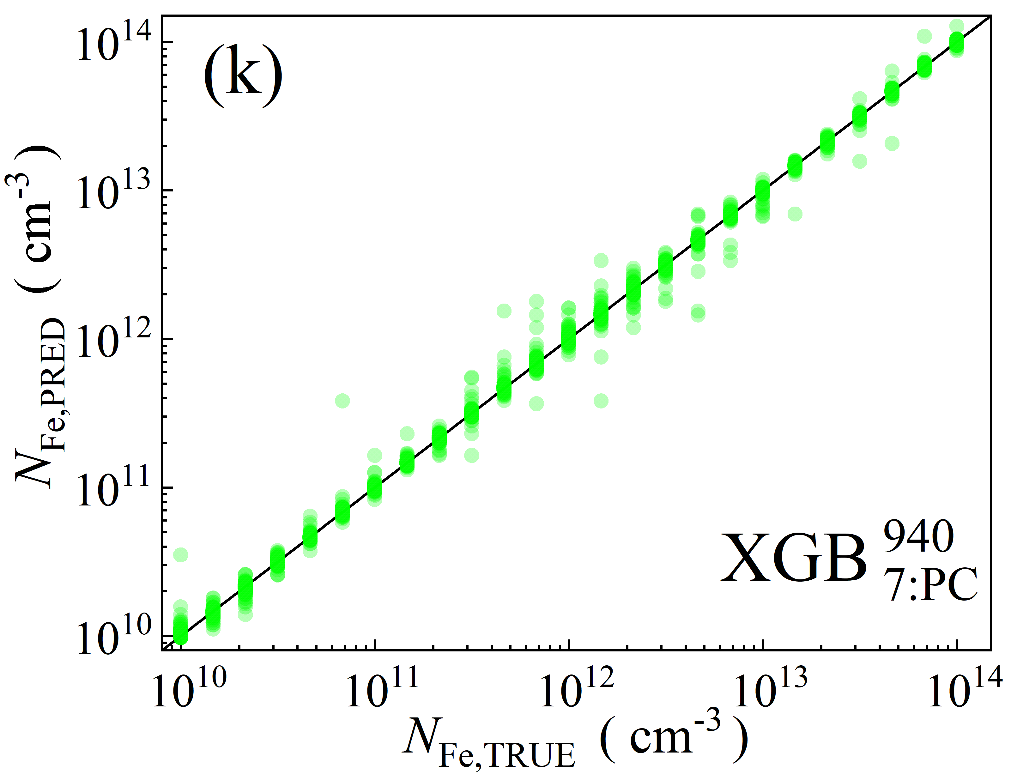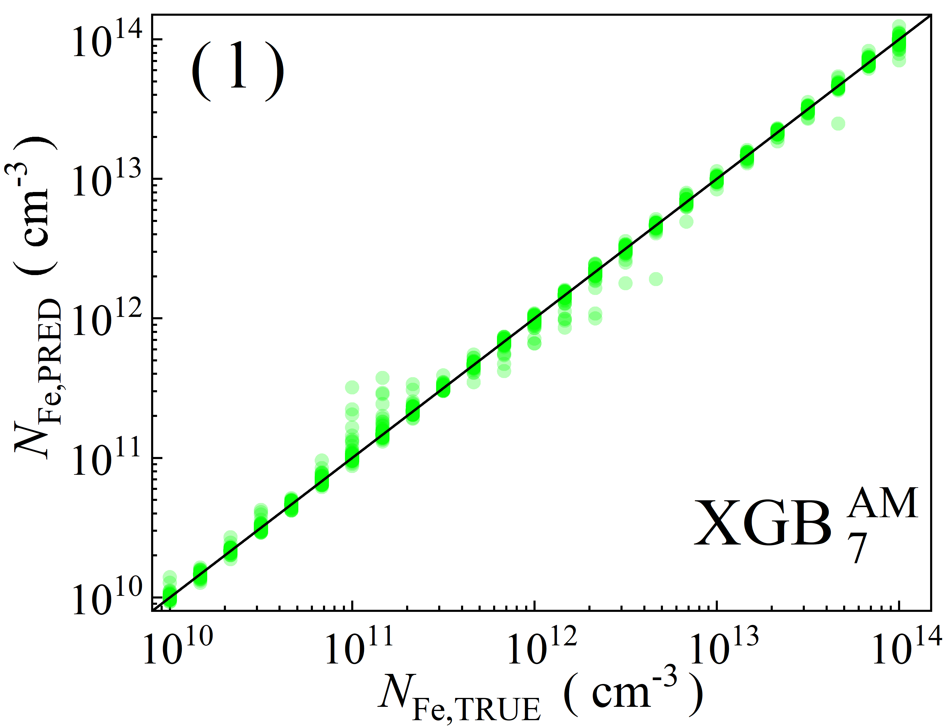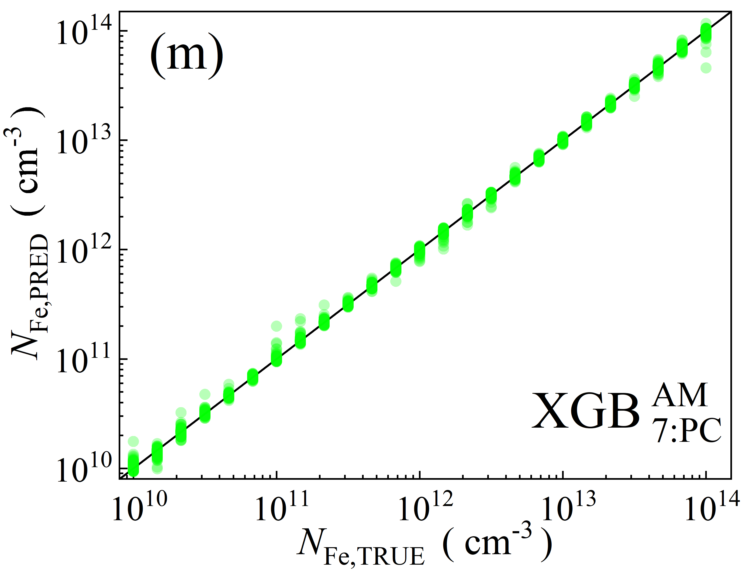

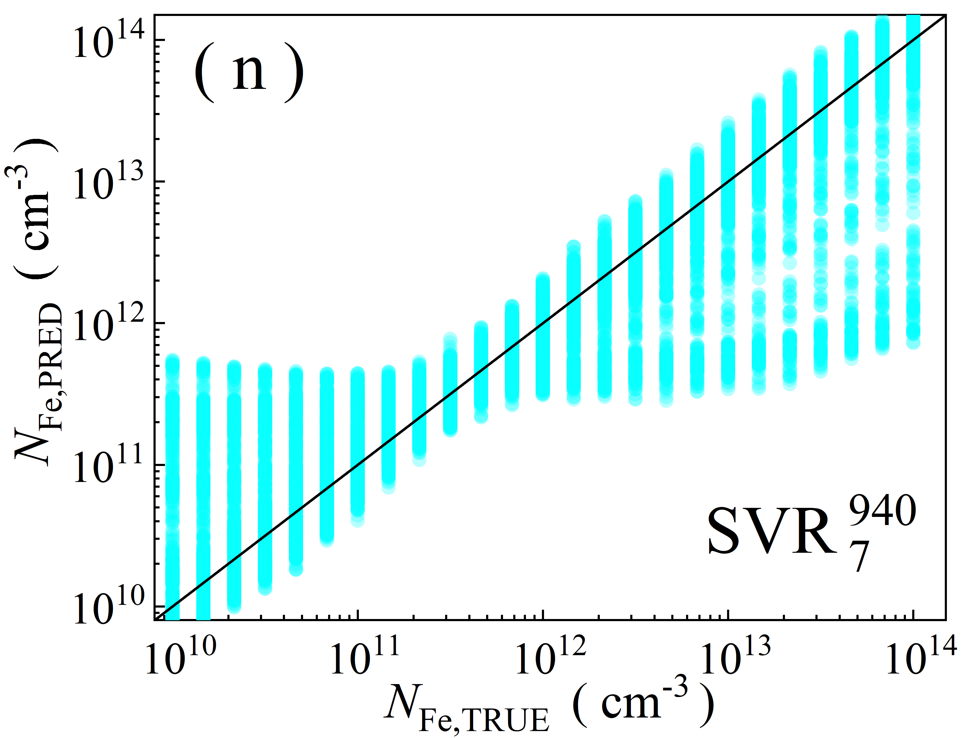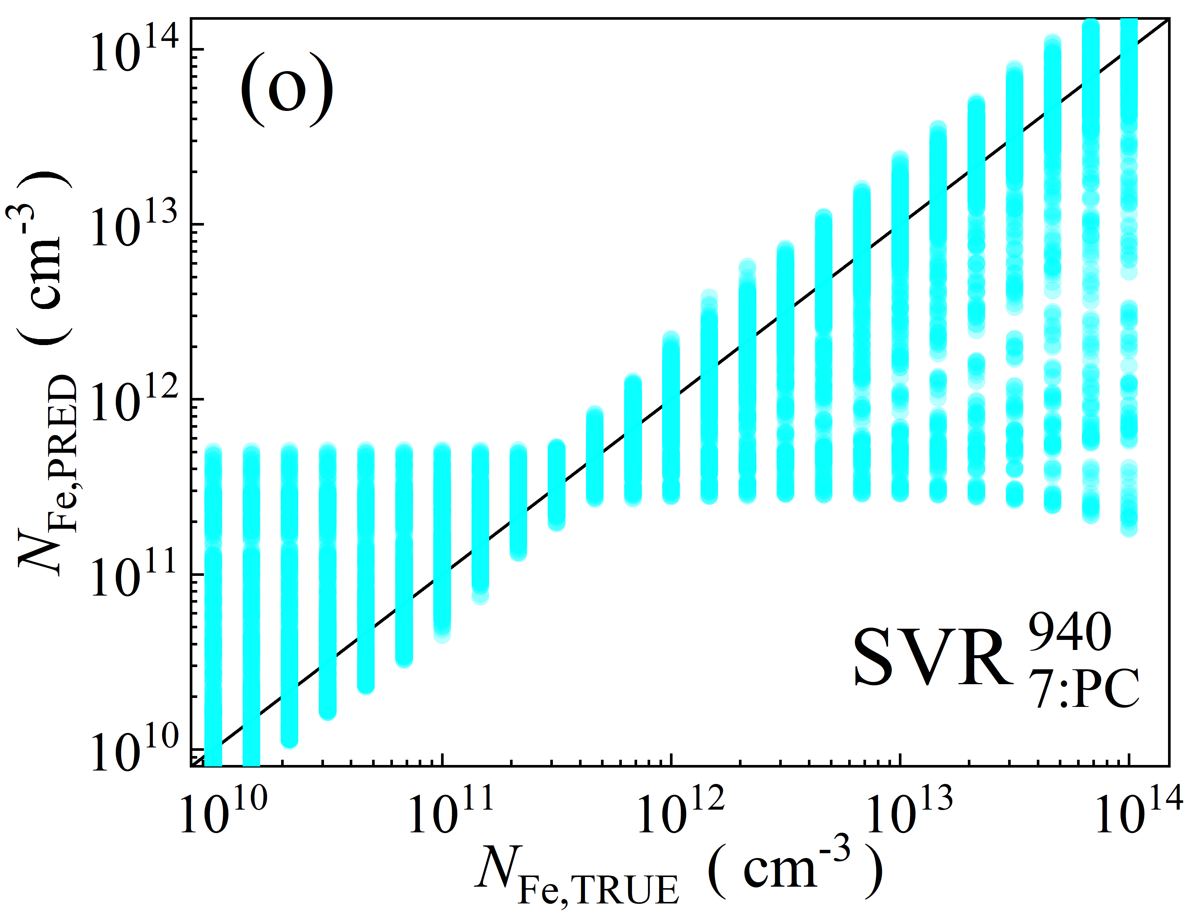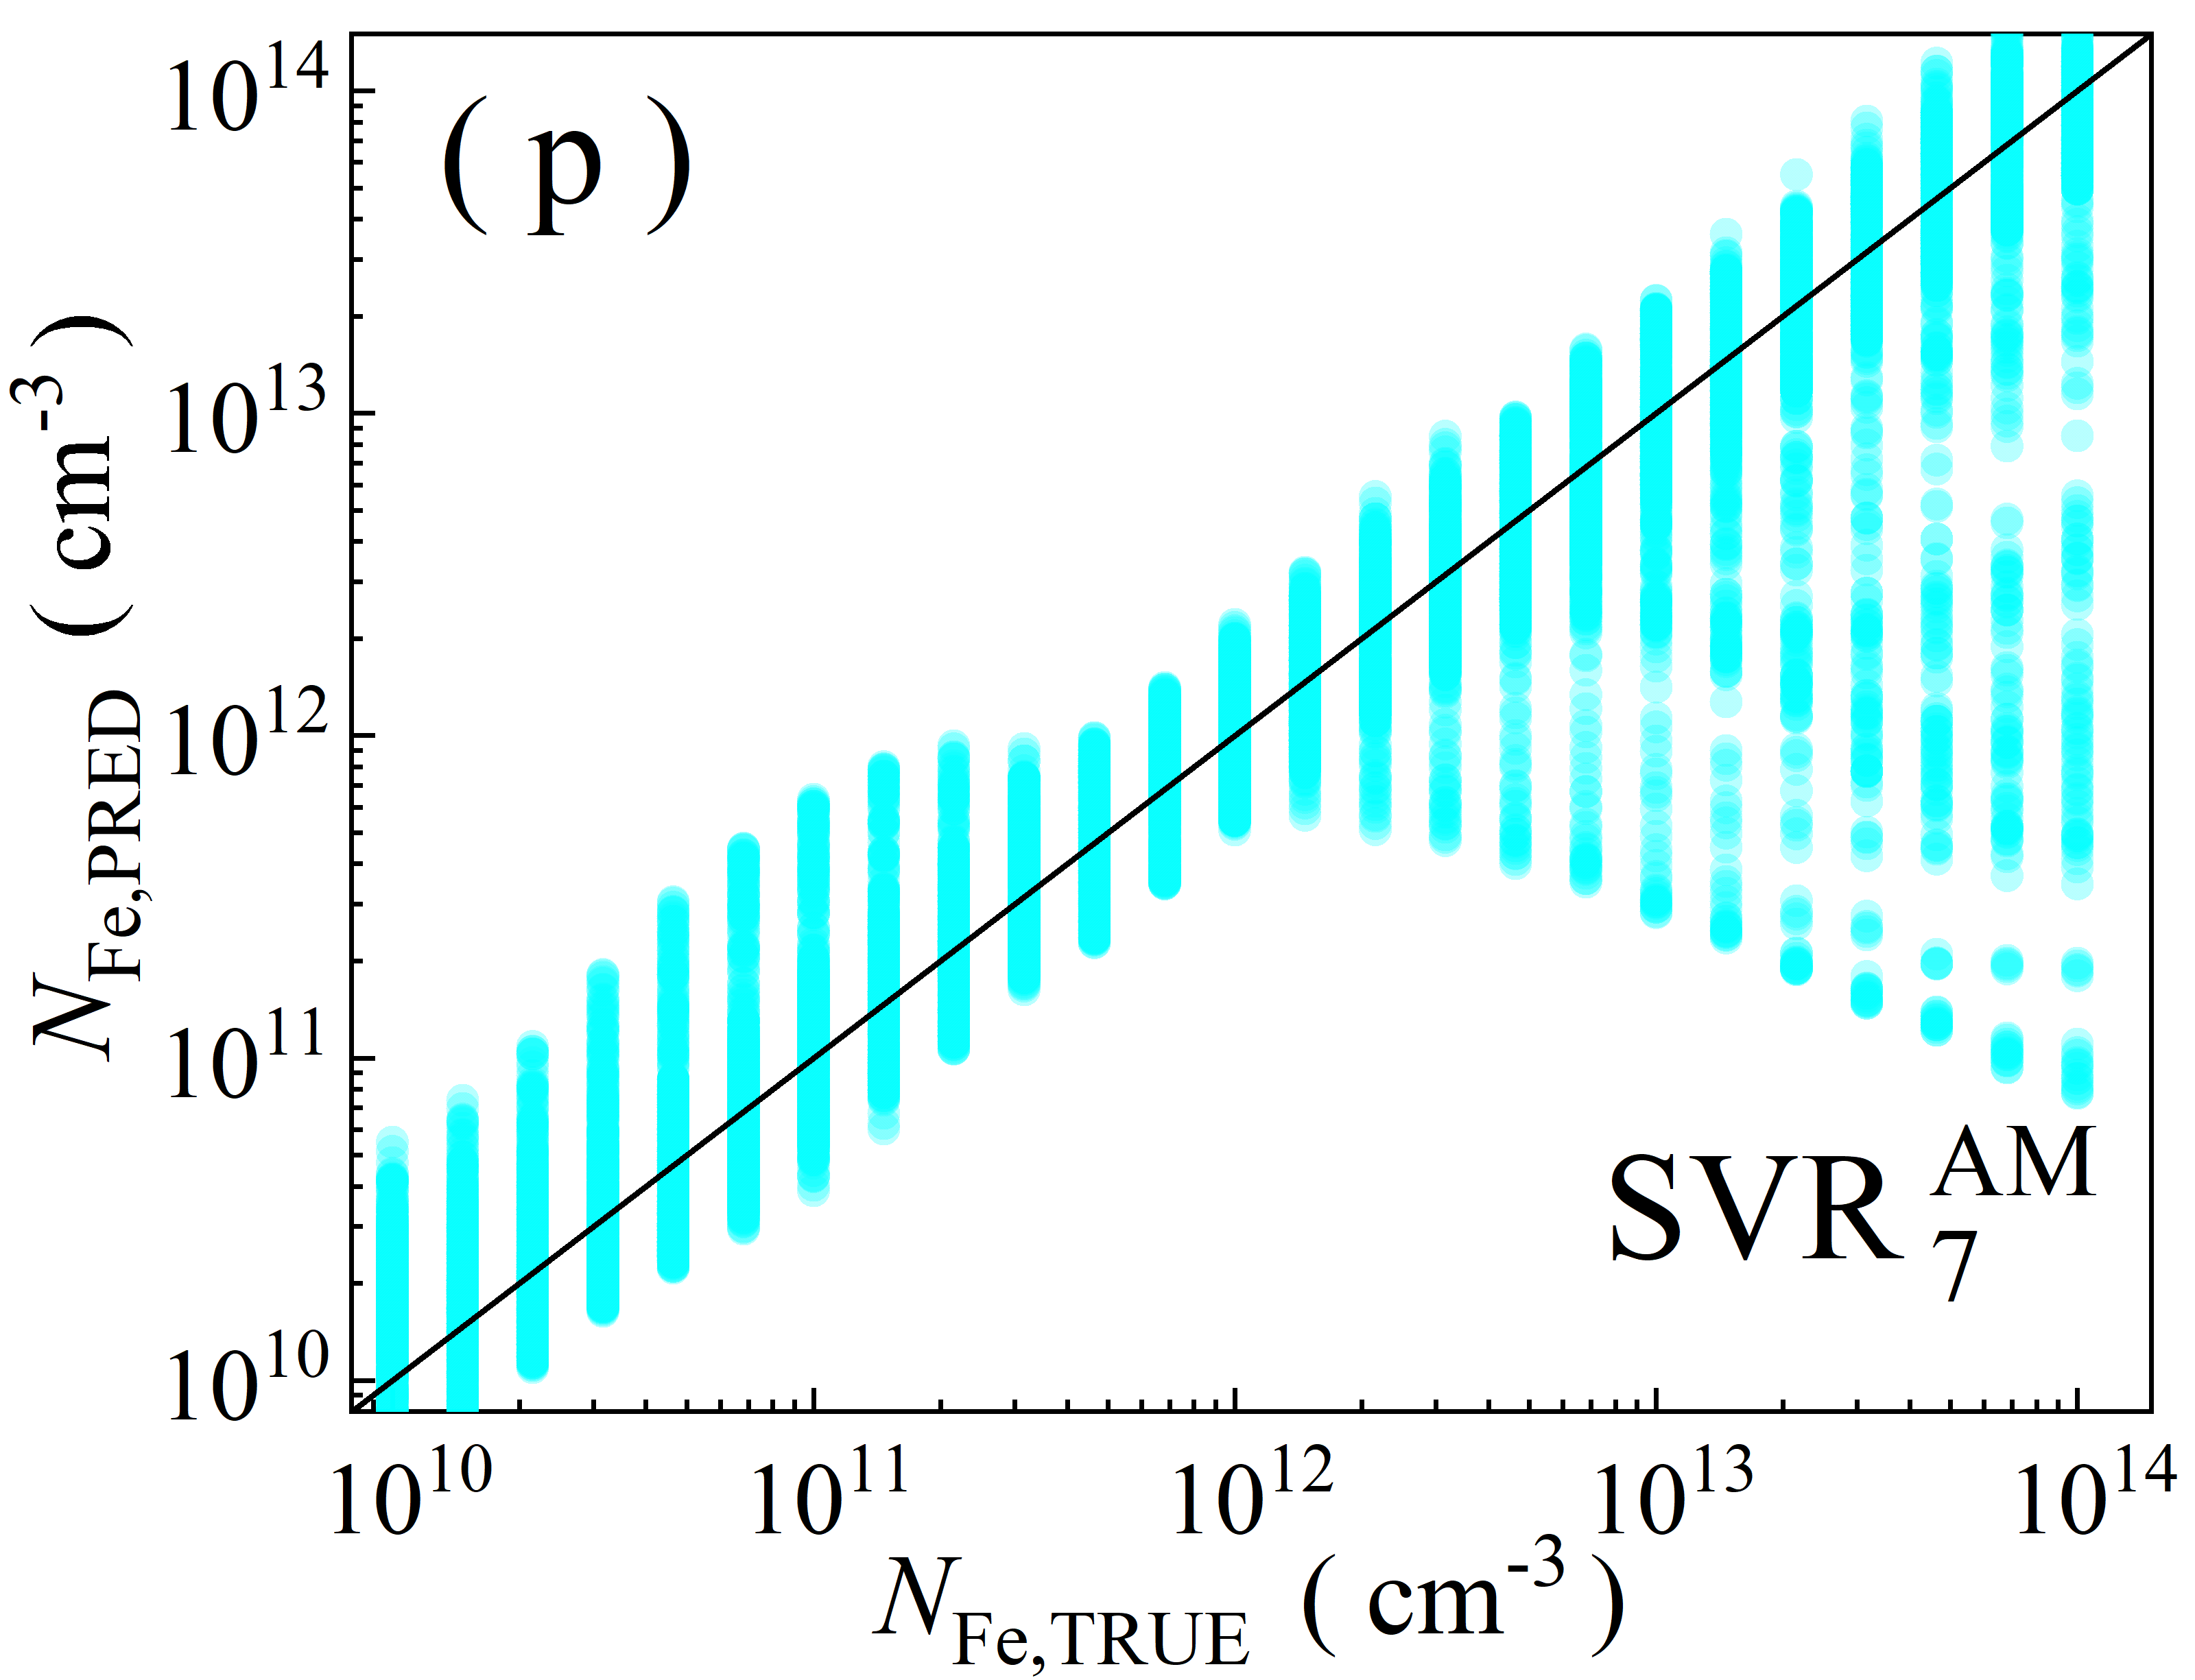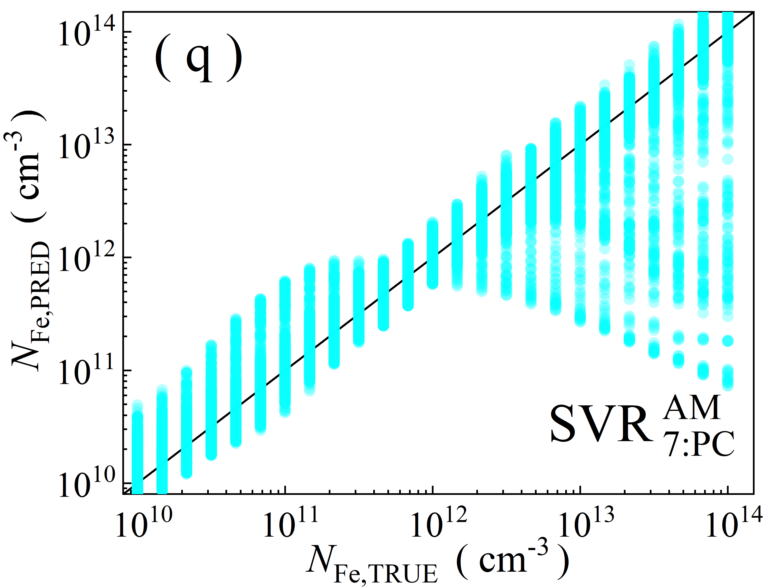

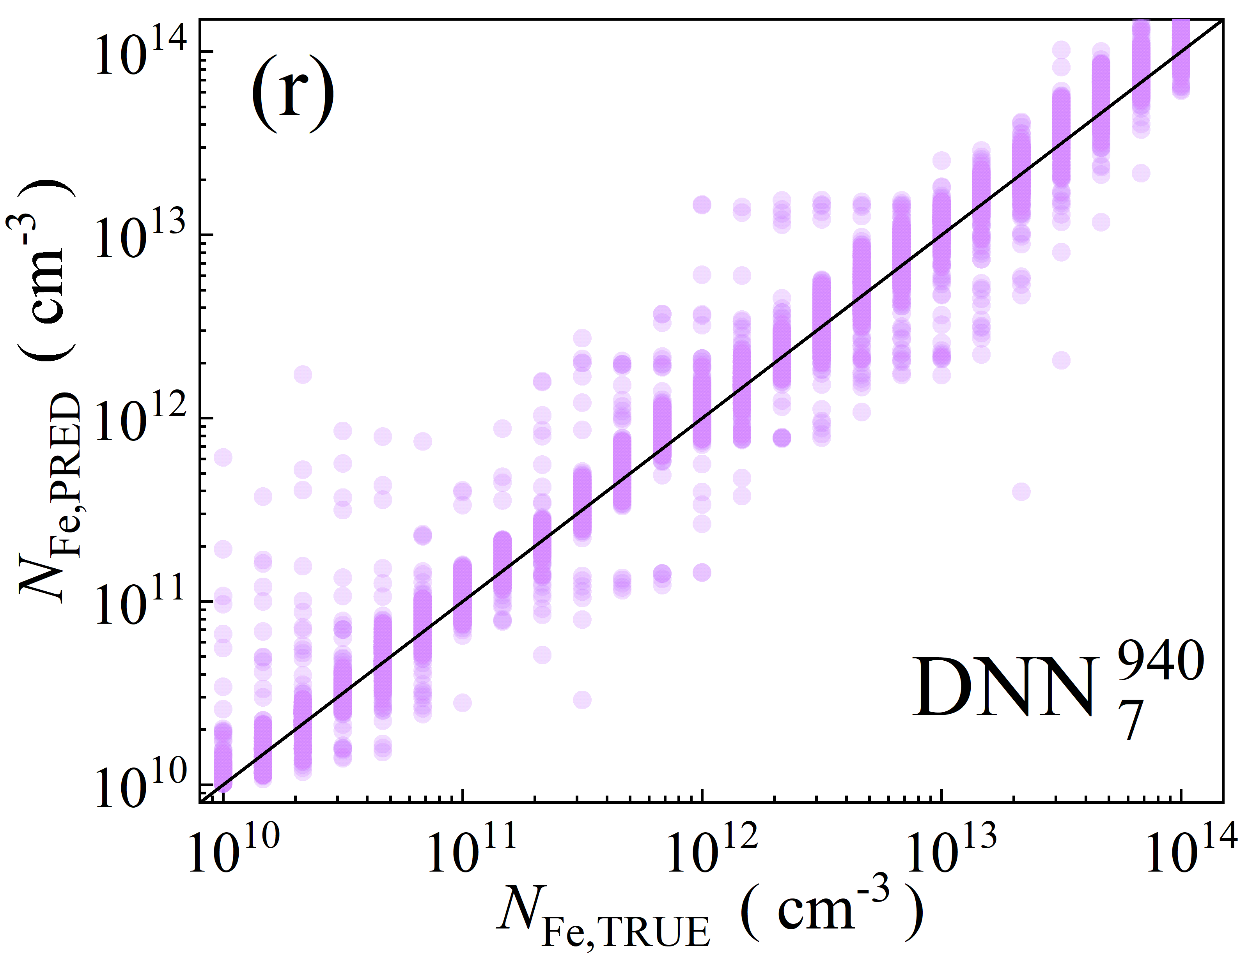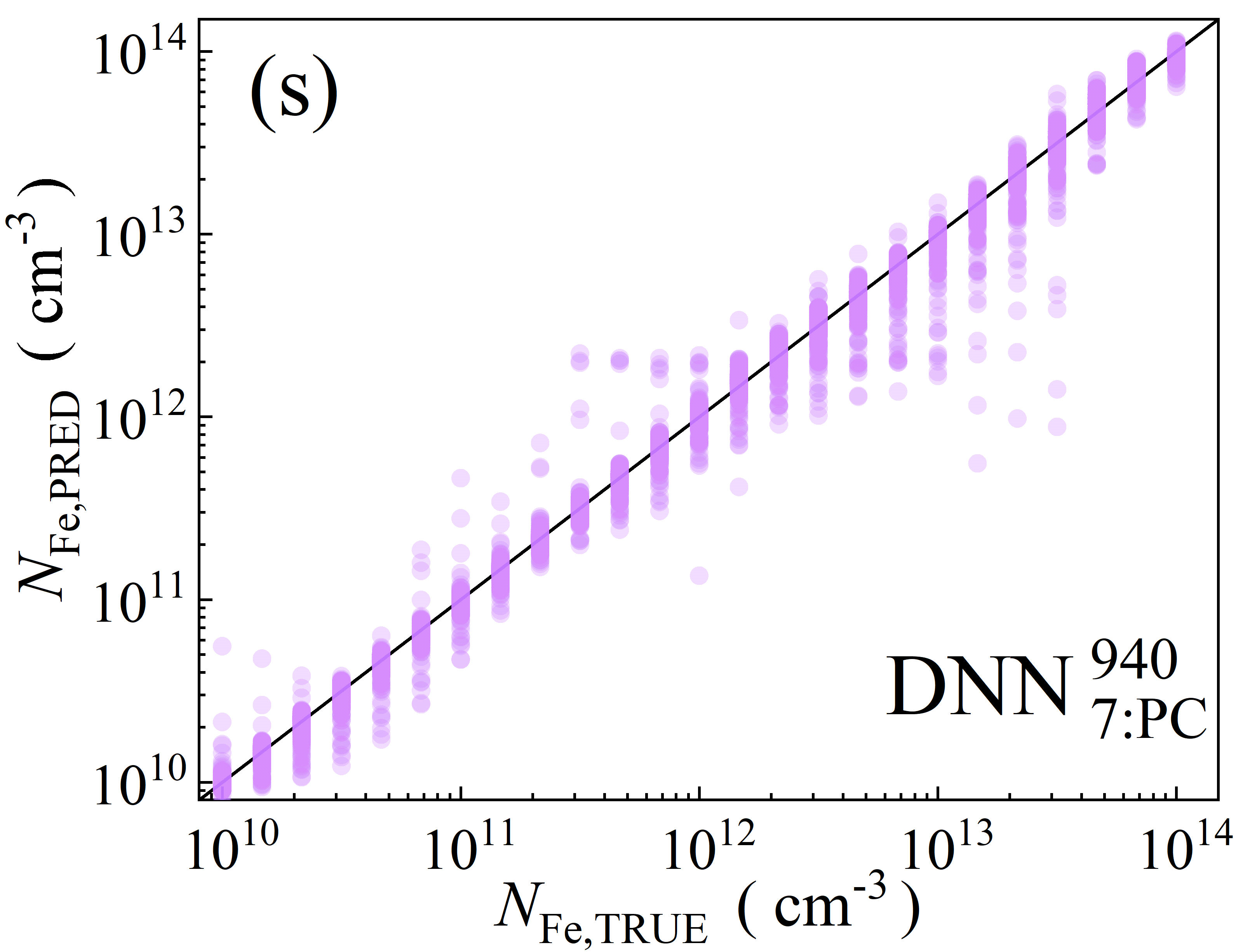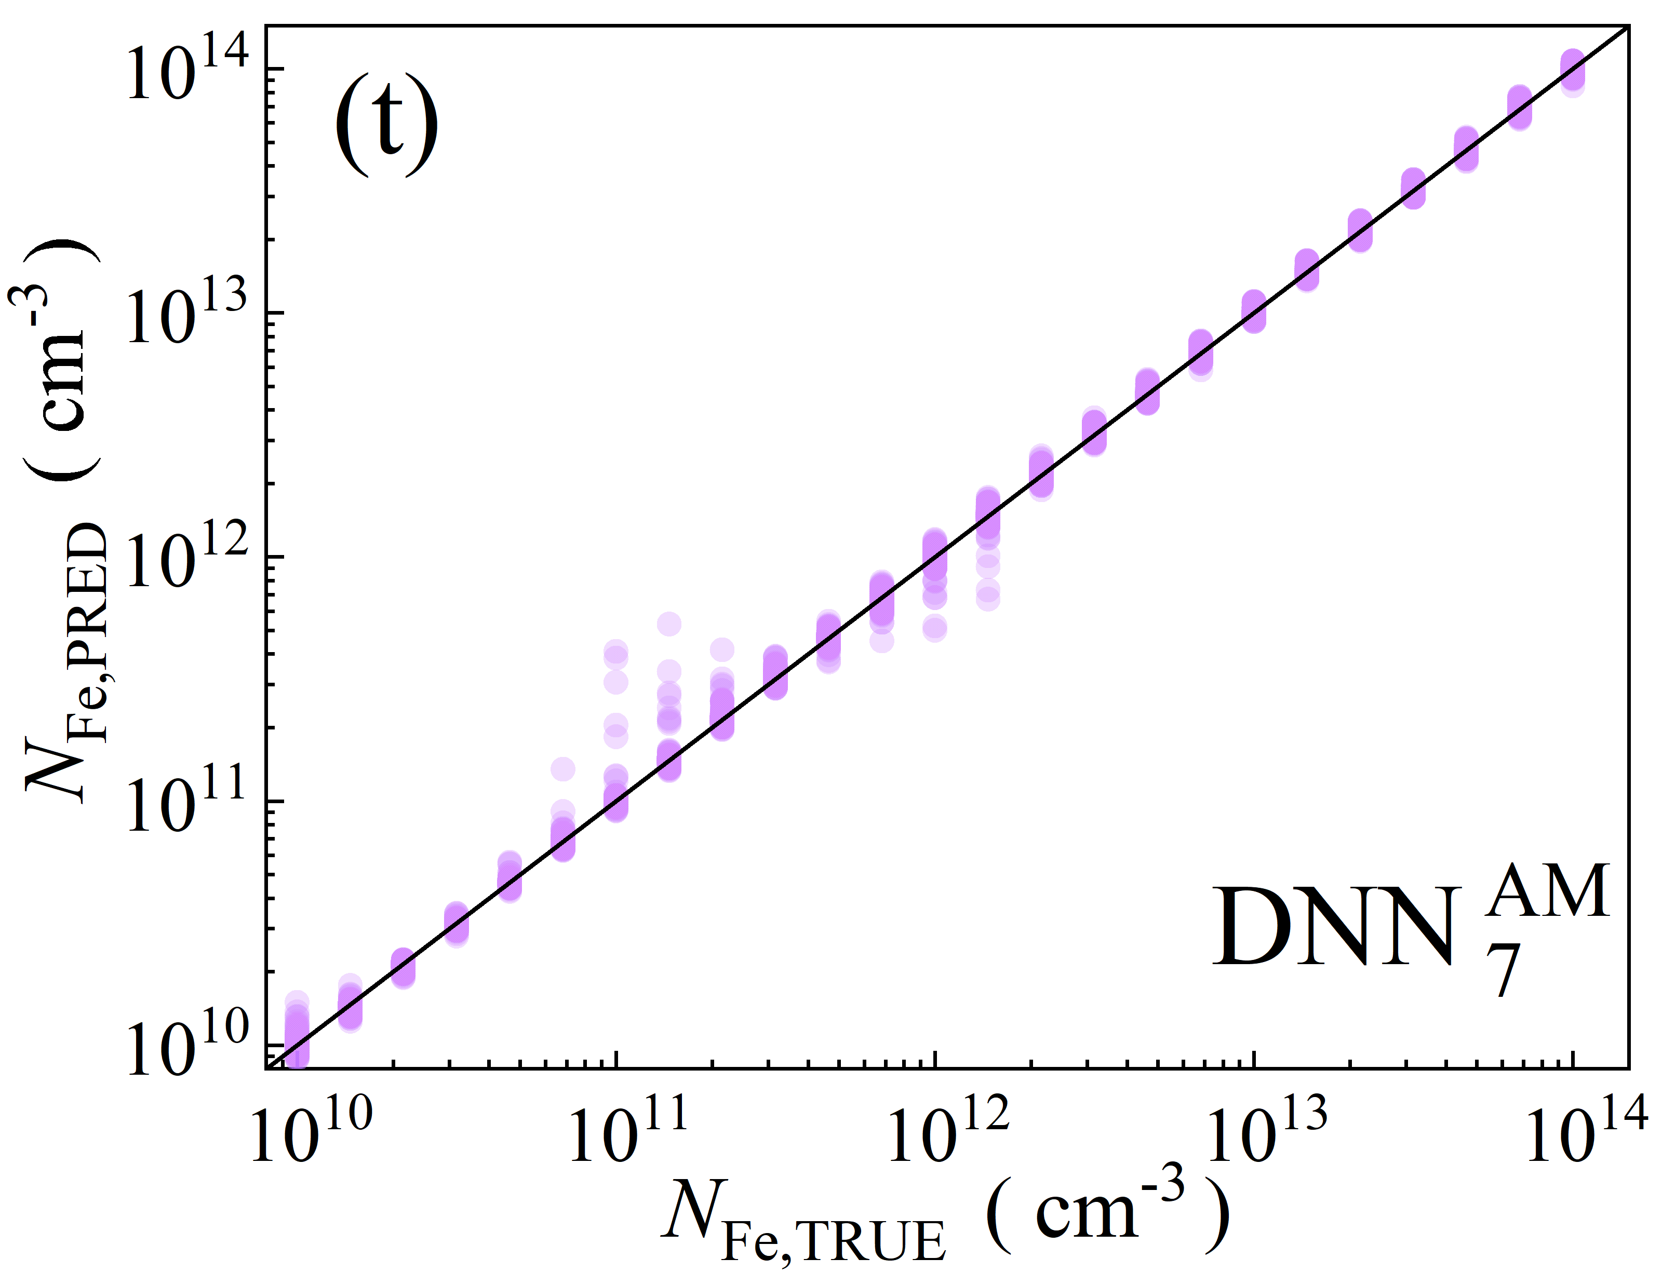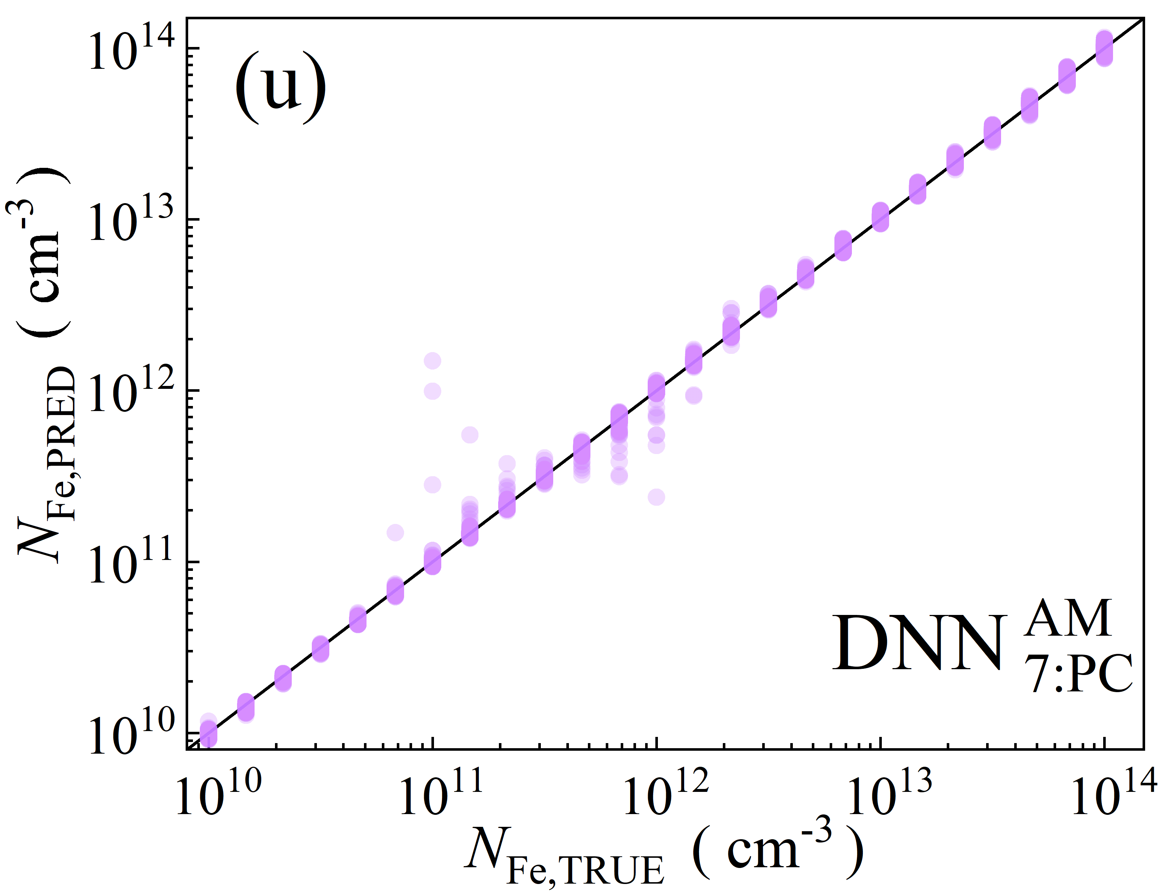

Fig.S6. Scatter plots of the iron concentrations between the reference values and ML predicted values for training phase in the case of 7D features. ML algorithms: RF (a-d), GB (e-i), XGB (j-m), SVR (n-q), DNN (r-u). The data are obtained for monochromatic (a, b, e, f, j, k, n, o, r, s) and AM1.5 (c, d, h, i, l, m, p, q, t, u) illuminations. PCA was used for the panels b, d, f, i, k, m, o, q, s, and u. The black lines are the identify lines servings as the references.

Performance comparison of considered models in four different seasons (